Laboratory Information Network Cymru Programme
(LINC)

Frequently Asked Questions
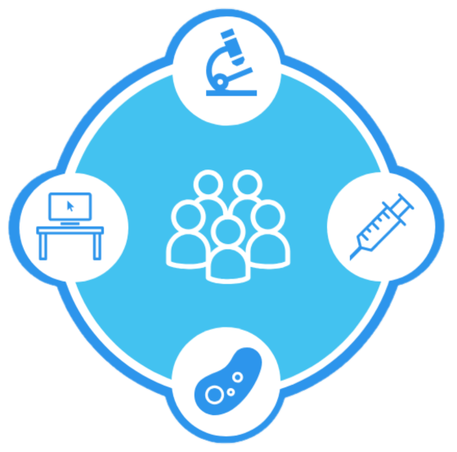

Contents
1. Purpose 3
2. Introduction 3
3. Business Intelligence 4
4. Requirements 4
5. Electronic Test Requesting 5
6. Deployment 6
7. Legacy Data 7
8. Integration 7
9. Quality Management 7
10. Roadshows 8
11. Service Levels 8
12. Standardisation 8
13. Document Control 10
13.1. Document Information 10
13.2. Document History 10
13.3. Reviewers (Draft) / Circulation List (Final) 10
13.4. References 11
13.5. Document Location 11
13.6. Authorisation 11

Purpose
This document has been developed to facilitate the frequently asked questions by the pathology service regarding the new Laboratory Information Management System (LIMS) being progressed by Laboratory Information network Cymru (LINC) programme. The LINC programme is a temporary organisation that has been established by the NHS Wales Health Collaborative and hosted by NHS Public Health Wales.

Introduction
The collection of questions has been sourced from interactive sessions with the pathology service and wider stakeholders. It is anticipated that this set of frequently asked questions will help provide assurance to the pathology service and wider NHS stakeholders in the development of the new LIMS service.
The mission of the LINC programme is to seek fundamental knowledge transfer on the development of the new LIMS being introduced operationally across NHS Wales by 2025. These frequently asked common questions about the LIMS have been grouped into ten categories for ease of use. There are also links to further information on the LINC website.

Business Intelligence
Are any of the proposed suppliers planning on using DeepSee? Is it integratable into other systems?
DeepSee is an InterSystems business intelligence product which is provided as part of the TrakCare Lab 2016 LIMS package. Each supplier will be offering their own solution for business intelligence, which will not be DeepSee for suppliers other than InterSystems.
Is there a plan for real-time Business Intelligence?
We have included the requirement for live dashboards in the procurement Schedule 2.1 The Authority’s Requirements.

Requirements
How did LINC develop the requirements for the new LIMS Service?
LINC held workshops and conferences and invited staff from pathology and other interested stakeholders from across Wales. Requirements were circulated to the discipline-specific Standing Specialist Advisory Groups (SSAGs) and to health boards and trusts for comments. A report was prepared on the consultation and governance to approve the requirements.
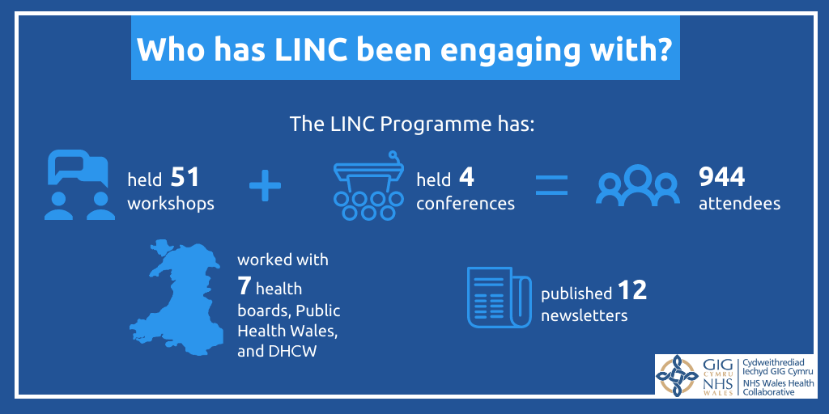
How will the new system address the differences between disciplines and what is included in reports e.g., non-numeric outputs and need for multiple modifications and updates?
The requirements for all disciplines, including reporting, have been included in the procurement Schedule 2.1 “The Authority’s Requirements”, which was developed in consultation with the Pathology service across Wales. These requirements have been discussed in dialogue with suppliers with discipline specific experts in attendance.
Additionally, Digital Health Care and Wales (DHCW) are developing, in conjunction with the Pathology service, electronic test requesting and results reporting for Histology which will be available in 2022 and will be integrated with the new LIMS service.
Why is molecular pathology not included in the new LIMS?
The All-Wales Medical Genetics service have procured their own LIMS system and is currently configuring and implementing the system. The preferred option for requesting tests and receiving relevant test results electronically back into the national LIMS is being considered. Integrated reporting is also being designed for the new LIMS service and would require the medical genetics results to be electronically feed into the LIMS to be added to a combined report.

Electronic Test Requesting
At the moment, test requesting, and results reporting are provided through the Welsh Clinical Portal (WCP) & GP Test Requesting (GPTR). How will our current supplier be managed via the LINC Programme?
The test requesting and reporting functionality will continue to be provided by DHCW. These products have a defined roadmap for development and improvement with DHCW. The LIMS suppliers were given a software development tool kit as part of the procurement documentation for information and will be working jointly with DHCW to integrate their system with the test requesting and results reporting functionality.
Is e-forms part of the phlebotomy module?
A phlebotomy module has been developed for secondary care ETR and will be available to work with either the current Electronic Test Requesting functionality or the future e-forms that are being developed. It is not available for use with manual paper-based requests.
Once the e-forms are fully implemented, will the systems for primary and secondary care Electronic Test Requesting merge into one?
No, they are two separate systems and will continue to be. However, the e-forms will be standardised as much as possible to support smooth working across both primary and secondary care. A GP Portal is being planned for development and this will include the test requesting e-form functionality and replace GPTR.
Is there a list of planned developments for WCP and GPTR?
Yes, there are ongoing planned developments for both systems. DHCW has a roadmap of these developments. The latest development was planned to go live with a new release in the autumn, but this has been delayed until the New Year because staff working on the integration of the new functionality into the WCP and WRRS have had to prioritise covid development work.
Is the proposal with LINC to replace GP Test Requesting (GPTR) and CliniSys ICE Order Communications System?
The rollout of GPTR will continue until 2022, when the wider introduction of a new GP Portal will replace the current GPTR. This will include the new e-forms currently being developed in the secondary care ETR system.

How is LINC maintaining oversight of GPTR development? GPTR developments and improvements will be integral to benefits realisation.
LINC is liaising with Digital Health and Care (DHCW) to support the development and rollout of GPTR and provide funding towards this. LINC will continue to support the rollout of the current solution.

Deployment
Will there be a support package in place to help the health board?
LINC is putting in place a task force to support each health board and trust to go live with the new LIMS Service. In addition, there will be a full support package in place for every health board once the LINC service is live and the stable operations has been signed off.
Are Cardiff and Vale University Health Board going live first? Is there going to be a large gap before Hywel Dda University Health Board then goes live?
Cardiff and Vale University Health Board are the first health board to go live, which is planned for April – September 2023. Hywel Dda University Health Board is currently the last health board to go live, which is planned for September – December 2024. There is a big gap between the two of them unless we can speed up deployment after Cardiff and Vale go live.
How will sendaways work when Cardiff and Vale University Health Board have gone live and other Health Boards have not?
Work is ongoing to decide on the process for this scenario. A national workshop to discuss the options was held on the Tuesday 3 August 2021 which suggested a national approach to sendaways across the service. A paper is being drafted for consideration based on this workshop and will be shared for consultation across the service.
When will we be able to look at a timeline for a development plan?
There is a broad timeframe in the table below. A detailed plan will be developed with the preferred supplier and then published.

Legacy Data
What is the expectation on the supplier in terms of migrating legacy data from memory, MasterLab, Telepath etc. Are they assisting or are we working with current suppliers to format data?
A specification for the required data extract was detailed in the procurement Schedule 2.1 The Authority’s Requirement and agreed with the supplier.
All required data is being captured from the Telepath/MasterLab legacy data system and transferred to the Trakcare LIMS Legacy Data Repository.
Legacy data that needs to be migrated into the new LIMS service will be up-to-date and all in one system, making it easier for InterSystems to extract and cleanse the data ready for data take-on into the new LIMS.
All agreed data will be extracted from the TrakCare live data base and transferred to the new LIMS prior to ‘go live’. Additionally, processes will be developed to transfer required data between TrakCare and the new solution during the period of implementation to maintain services whilst both systems are being used across Wales.

Integration
Will NHS Wales Informatics Service (NWIS) be responsible for connecting systems such as DAWN to the integration engine?
DHCW, formerly NWIS, will be responsible for connecting secondary systems to the solution via the integration services.
Is it still an aim to link output to other downline systems e.g., chemo care? Are there plans to connect systems that are not currently connected?
DHCW will be managing messages out of the new LIMS to secondary systems e.g., DAWN. There has been a request to connect LIMS to the new All Wales Intensive Care Information System. DHCW will also be maintaining the links between new LIMS to health board secondary systems as currently provided.

Quality Management
What is the LINC Quality Management System?
The LINC Quality Management System (QMS) will allow LINC to demonstrate its ability to consistently provide products and services that meet customer and applicable statutory and regulatory requirements. The LINC QMS will be certified to ISO9001 to support the management of the national validation of the new LIMS service and the standardisation of the NHS Wales Pathology services.

What is iPassport
iPassport is an electronic quality management system that underpins the LINC QMS primarily for document control but offers a full suite of modules to enable healthcare laboratories to digitise, streamline and improve the day-to-day management of
quality and compliance. The requirements for iPassport and the procurement were undertaken with the support of the All-Wales Pathology Quality and Regulatory Compliance Group. Welsh Government funded iPassport and sufficient licences were purchased to allow for use across the NHS. In addition to LINC iPassport is being used by DHCW, PHW Microbiology, Cwm Taf Morgannwg UHB Pathology and WEQAS.
Is there any future work planned for the migration from Q-Pulse to iPassport?
There are no plans to migrate Q-Pulse to iPassport. This is a health board decision, however, iPassport is available to all Health Board/Pathology to migrate their Quality Management System (QMS) if they wish to do so.

Roadshows
I was unable to attend any of the virtual roadshows that LINC did, is there a way I can access these now?
A video of the Cardiff & Vale University Health Board virtual roadshow can be watched here:
https://www.youtube.com/watch?v=WNk_rvm6JJg&list=PLNzz0zompToqNBIyynNoA1Q18PV515IK8&index=2
The 2021 Roadshows report can be read here:
https://collaborative.nhs.wales/programmes/laboratory-information-network-cymru-linc/linc-documents/2021-roadshows-report/

Service Levels
We've had issues with downtime on the live system in the past - how are we handling that going forward with the new system and supplier?
The new contract will be a supplier hosted and managed solution. The supplier will be fully responsible for the performance and reliability of the LIMS system and will need to meet stringent targets for availability as defined in the contract to be paid in full.

Standardisation
What has been standardised?
The LINC Pathology Team has extracted the current state configuration comprising more than 28,000 configuration items, of which more than 6,000 were no longer used or duplicates. A total of 21,678 configuration items have been identified as relevant for the new LIMS service, most of which were in a standardised form, but still required review to check for errors and make sure they are the latest available. The configuration items include business intelligence (186), code tables (100), core functionality (9627), reference ranges (10,210) and test set workflows (1,555). The most complex standardisation work is in the test set workflows which are being reviewed by the relevant standardisation group.
Is how we use our middleware being standardised as part of the standardisation project?
LINC is not standardising which middleware is used, but we are standardising the processes and workflows that occur when results are sent to the LIMS. Any decisions that need to be made around the use of middleware would be made by the Standardisation Groups.
When we get to the stage where we can’t agree on a standardisation process, what is the escalation?
Standardisation leads will escalate any issues to the discipline specific Standing Specialist Advisory groups (SSAG). If the SSAG cannot resolve the issue it will be escalated to the Standardisation Strategy Group (SSG), which is chaired by Dr Andar Gunneberg.
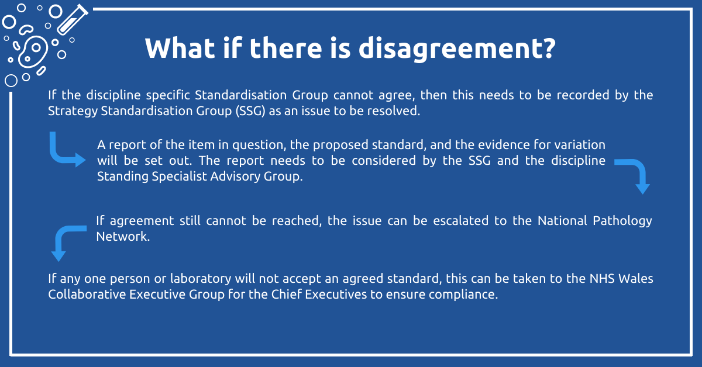

Document Control

Document Information
Document ID: | LINC FAQ1
Document Name: | LINC Frequently Asked Questions
Version: | 1.0
Date Issued: | 26 November 2021
Review Date: | N/A
Status: | Final Draft
Document Authoriser: | Judith Bates
Document Owner/Author: | Natalie Melliard
Contributor(s): | Judith Bates, Ana Maldonado, Kevin Williams, Brent Varley, Noel Bevan Lizzie Gladwyn, Paul Williams

Document History
Amended by | Version | Status | Date | Purpose of Change
Natalie Melliard | 0.1 | Draft | 22-Oct-21 | Creation of document
Lizzie Gladwyn | 0.2 | Draft | 25-Oct-21 | Review and amendment
Paul Williams | 0.3 | Draft | 26-Oct-21 | Review
Natalie Melliard | 0.4 | Draft | 27-Oct-21 | Review and amendment
Paul Williams | 0.5 | Draft | 28-Oct-21 | Review
Judith Bates | 0.6 | Final draft | 26-Nov-21 | Review
Judith Bates | 1.0 | Final | 26-Nov-21 | Approve

Reviewers (Draft) / Circulation List (Final)
Name | Title | Organisation
LINC PMO

References
Document | Version

Document Location
System | Location
iPassport: | NHSWHC LINC/ LINC Controlled Documents
Shared Drive: | \\rytu1srvfil0001\shared\NHS Wales Health Collaborative\LINC Programme\Documentation\Communications\FAQs
SharePoint: | https://phwsharepoint.cymru.nhs.uk/whc/LINCProgramme/Library

Authorisation
Authoriser’s Name: | Judith Bates
Title: | Programme Director
Organisation: | NHS Wales Health Collaborative
Role | Programme Director, LINC
Signature:

