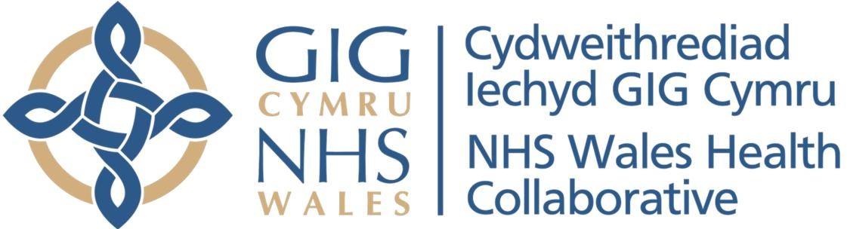

Laboratory Information Network Cymru Programme (LINC)

LINC STR3 Quality and Assurance Strategy

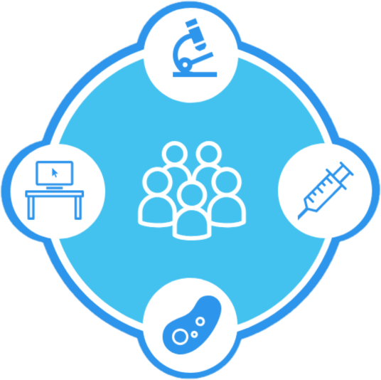

Contents
- Document Control 3
  - Document Information: 3
  - Document History 3
  - Circulation List (Final) 3
  - References 3
  - Document Location 4
  - Authorisation 4
  - Circulation List 5
  - Document Location 5
- Purpose 6
- LINC Programme 6
  - Aims and Objectives 6
  - Projects Dossier 6
- Definitions 6
- Scope 7
- Critical Success Factors 8
- Assurance Management in a Programme 10
  - Programme Assurance 10
  - Gated Reviews 11
  - Design Assurance 11
- LINC Programme Quality Plan 12

Document Control

Document Information:
Document ID: | LINC STR3
Document Name: | Quality and Assurance Strategy
Version: | 1.0
Date Issued: | 11 August 2020
Review Date: | July 2021
Status: | Draft
Document Authoriser: | Adrian Thomas
Document Owner/Author: | Judith Bates
Contributor(s):

Document History:
Amended by | Version | Status | Date | Purpose of Change
Judith Bates | 0.1 | Draft | 31-May-20 | Create document
Judith Bates | 0.2 | Draft | 4-Aug-20 | LDA feedback
Judith Bates | 1.0 | Final | 11-Aug-20 | Approved by LPB

Circulation List (Final)
Name
LINC Programme Board
LIMS Service Procurement Teams
LIMS Service Shortlisted Suppliers

References
Document | Version
Managing Successful Programmes, Crown Copyright | 2011
LINC POL1 Records Management Policy | V0.1
LINC SOP1 Controlled Document Management Procedure | V0.3
LINC SOP2 iPassport Document Management Procedure | V0.3
LINC SOP3 SharePoint Document Management Procedure | V0.1

Document Location
System | Location
iPassport: | NHSWHC LINC/ LINC Controlled Documents
Shared Drive: | S:\NHS Wales Health Collaborative\LINC Programme\Documentation\Programme Definition\Quality and Assurance Strategy
SharePoint: | https://phwsharepoint.cymru.nhs.uk/whc/LINCProgramme/Library

Authorisation
Authoriser’s Name: | Adrian Thomas
Title: | Executive Director of Therapies and Health Sciences
Organisation: | Betsi Cadwaladr UHB
Role | Senior Responsible Owner, LINC
Signature: | X

Circulation List
Name
LINC Programme Board
LINC Team
LIMS Service Procurement Teams
LIMS Service shortlisted suppliers

Document Location
System | Location
iPassport: | NHSWHC LINC/ LINC Controlled Documents
Shared Drive: | S:\NHS Wales Health Collaborative\LINC Programme\Projects- Information\Legacy Data Project (LDP)\Project Documents\Legacy Data Strategy
SharePoint: | https://phwsharepoint.cymru.nhs.uk/whc/LINCProgramme/Library

Purpose
In accordance with Managing Successful Programmes (MSP), the purpose of this strategy is to ensure that all management aspects of the programme are working appropriately and that LINC stays on target to achieve its objectives.

LINC Programme

Aims and Objectives
The LINC Programme aims to use information and technology to transform pathology services underpinning the Pathology Statement of Intent, which seeks to deliver a modern, sustainable, standardised and safe pathology service across NHS Wales.

The LINC objectives are to:

- Deliver benefits that improve patient care, safety & outcomes
- Engage the Pathology and wider NHS to ensure commitment
- Procure new LIMS service to replace three current LIMS
- Ensure long term ownership and management of the service
- Deliver a seamless end-to-end electronic Pathology solution
- Standardise Pathology services, with warranted variation
- Establish a national quality management service and system
- Develop information and business intelligence services
- Develop a different approach to integration services 10.Learn the lessons from WLIMS1

Projects Dossier
The programme has three project streams:

    - Standardisation and Design Project Stream to deliver the standardised design (with warranted variation), provide the business change to support the pathology service during the change and establish a quality management service to support standardised services
    - LIMS Service Project Stream to procure and implement a new LIMS service to replace the current laboratory information management systems (LIMS), including InterSystems Trakcare Lab (TCL) (knowns as WLIMS1), DXC Telepath and Clinisys Masterlab
    - Information Projects Stream to develop a benefits realisation strategy for the LINC full business case, a legacy data strategy and develop business intelligence for the current LIMS upgrade, the new LIMS service and to support Welsh Government in the planning and monitoring of pathology services.

Definitions
MSP defines quality as the totality of features and inherent or assigned characteristics of a product, person, process, service and/or system that bears on

its ability to show it meets expectations or stated needs, requirements or specification.

Assurance is the systematic set of actions necessary to provide confidence to the Senior Responsible Owner (SRO) and stakeholders that the programme remains under control and on track to deliver and that it is aligned with the LINC strategic objectives.

Quality in a programme is about identifying the right thing to do and doing them correctly. Thus, quality and assurance management run continuously throughout the life of the programme and are an integral part of day-to-day activities. They operate at a whole systems level, aligned to the LINC environment incorporating political, organisational, governance, legal, standards, financial, commercial, professional, scientific, service and technical dimensions. These may change during the life of the programme, which needs to ensure its vision, blueprint and plans remain aligned to corporate priorities.

Quality at a project level is checking that the ‘project is delivering what it is supposed to be delivering’ as specified in the product descriptions, which include the acceptance criteria for individual products. The programme needs to ensure that the projects are delivering products which are fit for purpose to enable the programme to create the capability to deliver anticipated outcomes and benefits.

Scope
The scope includes eight processes that need to be addressed for the programme to be effective. Many are covered in the governance themes:

  - Communication management with stakeholders based on the LINC Stakeholder Management Strategy underpinned by a LINC Communications Plan to understand and deliver their requirements for change.
  - Supply chain management by ensuring suppliers apply quality management to their processes in order to ensure they deliver their obligations to the programme and aligned to the way the programme operates including the new LIMS supplier and the eQMS supplier as well as any consultancy services provided to the programme as set out in contract documentation. NWIS too is a supplier and ways of managing this relationship to required standards requires further investigation as part of the LIMS Service Governance Strategy.
  - Standards management is critical to the success of LINC, to ensure the programme is aligned to corporate standards and policies as defined by Welsh Government, Public Health Wales, NWIS, the NHS Wales Collaborative Executive Group and NHS Wales Health Collaborative. Quality management assures the programme and projects are being undertaken to the required standards, not only corporate standards but also legal and professional standards from CE marking and data protection to ISO20001 for service management and SNOMED Clinical Terms.
  - Process management to achieve the programmes objectives in the most effective way from managing tranches of work to interdependencies within the programme and other programmes of work. Success involves

understanding the critical path focusing on the key processes, taking account of known constraints, such as service capacity, and unexpected ones, like covid-19. It is essential to define clear responsibility and accountability and to build in measurement and control against deviation. LINC is achieving this through programme definition and project initiation documents along with strategies to set out the approach to managing the programme and delivering project outputs and programme outcomes, such as the LINC Risk Management and Issue Resolution Strategy.
  - Information management is required to provide the right information in the right format to the right people at the right time. This is explained further in the LINC Information Management Strategy and Plan supported by the LINC document management procedures for iPassport, SharePoint and controlled documents created from MS Office templates.
  - Asset management to identify, track and protect the programme’s assets which include people, finance, services, information, software and physical assets. Assets may be external such as legislative changes or Welsh Government policy that impact the programme; programme assets such as the blueprint and programme plan; Internal assets such as project progress reports and project outputs from design documents to developed software or training.
  - Programme leadership to assure the quality of decisions made, providing clear direction and communicating that direction inside and outside the programme. This is underpinned by the LINC governance framework and organisation structure including well-defined roles and accountability such as the LINC Programme Board terms of reference regularly reviewed as part of the LINC quality review activities. Key roles include the LINC Senior Responsible Owner and Programme Director.
  - People management including leading change, communicating a better future and learning from experience, especially WLIMS1. This will be taken forward by the Business Change Project for the wider service. In addition, for the LINC programme team this includes providing an induction for new staff; clear roles, responsibilities and appraisal combined with skills development and training linked to performance improvement as set out in Public Health Wales My Contribution; relevant terms and conditions such as secondments and exit plans to reintegrate staff back into the business or as part of a service handed over to operations.
The scope excludes the specific quality management requirements for an individual project, which is specified in the project quality plan and associated product descriptions.

Critical Success Factors
Critical success factors (CSFs) are the few key areas that must go right to ensure the successful completion of the programme, the desired business improvements to be achieved and anticipated benefits realised. Identifying and communicating these CSFs can help to ensure everyone remains focused on the activities that are most important. CSFs can be considered in different ways:

  - MSP CSFs for programmes
  - Better Business Cases CSFs for business cases

  - LINC specific CSFs

MSP describes the principles of quality management as CSFs, which include:

- Remaining aligned to corporate strategy, in particular the Welsh Government Pathology Statement of Intent, A healthier Wales; our plan for health and social care, Informed health and care: a digital health strategy for Wales and, more recently the NHS Wales Digital Architecture Review.
- Leading change as demonstrated through the level of support for and resistance to LINC. To date LINC has been recognised for achieving good engagement with the pathology disciplines and professional networks, enabling them to lead the decision making for their future services.
- Envisaging and communicating a better future, which LINC has been doing through workshops, newsletters, events, project and procurement teams and defining the blueprint (current, interim and future state). Most recently is the launch of a twitter site to provide daily updates on LINC. Roadshows are planned as soon as allowed following covid-19.
- Focusing on benefits and threats to them. A benefits management strategy has been developed to provide a robust analysis for the LINC full business case. LINC will work with each health board and trust to develop and commit to their own benefits plan to delivering the benefits for their organisation.
- Adding value, which involves assuring that the programme remains justified and aligned to corporate objectives. This is achieved through accountability to NHS Wales Collaborative Executive Group via the NHSWHC annual planning process; reporting to the National Pathology Network, Laboratory Services SubCommittee and LINC representation on the per discipline Standing Specialist Advisory Groups (SSAGs). Tranche reviews also take an opportunity to assess the programme to ensure it continues to meet its objectives. External gateway reviews also ensure the programme is delivering, aligned and adding value.
- Designing and delivering a coherent capability. This is primarily delivered through the effective management and control of project outputs, as defined in their product descriptions, setting out the acceptance criteria and ensuring these are met. These products should all contribute to delivering the capability to meet the blueprint, which is being defined through the standardisation work being led by the service.
- Learning from experience especially from the experience of WLIMS1. Significant analysis of lessons learned from WLIMS1 has been undertaken including how these lessons will be addressed within LINC. These are taken into account in every strategy written and every workshop held and reviewed every six months to ensure nothing has been missed. In addition LINC is now starting to record its own lessons from the programme to date.
Welsh Government guidance on Better Business Cases sets out the CSFs that need to be considered during the options appraisal in the economic case and were used accordingly in the LINC Outline Business Case , including:

- Strategic fit and business need; how well the option meets the agreed spending objectives, related business needs and service requirements, and

provides holistic fit and synergy with other strategies, programmes and projects.
- Potential value for money; how well the options optimises social value (social, economic and environmental), in terms of the potential costs, benefits and risks.
- Supplier capacity and capability; how well the option matches the ability of potential suppliers to deliver the required services, and is likely to be attractive to the supply side.
- Potential affordability; how well the option can be funded from available sources of finance, and aligns with sourcing constraints.
- Potential achievability; how well the option is likely to be delivered, given the organisation’s ability to respond to the changes required, and matches the level of available skills required for successful delivery.
LINC specific CSFs against which the success of the programme can be measured include:

- Standardised LIMS design completed with warranted variation by June 2021
- Contract awarded for a new LIMS service by June 2021
- New LIMS service operational governance approved by June 2021
- National quality management system ISO9001 certified by March 2021
- 90% electronic test requesting in primary & secondary care by March 2022
- New LIMS service validated by MHRA by December 2022
- Standardised business intelligence fully developed by December 2022
- New LIMS service fully deployed by September 2024
- Welsh Government has national Pathology data and KPIs in place by 2024
- LINC has delivered against Pathology Statement of Intent priorities by 2024

Assurance Management in a Programme

Programme Assurance
MSP sets out the principle of assurance management to ensure the SRO and stakeholders can maintain confidence in LINC, these are:

    - Assurance is independent of the programme, with assessors having no direct line management of the programme team. They should be disinterested in, and have no control over programme outcomes, project outputs or service operations.
    - Integrated assurance is the planning, coordination and provision of assurance activities across the programme and throughout the life of the programme from the initiation mandate to benefits realisation.
    - Linked to major decision points at tranche ends or key approval points (e.g. Welsh Government finding approvals) throughout the programme
    - Risk-based assurance focusing on areas of greatest risk to commercial, legal, financial, regulatory, investment and performance requirements.
    - Appropriate action taken to address any serious issues found.

Gated Reviews
The key method of programme assurance undertaken is gated reviews. The Welsh Government Assurance Hub organises external gateway reviews to provide a health check to gain an objective assessment of how well the programme is performing relative to its objectives and any relevant processes or standards. The review provides a snapshot of the status of the programme and makes recommendations to maximise the potential for the success of the programme.

The gateway reviews are carried out towards the end of each tranche of the programme and are aligned to the Office of Government Commerce (OGC) stages:

    - OCG gateway review 0: strategic assessment
    - OGC gateway review 1: business justification (strategic outline case)
    - OGC gateway review 2: delivery strategy (outline business case)
    - OGC gateway review 3: investment decision (full business case)
    - OGC gateway review 4: readiness for service
    - OGC gateway review 5: operations review and benefits realisation

The gateway reviews have a defined scope and new, more flexible, approach has now been adopted, known as a Programme Assessment Review (PAR).

LINC did not have a gate 0 or 1 review as the programme went straight to developing an outline business case, in part, because of the need to re-procure the LIMS. An initial gate 2 was carried out in April 2019 and the recommendation was that LINC was not ready to proceed and a further gate 2 review would be required. In the event, as LINC is a transformational programme, not limited to a re-procurement, a PAR was carried out in September 2019 to assess the wider programme scope and objectives. The main recommendation was that LINC was ready to proceed to procurement. The next PAR will be undertaken in line with the gate 3 when the full business case has been developed, around April 2021.

Design Assurance
Design assurance is provided by the LINC Design Authority (LDA), which maintains a consistent, coherent and complete perspective of the programme design, defining the programme critical interfaces, such that business operations can be changed and benefits secured in a coordinated manner across Wales. It advises the LINC Programme Board (LPB) that the programme artefacts are fit for purpose and clinically safe. The terms of reference for the LDA are embedded below.

LINC Design Authority Terms of Re

The LDA is responsible for ensuring the integrity of the programme; focusing inwardly on the internal consistency of the programme; and outwardly on its coherence with health board and trust corporate and operational requirements and, other national programmes and external requirements such standards, validation and accreditation.

The LDA has a key role to play in signing off key design artefacts, some of which will be critical for the programme to move to the next stage or tranche, including but not limited to:

    - LINC blueprint, setting out the current, interim and future states
    - LINC procurement schedules and documentation
    - LINC strategies
    - LINC projects’ management and specialist products
    - LINC requirements traceability matrix

LINC Programme Quality Plan
A quality plan will be developed to set out and monitor progress towards all the individual elements that need to be in place and to implement this strategy and ensure quality is delivered at a programme and project level.

