Laboratory Information Network Cymru Programme
(LINC)

Risk and Issue Management Strategy

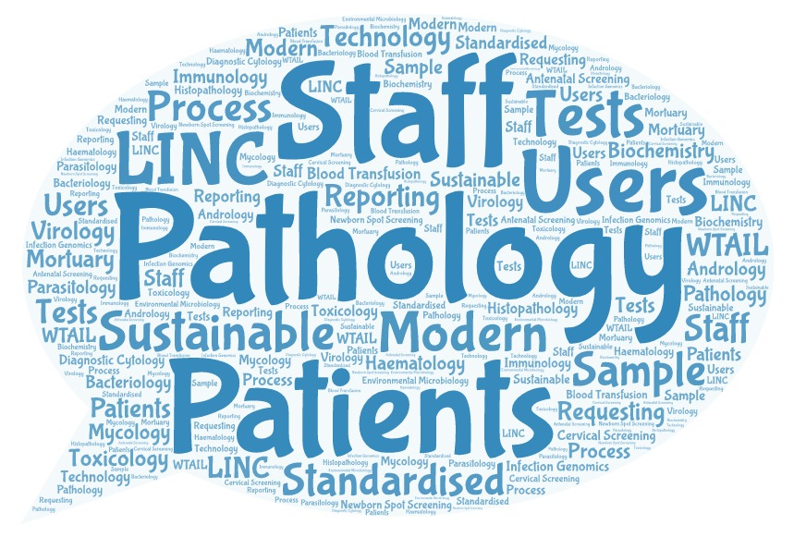

Document Control

Document Information:
Document ID: | LINC STR2
Document Name: | Risk and Issue Management Strategy
Version: | 1.0
Issue Date: | 28 January 2019
Status: | Draft
Document Owner: | Adrian Thomas
Document Author: | LINC PMO

Document History:
Amended by | Version | Status | Date | Purpose of Change
Kalee Thomas | 0.1 | Draft | 30-Oct-18 | Create first draft
Judith Bates | 0.2 | Draft | 13-Jan-19 | Review strategy
Judith Bates | 1.0 | Final | 28-Jan-19 | Approved by the LINC Programme Board

Circulation List:
Name | Title | Organisation
LINC Programme Board

Purpose
The purpose of this strategy is to describe the specific risk and issue management techniques and standards to be applied and the responsibilities for achieving an effective risk and issue management procedure. The approach proposed is based on Managing Successful Programmes (MSP) best practice and NHS Wales Health Collaborative (NHSWHC) arrangements in accordance with Public Health Wales risk management policy and procedures.
The management of risks and issues is of paramount importance in ensuring that the LINC Programme maintains visibility of and proactively manages all factors that may adversely affect the achievement of its objectives. It is closely linked to the delivery of programme and project objectives and benefits realisation. It is therefore essential that the management of risks and issues is fully embedded in management processes and consistently applied. To best achieve this, this strategy along with the programme and projects risk and issue registers will be widely available to everyone with an interest in the programme.

Risk and Issue Definition
The notion of risks and issues are often confused. To avoid uncertainty risks and issues for the LINC Programme are defined as follows:
A Risk is defined as uncertainty of outcome, which may a positive opportunity or a negative threat. Risks may happen at some point in the future and require active management (where posing a threat) to reduce their likelihood of happening, their impact on the programme, or both.
An Issue is something that is or has happened that affects the programme or project and needs to be actively dealt with and resolved. An issue may be raised by anyone. A risk, should it occur, becomes an issue.

Roles and Responsibilities
- The Programme Director, on behalf of the Senior Responsible Owner, is responsible for ensuring risk management and issue resolution is operating effectively and that key strategic risks and issues are being dealt with at the appropriate senior level;
- The Programme Manager is responsible for the development and implementation of the strategies for handling risks and issues;
- The Risk/Issue Owner is responsible for carrying out the necessary response actions or mitigation plans;
- The Risk/Issue Actioner is responsible for any specific agreed actions relating to the mitigation of a risk or resolution of an issue.
- The PMO owns the process of risk management and issue resolution for the programme, managing and coordinating programme-wide risks and issues information and support systems;
- At a project level, the Project Sponsor is responsible for notifying the Programme Manager of any risks that affect the project’s ability to meet programme objectives, making decisions on recommended responses, striking a balance between level of risk and potential benefits;
- The Project Manager is responsible for ensuring project risks are identified, recorded and regularly reviewed;
- The Team Manager is responsible for managing risks associated with a work package they are managing.

Risk Management Framework
Management of risk is an iterative process and must be undertaken during the life of the LINC Programme. This risk management framework covers two distinct phases:
- Risk Analysis – identifies the risk, assesses its likelihood of occurring and potential impact on the programme, the risk owner and proposed mitigation.
- Risk Management – a monitors the risk recording any movement since the last review, provides updates and puts in appropriate controls.

Risk identification
Identifying risks is initially undertaken during programme definition and project start up but remains a continuous activity throughout the life of each project and the programme as a whole. It involves identifying exactly what is a risk (e.g. timescales, resources, etc.) and recording the risk in the Programme or Project risk register, a central repository of known risks. The risk register provides the basis for prioritisation, action, control and reporting. Risks may occur at four levels: strategic, programme, project and operational and managed accordingly.

Risk Ownership and Allocation
Risk management is primarily the responsibility of the Programme and Project Managers. However, each identified risk will be allocated to the individual best placed to manage any appropriate mitigation and contingency actions. They should have the relevant seniority, authority and responsibility to fulfil this role within a project or for the programme as a whole. Specific actions may also be allocated to a risk actioner as required.

Risk Evaluation
Evaluation of each risk is in accordance with the NHSWHC risk guidance as set out in Appendix 1. This involves scoring the likelihood and impact of the inherent, current (residual) and target risk; the combined score being RAG rated.

Risk Response
Each risk will have a range of possible mitigation actions, known as the ‘five Ts’:
- Terminate the risk by adjusting the programme or project so that the risk no longer applies;
- Tolerate the risk using existing management arrangements to handle results of the risks happening;
- Transfer the risk to a third party, best placed to manage it;
- Treat the risk – contingent: plan a series of mitigating actions that address either the probability or impact of the risk to reduce the risk to an acceptable level;
- Treat the risk – containment: a series of mitigating actions to be put into place if the risk becomes an issue.
Having determined the most suitable responses to the identified risks, the relevant actions will be planned, resourced and implemented. Risk and the selected responses will be communicated to stakeholders particularly those affected by the risk or by the actions taken to contain the risk.
If you are unable to apply any of these risk mitigations you may need to escalate the risk to the next level.

Risk Register
There will be a separate risk register for the programme as a whole, for each project and within each work package. The PMO will maintain the risk registers, which are used to capture and actively manage risks. The PMO will review the register monthly, or more frequently if required, and follow up with the risk owner or actioner to monitor progress and agree any follow up actions required. It is essential that the risks are reviewed within the context of a learning environment on a constructive no blame basis.
All risk registers will be consistent and comprise:
- A unique reference for each risk identified and the date raised;
- The category of risk as defined in the NHSWHC guidance;
- A description of the risk;
- The risk rating: the likelihood and impact scores for the inherent, current (residual) and target risks and the calculated risk scores for each.
- The risk owner;
- The date of the last review and the reviewer;
- The change since the last review: worsened, no change or improved;
- Any related risks and issues;
- The risk owner;
- The proposed mitigation as per the five Ts and mitigating response;
- The risk status: open, closed or transferred;
- Progress updates as a minimum monthly or as they occur for more frequent reporting as required.

Risk Escalation
Project risks will be managed within the project unless its impact is wider and will then be escalated to the Programme. Programme risks with a red RAG rating will be reported to the LINC Programme Board and the NHS Wales Collaborative Executive Group Senior Management Team. The Programme Director will additional report strategic risks to the NHS Wales Collaborative Executive Group.

Issue Resolution Framework
issues have a current impact on programme/project delivery and may need to be resolved as a high priority, The issue resolution framework defines a mechanism for efficiently dealing with anything that arises by having processes and responsibilities in place including:

Issue source
Issue may arise from any number of sources such as cost, scope, timescale or third parties. Regardless of the source, all issues will be logged in the programme, project or work package issue register, which provides a management tool for the ongoing tracking and monitoring of issue resolution.

Issue Type
Typically issues can be classified into one of three types:
- A previously identified risk which has now happened and required the appropriate risk management action;
- A required change to some aspect of the programme, project or work package;
- A general issue such as a problem or question affecting all or part of the programme.

Issue Priority
Issues will be prioritised to focus attention on key issues. Some issues may impact the programme as a whole and these will be given a high priority because of the need to consider the wider implications of any management action or intervention.

Issue Resolution
Issues will result in four types of action:
- A change request, which will be actioned as part of the change control process;
- A transfer – a future risk will be moved to the appropriate risk register and managed under the risk management framework. Sometimes a resolved issue may result in a residual risk if the issue reoccurred. In this case, the issue will be transferred to the appropriate risk register once it has been resolved;
- Resolved within the programme or project tolerances;
- Escalated to the LINC Programme Board, NHSW Senior Management Team or the NHS Wales Collaborative Executive Group, as appropriate.

Issue Owner
As with risks, issue management is primarily the responsibility of the Programme and Project Managers. However, each issue will be assigned to the individual who is best placed to take or mange the necessary actions and monitor their effectiveness.

Issue Communications
Relevant stakeholders should be engaged and kept informed throughout the resolution process and feedback provided to the source.

Issue Register
There will be a separate issue register for the programme as a whole, for each project and within each work package. The PMO will maintain the issue registers, which are used to capture and actively manage issues. The PMO will review the register monthly, or more frequently if required, and follow up with the issue owner or actioner to monitor progress and agree any follow up actions required. The aim will be to clear straight forward issues as quickly as possible at the same time as ensuring critical risks are given priority.
There will be a separate issue log for the programme, each project and work package but all registers will be consistent and comprise:
- A unique reference for each issue identified, the date raised and by whom;
- A description of the issue;
- The issue rating: low, medium, high or critical.
- The change since the last review: worsened, no change or improved;
- The issue owner;
- The issue status: open, closed or transferred;
- The date of the last review and the reviewer;
- Any related risks and issues
- The proposed action;
- Progress updates as a minimum monthly or as they occur for more frequent reporting as required.

Appendix 1 NHSWHC Risk Management Guidance

Risk Description
Describe the following:
- The description or source of something that might happen (e.g. there is a risk funding for project X will cease in 2019);
- What will cause the risk to occur (e.g. Welsh Government may not fund the project beyond 2019);
- The impact (e.g. the project will not be rolled out to all of Wales and staff will need to be re-deployed).

Inherent, Current and Target Risk Columns
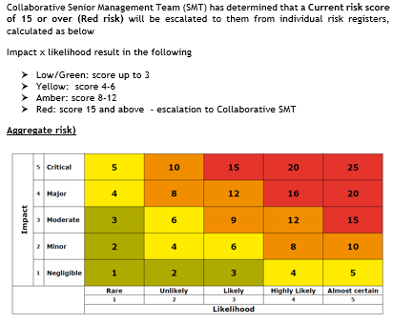
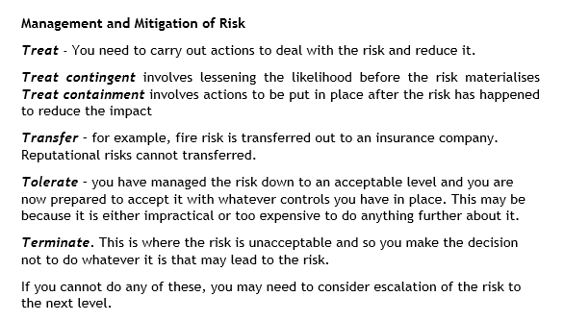
- Inherent risk – is the risk considered without taking account of any controls. Sometimes called the raw risk score, this is important as it shows the true severity of the risk should it ever be realised;
- Current (residual) risk – is the risk, considered with any existing controls taken into account. It will always be lower than the inherent risk and a greater difference between the two scopes means a greater the reliance on the control environment;
- Target risk – is the risk that the Risk Owner, having decided to treat the risk, needs to be actively working towards. The score may be the same or lower than the current risk.

Scoring
Impact | Likelihood
Negligible 1  Minor 2  Moderate 3  Major 4  Critical 5 | Rare 1  Unlikely 2  Likely 3  Highly likely 4  Almost certain 5
Scores for inherent risk, current (residual) risk, and target risk will each be calculated as Impact x Likelihood e.g. 4x4 = Score of 16.

RAG Rating
Scores are RAG rated in accordance with the table below:
Green (low) rating: 1-3
Amber rating: 4-6
Orange rating: 8-10
Red rating: 15-20

Red rating scores of 15 and above are escalated to the NHSWHC Senior Management Team
Table 1: Risk Score calculated from Likelihood x Impact

Arrangements for risk management in the Collaborative, 4 May 2018

