National Strategic Clinical Network for Diabetes

Workplan 2024/25

Background

1.1 Strategic Network Background
Diabetes affects 8% of the population in Wales, that’s percentage equates to 212,716 in Wales living with diabetes. This number includes 16,000 cases of people living with type 1 diabetes. The statistic for Wales now indicates that 1 in 13 people live with diabetes, which is the highest level of prevalence of any of the UK Nations. Over the last twenty years there has been a rapid increase in the diagnosis of diabetes, this is due in part to the growing rate of type 2 diabetes diagnosis, with an estimated 65,000 people in Wales living with undiagnosed type 2 diabetes and 350,000 people are thought to be at high risk of developing type 2 diabetes. Diabetes has a significant impact on the economy due to the healthcare costs associated with treating the condition and its serious complications, and the personal impact of managing the condition. The prevalence of diabetes is rising and is estimated to reach 10% of the population by 2035.
Diabetes has a significant impact on people’s lives. People living with type 2 diabetes will need to make significant long-term changes to their lifestyle, with many requiring long-term medication to delay the progression, and with many requiring insulin. People living with type 1 diabetes will need to have insulin for their whole lives and pay strict attention to managing their blood glucose levels. Poor management of diabetes can lead to serious short-term complications, such as diabetic emergencies and long-term damage to the heart, kidneys, eyes and feet. Diabetes can have a significant impact on the psychological wellbeing and the person’s ability to manage their diabetes. As well as these personal and societal impacts, it also creates a very large healthcare burden for the NHS, estimated at around 10% of the cost of delivering NHS services, currently £501,040,000.
All Wales Diabetes Implementation Group was established 2014 to improve the care received by people living with and caring for those with diabetes across Wales. On the 1st of October 2023, the All Wales Diabetes Implementation Group became the National Strategic Clinical Network for Diabetes in line with the National Clinical Framework (National Clinical Framework - NHS Wales Executive). The Diabetes Strategic Network will focus on providing a greater strategic direction for diabetes care across Wales. The initial primary task has been to transition into a fully functioning National Strategic Clinical Network building on the legacy of the All Wales Diabetes Implementation Group.
As a defined network working within the NHS Executive, the Diabetes Strategic Network has the opportunity to improve health outcomes for people living with diabetes across the population of Wales and support the delivery of better care. This will require a whole system approach and we are keen to strengthen engagement and collaboration within the NHS Executive functions and enable an in-depth engagement with key stakeholders. In particular, the establishment of a Leadership Group and Clinical Reference Group that will ensure that key stakeholders such as third sector colleagues enable the voice of those living with and caring for those with Diabetes help to shape the future delivery of services.
The National Strategic Clinical Network for Diabetes will work to improve the quality, safety, sustainability, and outcomes of NHS Services within diabetes. The Diabetes Strategic Network sits within the NHS Executive as a core component of the ‘learning health and care systems’ described in the National Clinical Framework (NCF), and sits in the space between operational service delivery in Health Boards and the formulation of policy and strategy in Welsh Government, guided by the Quality Statement for Diabetes published by Welsh Government (Quality statement for diabetes [HTML] | GOV.WALES) on the 13th of June 2023. We have developed the priorities within our workplan by considering the Quality Statement for Diabetes, policy imperatives and relevant priorities in the NHS Executive’s remit letter, together with the knowledge and intelligence on current service delivery issues and challenges.
We will endeavour to:
- Standardise evidence based, co-produced pathways and care models aimed at reducing variation and improving outcomes,
- Develop and enhance clear evidence based service standards and specifications,
- Utilise and develop dashboards and other tool enabling clinical services to assess and improve the quality of their services.
We will focus on the following themes with patient outcomes, quality and safety, and prudent health and Value Based Health Care at the core:
- Workforce
- Capacity and Demand
- Sustainability
- Service Improvement
- Improved and equitable access to care
Each priority will feed into quarterly updates which will include SMART goals, tasks, and resources, and will have related milestones and deadlines that will be closely monitored. Advisory or Task and Finish groups will be established to support undertaking of the actions required.

1.2 Strategic Network Governance
As demonstrated in the reporting structure in Figure 1 below:
The leadership arrangements for the National Strategic Clinical Network for Diabetes is centred around the Network Leadership Team including the National Clinical Lead and the Network Manager.
The Clinical Lead will be accountable for reporting to the NHS Executive Clinical Networks Director, and the Network Manager to the NHS Executive Networks and Planning Director.
The Clinical Reference Group will report to the Leadership Group, with any associated task and finish/ advisory groups reporting to the Clinical reference Group for overall governance and assurance.

Figure 1. National Strategic Clinical Network for Diabetes Reporting Structure
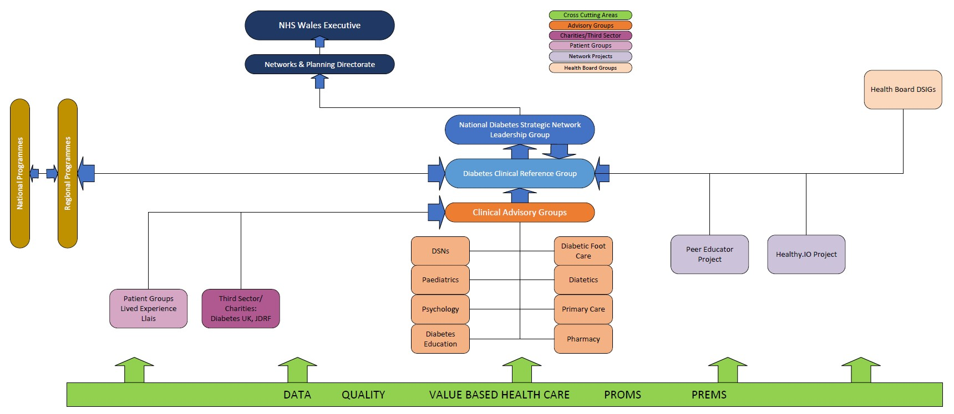

1.3 Strategic/Policy Drivers
The Welsh Government has introduced Health and Social Care (Quality and Engagement) (Wales) Act 2020 and included the Duty of Quality Duty of Quality Statutory Guidance (gov.wales)
which means all the NHS organisations have a legal responsibility to continually improve the quality of the services they provide. The Duty of Quality came into effect in April 2023. It applies to every aspect of the NHS in Wales, to help improve and protect the health, care, and well-being of the current and future population of Wales. The two overarching aims of the Duty of Quality are:
- To improve the quality of healthcare services
- To improve outcomes for people in Wales
The Network’s strategic vison will be informed by the six domains of quality, safe, effective, timely, efficient, equitable and person-centred care. These will be linked to the six quality enablers leadership, workforce, culture, information, learning improvement and research, whole systems approach. This process will allow the Network to guide the Health Boards to deliver the strategies and to shape what good quality care looks like in diabetes care through the NHS. It will also help to shape a system wide culture of learning and improvement. The Network will support a Healthier Wales via the Well-being of Future Generations (Wales) Act 2015, in which people’s physical and mental wellbeing is at the forefront of care and how their choices and behaviours will impact on their future health. This will be achieved through long-term planning, prevention and remission of type 2 diabetes.
Improvements to the diabetes services will be based upon the best available evidence of clinical effectiveness and align to professional standards and the commitments and quality attributes described in the Diabetes Quality Statement.
Other relevant strategic and policy drivers for the National Strategic Clinical Network for Diabetes can be found below, along with how the network will support this national direction in Table 1.
Table 1.
NHS Wales Planning Framework 2024 – 2027 ⁽National Clinical Framework 8.0 (gov.wales) | Sets out the statutory planning direction for NHS organisation for the coming year, looking ahead to the following 3 years. Guidance outlines the key drivers to achieve change with a focus on digital opportunities, reducing inequalities especially for women and children, national programme priorities as well as work streams of the value and sustainability. | Value-based approaches can be used to identify and eradicate low value work, reducing unwarranted clinical variations and reallocate resources to high value effective services that meet the needs of the people of Wales. Diabetes services in Wales and the Diabetes Network will adopt value-based methods, quality assuring attainment of outcomes that matter (to person, system, and society) with appropriate resource use across the triple bottom line (financial, environmental, and societal).
A Healthier Wales: Our Plan for Health and Social Care (June 2018) A Healthier Wales (gov.wales) | ‘A Healthier Wales’ is the Welsh Government’s response to the Parliamentary Review. It sets out the vision of a ‘whole system approach to health and social care’ which is focused on health and wellbeing, and on preventing physical and mental illness. It focuses on ‘providing more joined-up services, in community settings’, and shifts the emphasis from treating illness to prevention and supporting people to stay well and lead healthier lifestyles. | The Diabetes Network shall provide the vision and long-term plan for Diabetes health in Wales, and work toward the quadruple aim (monitored through the performance framework).
The Wellbeing of Future Generations (Wales) Act 2015 Well-being of Future Generations (Wales) Act 2015 (legislation.gov.uk) | The Wellbeing of Future Generations Act is about improving the social, economic, environmental, and cultural wellbeing of Wales. It makes the public bodies listed in the Act think more about the long-term, work better with people and communities and each other, look to prevent problems and take a more joined-up approach. | Deliver sustainable Diabetes services that focuses on:  - Addressing health inequalities.  - Focus on long-term planning.  - Addressing aspects of care that prevent Diabetes conditions.  - Improving outcomes for patients.  - Collaboration with colleagues.  - Involvement of patient voices.
Prudent Healthcare:  Securing Health and Well-being for Future Generations (2023) Welsh Government’s Well-being of Future Generations continuous learning and improvement plan for 2023 to 2025 [HTML] | GOV.WALES | Guides the whole health and care system, giving permission to health professionals to develop and deliver services in a way which better aligns with individual need and experience. It aims to empower people in taking a more active role in their own healthcare and improve outcomes. | The Diabetes Network shall follow the principles of prudent healthcare, such as:  - The public, patients, and professionals as equal partners through co-production.  - Do only what is needed, no more, no less; and do no harm.  - Reduce inappropriate variation using evidence-based practices consistently and transparently.
Promote, prevent, and prepare for planned care (2023) Promote, prevent and prepare for planned care [HTML] | GOV.WALES | This policy was developed in response to the increasing demand and waiting time for planned care. It describes a clear drive for whole pathway approach to promoting healthy behaviours, preventing worsening health through secondary prevention, and supported self-management, and preparing for interventions to reduce risk and maximise benefit. The three Ps include:  - Promote - improved health behaviours.  - Prevent - worsening health.  - Prepare - for treatment and recovery. | Diabetes and the associated complications and long-term conditions that impact on increased demand for planned care.  Diabetes Network teams will embed this approach into delivery and design of their pathways of care.  The Diabetes Network will adopt the principle of whole pathway approach and adopt the 3P’s into the vision, mission, approach, and principles of the strategic, all-Wales network.

1.4 Key NHS Exec/System Stakeholders
The Diabetes Strategic Network has undertaken a stakeholder mapping exercise to inform the planning, implementation and delivery of agreed national and standardised approaches. Below in Figure 2 is the outcome of the mapping exercise undertaken by the core members of the Network.
Figure 2. – Stakeholder Mapping
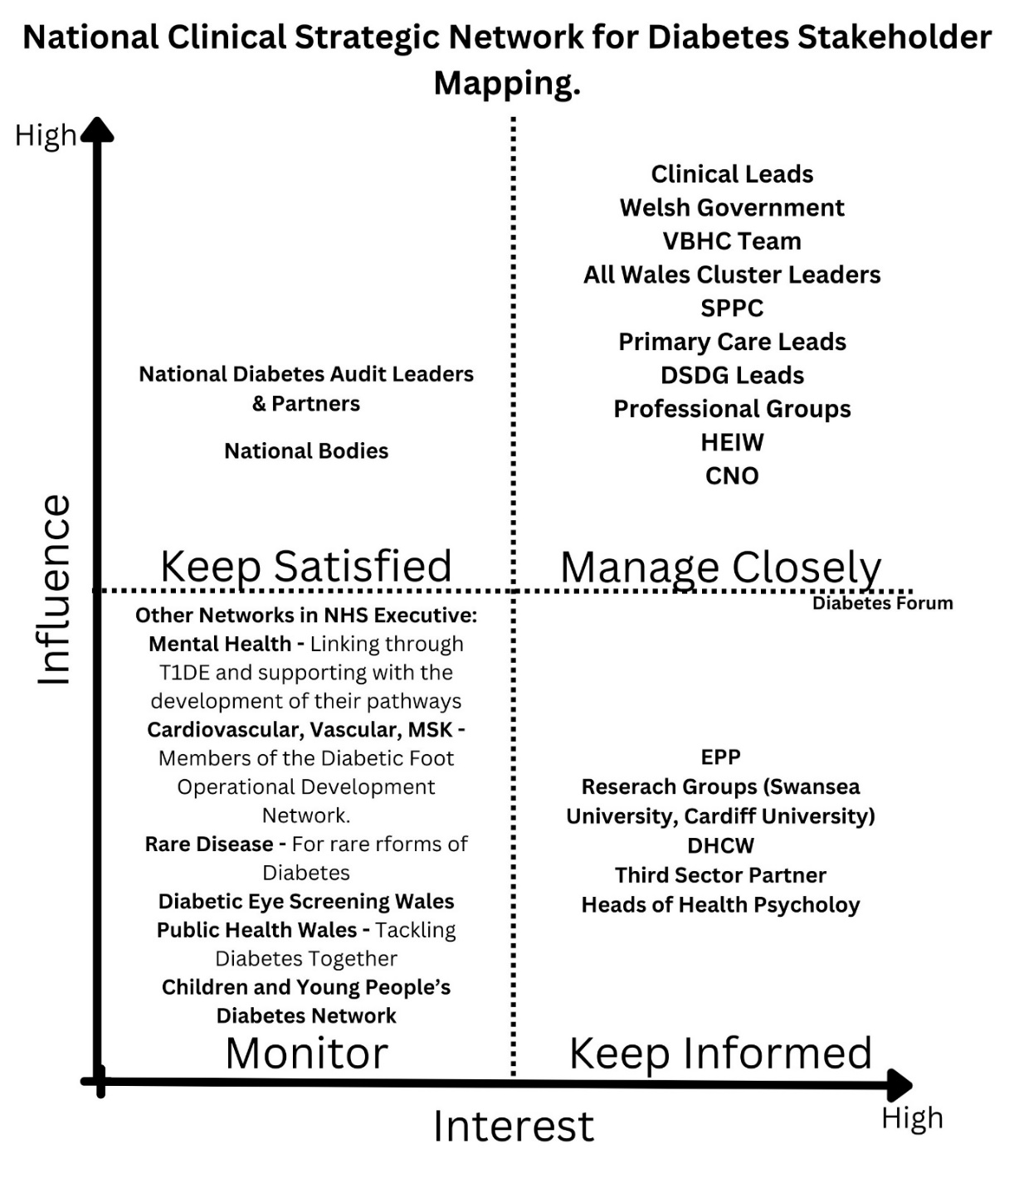
The Network is currently working with our key stakeholders to identify new ways of engaging and working with people living with and caring for people living with diabetes. This work will support the inclusion of the lived experience to strengthen the new ways of working. This will ensure a person centred care approach is at the heart of all aspects of the Network. We also now have an excellent opportunity to work collaboratively with Public Health Wales colleagues with the recently established Tackling Diabetes Together Programme. The Network priorities are linking into this developing strategic work programme and stakeholder engagement and coproduction will be essential for the success.

2024/25 priorities and longer-term vision

2.1 Identifying long-term vision and outcomes
This annual plan and subsequent plans will contribute towards the delivery of the National Strategic Clinical Network for Diabetes Plan that will identify the priorities for the next three, five and ten years. Identifying of these key priorities will be led by the Clinical Lead, the Leadership Group and Clinical Reference Group but will be informed by the needs reported by the Health Boards to the Network. The identified priorities will be developed in line with A Healthier Wales (gov.wales), the (Quality statement for diabetes [HTML] | GOV.WALES, and the National Clinical Framework - NHS Wales Executive. This will enable the priorities to be strategic and forward thinking. There will need to be a series of quick wins to gain the confidence in the Network and this can be capitalised upon to successfully deliver the Networks Medium Term-Plan.

2.2 Identifying priorities and actions for 2024/25
In setting its priorities, the Diabetes Network will ensure that there are measurable outcomes that can provide evidence-based assurance to demonstrate benefits, improvements and impact and provide assurance that quality and safety is at the forefront of all activity. It will utilise outcomes via reliable national data sources that are available and include the Diabetes National Audit, primary care data sources such as the current Audit Plus dataset, and any subsequent replacements, Diabetes Atlas of Variation (DIVA), Welsh Information Solution for Diabetes Management (WISDM), Diabetes Care Accreditation Programme (DCAP). The introduction of diabetes specific Patient Reported Outcome Measures (PROMs) and Patient Reported Experience Measures (PREMs) will also be valuable sources of data to be utilised to inform service improvement. These Value-Based Healthcare will be utilised to assess the impact of the care received by people living with diabetes to ensure that service improvement can be made to ensure they receive the right care at the right time.
The vison for the Strategic Clinical Network for Diabetes is to improve care for people living with and caring for people living with diabetes and support the prevention and remission of type 2 diabetes. This requires a shift of resources upstream; the majority of resources are currently spent on treating the complications of diabetes and this focus needs to be on prevention, remission and effective early care.
Provide equitable access to diabetes care across Wales and ensure people living with diabetes have the psychological support required to live with a long-term condition.
The Network will seek to improve care through increasing and retaining the diabetes workforce to ensure people living with diabetes receive the education and support they require. A robust workforce will help prevent poor management and reduce future complications associated with diabetes and reduce the number of inpatient admissions for people living with diabetes through structured education programmes.

Table 2.
Priority: Strategic/ policy drivers | Quarter | Network actions | Measure (to be achieved by April 2025) | Collaborative working
Priority 1  Prevention of Type 2 Diabetes | Quarter 1 (April- June) | Identify funding for MyDESMOND and other digital resources to support the population of Wales living with type 2 or pre-diabetes and support the development of business cases within the Health Boards for future funding. | - Agree short-term funding for the continuation of MyDESMOND App (May to September 2024) | - Networks and Planning  - Finance
Priority 1  Prevention of Type 2 Diabetes | Quarter 2 (July to September) | Begin discussions with Chief Executives, Primary Care Leads and Procurement regarding the funding for MyDESMOND and other digital resources for people living with type 2 diabetes. Request support from Public Health Wales – Tackling Diabetes Together Programme to support the continuation of funding from 1st of October 2024.  Support and share a robust evaluation of the platform and a cost benefit analysis with all stakeholders. | - Funding source agreed by Public Health Wales to support the continuation of the MyDESMOND platform until March 2025 | - Health Boards  - Primary Care  - Procurement  - Public Health Wales  - NHS Executive Communications Team
Priority 1  Prevention of Type 2 Diabetes | Quarter 3 (October to December) | Develop Situation, Background, Assessment, Request (SBAR) document for each Chief Executive and Primary Care Leads for the Health Boards outlining the benefits of the platform and the need for continued funding to support those with pre-diabetes and those living with type 2.  Incorporate the robust evaluation of the platform and a cost benefit analysis  Develop a new pathway for young people (18 to 40) living with type 2 diabetes | - Completion of document and submission to the Health Boards and Primary Care  - Transition Coordinator developing a pathway to enable improved support and service provision during the transition of people aged 18 - 40 with type 2 diabetes | - Networks and Planning  - Finance  - Procurement  - Public Health Wales  - NHS Executive Communications Team
Priority 1  Prevention of Type 2 Diabetes | Quarter 4(January to March) | Planning for the handover of the funding to the Health Boards to be included in their Integrated Medium Term Plans for funding | - Complete handover of the funding for the MyDESMOND platform to the Health Boards for future funding | - Networks and Planning  - Finance  - Procurement  - Public Health Wales
Priority 2  Education and self-management for people living with diabetes | Quarter 1 (April- June) | Review existing resources provided to people living with diabetes across Wales. | - Identify the current resources available, cost and waiting times | - Health Boards  - Primary Care  - Procurement  - Public Health Wales
 | Quarter 2 (July- September) | Review the education options available and undertake review of the current information for people on Hybrid Closed Loop systems to support the National Institute of Health and Care Excellence (NICE) Technology Appraisal for Hybrid Closed Loop. | - Establish a working group with colleagues across all Multidisciplinary Teams to review the current education sources | - Health Boards  - Primary Care  - Public Health Wales
 | Quarter 3 (October – December) | Share findings of the review of the documentation and identify areas for improvement in the information  Identify the barrier for accessing the education for people living with diabetes and work collaboratively with key stakeholders to establish ways of mitigating the barriers | - Produce document outlining the gaps in the education for patients following the review and mapping document for areas of improvement including the barriers for accessing education | - Health Boards  - Primary Care  - Public Health Wales  - Diabetes UK Cymru  - Breakthrough T1D  - NHS Executive Communications Team  - The Mentor Ring  - Kidney Wales
 | Quarter 4 (October – December) | Engage with Third Sector Charities, patients and Industry Partners to identify solutions to the barriers accessing education. | - Stakeholder engagement event to develop solutions to overcoming the barriers to accessing education for people living with diabetes | - Health Boards  - Primary Care  - Public Health Wales  - Diabetes UK Cymru  - NHS Executive Communications Team  - Breakthrough T1D  - The Mentor Ring  - Kidney Wales  - Diabetes Patient Forum
Priority 3  Increase the uptake of the 8 Essential Care Processes for people living with diabetes | Quarter 1 (April- June) | Establish regular reporting mechanisms to outline each Health Boards performance against the uptake of the 8 Essential Care Processed for people living with diabetes | - Develop report template to outline the performance of each Health Board | - Networks and Planning  - Health Intelligence
 | Quarter 2 (July- September) | Provide Quarter 1 updates to the Clinical Leads, Primary Care Leads and Transformation Leads in Each Health Board outlining the status of the Health Boards regarding the uptake of the processes | - Produce report and Health Board Comparison and outline areas for improvement | - Networks and Planning  - Health Intelligence  - Health Boards  - Primary Care
 | Quarter 3 (October – December) | Provide Quarter 2 updates to the Clinical Leads, Primary Care Leads and Transformation Leads in Each Health Board outlining the status of the Health Boards regarding the uptake of the processes | - Produce report and Health Board Comparison and outline areas for improvement | - Networks and Planning  - Health Intelligence  - Health Boards  - Primary Care
 | Quarter 4 (October – December) | Provide Quarter 3 updates to the Clinical Leads, Primary Care Leads and Transformation Leads in Each Health Board outlining the status of the Health Boards regarding the uptake of the processes | - Produce report and Health Board Comparison and outline areas for improvement | - Networks and Planning  - Health Intelligence  - Health Boards  - Primary Care
Priority 4  Increase in the use of technology for people living with diabetes | Quarter 1 (April- June) | Identify current use of technology for people living with diabetes  Plan for the implementation of Hybrid Closed Loops Systems following the National Institute of Health and Care Excellence (NICE) Technology Appraisal | - Review of the current technology offered to people living with diabetes  - Identify the numbers per Health Board for people on Pump Therapy, Continuous Glucose Monitoring (CGM)  - Establish working Group to develop the 5 year plan | - Networks and Planning  - Health Intelligence  - Health Boards  - Primary Care  - Welsh Government  - NHS Executive Communications Team
 | Quarter 2 (July- September) | Undertake a review of the current number of people using technology and identify the priority groups for Hybrid Closed Loop  Prepare reports on the Hybrid Closed Loop for Medical Directors, Directors of Finance, Senior Leadership  Hybrid Closed Loop Education Day for staff across South Wales  Presentation of paper to NHS Leadership Board, 23rd July 2024. | - Priority identified and shared with the group  - Review of documentation by the established group to ensure information is robust  - Date arranged for the 18th of June 2024  - Follow up on discussions and delivery of agreed actions in Sept 2024. | - Networks and Planning  - Finance  - Health Boards  - Primary Care  - Welsh Government  - NHS Executive Communications Team
 | Quarter 3 (October – December) | Develop a Communications and Engagement strategy for the use of technology across Wales and for the implementation of the Hybrid Closed Loop  Hybrid Closed Loop Education Day for staff across North Wales  Delivery and feedback on agreed actions from NHS Leadership Board. | - Outline the need for change  - Identify barriers  - Identify the cost per Health Board  - Date to be agreed for November 2024  - Date agreed for communication on agreed priorities. And actions. | - Networks and Planning  - Finance  - Health Boards  - Primary Care  - Welsh Government  - NHS Executive Communications Team  - NHS Exec Networks team
 | Quarter 4 (October – December) | 5 year plan proposal to be developed | - Develop draft plan for the implementation of the Hybrid Closed Loop and increase in the use of diabetes technology | - Networks and Planning  - Finance  - Health Boards  - Primary Care  - Welsh Government
Priority 5  Digitalisation of Diabetes Services and Data collection | Quarter 1 (April- June) | Upgrade of the Diabetes Insight Variation Atlas (DIVA) | - Necessary stakeholder feedback on the upgrade and evaluation of the new data set | - Finance Delivery Unit  - Health Boards  - Networks and Planning  - Primary Care
 | Quarter 2 (July- September) | Launch of upgraded Diabetes Insight Variation Atlas (DIVA)  Completion of the Welsh Information Solution for Diabetes Management (WISDM) | - Produce reports using the upgraded information  - Evaluation of the of the Welsh Information Solutions Diabetes Management (WISDM) project | - Finance Delivery Unit  - Health Boards  - Networks and Planning  - Primary Care  - Digital Health Care Wales
 | Quarter 3 (October – December) | Support the transition of the Welsh Information Solution for Diabetes Management (WISDM) to business as usual | - Produce reports on the integration of the project  - Collate feedback from uses in the ease of transition to business as usual | - Finance Delivery Unit  - Health Boards  - Networks and Planning  - Primary Care  - Digital Health Care Wales
 | Quarter 4 (January – March) | Support the implementation Welsh Information Solution for Diabetes Management (WISDM) across all Welsh Health Boards | - Produce a report on the benefits of the digital solutions  - Develop a Communication and Engagement | - Finance Delivery Unit  - Health Boards  - Networks and Planning  - Primary Care  - Digital Health Care Wales
Priority 6  Mental Health | Quarter 1 (April- June) | Identify and secure funding for a Lead Diabetes Psychologist | - Funding secured for the role and | - Networks and Planning  - Finance
Priority 6  Mental Health | Quarter 2 (July- September) | Develop Job Description for the Lead Diabetes Psychology Role | - Role description developed to match with the priorities of the Network | - Networks and Planning  - Business Unit
Priority 6  Mental Health | Quarter 3 (October – December) | Appoint to Lead Diabetes Psychology Role | - Lead Diabetes Psychologist inducted into the post | - Networks and Planning  - Business Unit
Priority 6  Mental Health | Quarter 4 (January – March) | Review of current mental health support available to people living with diabetes, and identify health inequalities | - Update resources and identify barriers to accessing services and digital solutions | - Networks and Planning  - Third Sector Charities  - Diabetes Patient Forum  - Health Boards  - Primary Care.
Priority 7  Remission of Type 2 Diabetes | Quarter 1 (April- June) | Identify funding for the remission service across Wales, to support those with type 2 diagnosed in the last 6 years to put their diabetes into remission through a structured weight- loss programme. | - Identify funding solutions for the continuation | - Networks and Planning  - All Wales Diabetes Prevention Programme  - Health Boards  - Weight Management Service  - Primary Care  - Public Health Wales (Tackling Diabetes Together Programme)
Priority 7  Remission of Type 2 Diabetes | Quarter 2 (July- September) | Develop Situation, Background, Assessment, Request (SBAR) document for each Chief Executive and Primary Care Leads for the Health Boards outlining the benefits of the platform and the need for continued funding to support those with pre-diabetes and those living with type 2 who could benefit from the remission programme | - Draft document outlining the benefits and cost savings of the Remission Programme | - Networks and Planning  - All Wales Diabetes Prevention Programme  - Health Boards  - Weight Management Service  - Primary Care  - Public Health Wales (Tackling Diabetes Together Programme)
Priority 7  Remission of Type 2 Diabetes | Quarter 3 (October – December) | Begin discussions with Chief Executives, Primary Care Leads outlining the benefits of the programme and the need for funding. Request support from Public Health Wales – Tackling Diabetes Together Programme to support the continuation of funding from 1st of October 2024.  Pilot Project to reduce harm from type 2 diabetes in the under 40’s. Identifying the additional clinical support required and care tailored to the individuals diagnosed under the age of 40 and explore the links with health inequalities and socioeconomic deprivation. | - Completion of document and submission to the Health Boards and Primary Care  - Submit request for slippage funding to support the project | - Networks and Planning  - All Wales Diabetes Prevention Programme  - Health Boards  - Weight Management Service  - Primary Care  - Public Health Wales (Tackling Diabetes Together Programme)  - NHS Executive Communications Team
Priority 7  Remission of Type 2 Diabetes | Quarter 4 (January – March) | Planning for the handover of the funding to the Health Boards to be included in their Intergrated Medium Long Term Plans for funding | Complete handover of the Remission Project to the Health Boards | - Networks and Planning  - All Wales Diabetes Prevention Programme  - Health Boards  - Weight Management Service  - Primary Care  - Public Health Wales (Tackling Diabetes Together Programme)  - NHS Executive Communications Team
Priority 8  Patient Reported Outcome Measures | Quarter 1 (April- June) | Identify Patient Reported Outcome Measures (PROMs) for use across the diabetes service | - Meet with Health Care Professionals, Value Based Health Care and identify suite of documents suitable | - Networks and Planning  - Health Boards  - Value Based Health Care
 | Quarter 2 (July- September) | Review the documents and agree the documents for national roll out | - Collate feedback and share with Value Based Health Care Team | - Networks and Planning  - Health Boards  - Value Based Health Care
 | Quarter 3 (October – December) | Present the chosen documents to the Health Board Value Based Health Care Teams and identify reporting mechanisms and timelines for implementation | - Timeline for implementation agreed and reporting frequency Identified | - Networks and Planning  - Health Boards  - Value Based Health Care
 | Quarter 4 (January – March) | Implement the Patient Reported Outcome Measures (PROMs) nationally. | - Data collected from the first completed outcomes | - Networks and Planning  - Health Boards  - Value Based Health Care
Priority 9  Tackling Inequalities | Quarter 1 (April- June) | Establish Stakeholder meeting to identify the inequalities of care for people living with diabetes across Wales | - First stakeholder meeting 2nd of May 2024 | - Networks and Planning  - Health Boards  - Diabetes UK Cymru  - NHS Executive Communications Team
 | Quarter 2 (July- September) | Collate feedback from the event and identify common themes in the inequalities of care and the barriers | - Produce report outlining the finding  - Plan follow-up event | - Networks and Planning  - Health Boards  - Diabetes UK Cymru
 | Quarter 3 (October – December) | Stakeholder engagement meeting to map inequalities and barriers to accessing care | - Evaluate the stakeholder engagement event  - Evaluation of plan with recommendations | - Networks and Planning  - Health Boards  - Diabetes UK Cymru  - Public Health Wales  - Diabetes Patient Forum  - NHS Executive Communications Team
 | Quarter 4 (January – March) | Use the stakeholder engagement meeting to identify the key are of focus for the Network and used to map the priorities for 2025/26 | - Tackling inequalities to be a cross cutting theme across the Networks priorities and included in each work-stream | - Networks and Planning  - Health Boards  - Diabetes UK Cymru  - Public Health Wales  - Diabetes Patient Forum  - NHS Executive Communications Team
Priority 10  Improve inpatient care for people living with diabetes | Quarter 1 (April- June) | Review the data from the pilot sites for the Diabetes Care Accreditation Programme (DCAP) Assessment to be completed on the inpatient care for diabetes  Identify if the sites would like to continue with the Diabetes Care Accreditation Programme (DCAP) Assessment process | - Produce a report with the findings to the inpatient services, to include areas of good practice, improvements required, and lessons learnt | - Networks and Planning  - Health Boards
 | Quarter 2 (July- September) | Share findings from the assessments and identify common themes across the Health Boards. | - Produce a report for the Diabetes Clinical Reference Group and Leadership Group | - Networks and Planning  - Health Boards
 | Quarter 3 (October – December) | Meet with Health Board Leads to discuss the future funding of the project and encourage the Health Boards currently participating in the assessment of its worth | - Produce a cost analysis plan for Health Boards  - Produce plan outlining the key areas requiring improvement | - Networks and Planning  - Health Boards
 | Quarter 4 (January – March) | Support the completion of the Diabetes Care Accreditation Programme Assessment across the inpatient services in Swansea Bay University Health Board, Llandough and University Hospital of Wales In Cardiff and Vale University Health Board and The Grange Hospital in Aneurin Bevan University Health Board. | - Produce a report to outline the areas of Improvement, Common Themes and Education needs for non-specialist diabetes Healthcare Professionals | - Networks and Planning  - Health Boards  - Health Education and Improvement Wales (HEIW)  - Performance and Assurance  - Quality, Safety and Improvement
Priority 11  Workforce | Quarter 1 (April- June) | Collect job descriptions for all Diabetes Specialist Nurses (Band 5 to 8C) from across Wales and review the essential and desirable criteria for each band | - Undertake a review of the current job descriptions  - Evaluate the requirements for each band and identify gaps in knowledge and education | - Networks and Planning  - Health Boards  - Health Education and Improvement Wales (HEIW)
 | Quarter 2 (July- September) | Review the competencies required per band for Diabetes Specialist Nurses | - Undertake a review of the current competencies and identify gaps in knowledge | - Networks and Planning  - Health Boards  - Health Education and Improvement Wales (HEIW)
 | Quarter 3 (October – December) | Develop a Wales specific job description for Diabetes Specialist Nurses to future proof the service and ensure progression for staff | - Develop a repository of job description for each band of Diabetes Specialist Nurse that can be accessed by the Health Boards for recruitment | - Networks and Planning  - Health Boards  - Health Education and Improvement Wales (HEIW)
 | Quarter 4 (January – March) | Develop a Wales specific set of Diabetes Specialist Nurses competency framework to ensure the standardised approach to learning and competence | - Develop a competencies document for Diabetes Specialist Nurses outlining the education requirements for each band to ensure excellent patient care is delivered | - Networks and Planning  - Health Boards  - Health Education and Improvement Wales (HEIW)

2.3 Risks
The Network has created a Risk Register to monitor the risks that may affect the progress of the Network. The Risk Register is discussed at the Clinical Reference Group bi-monthly meeting and escalated to the Leadership Group. The risks identified are also discussed at the monthly Business Partner Meetings and added to the Directorate Risk Register.
The following risks have been identified that are linked to the Networks priorities.
Priority | Risk to implementation/delivery | Mitigation
Audit and Data | Withdrawal of the Audit Plus will impact on the Welsh Data submitted to the National Diabetes Audit.  National Diabetes Audit which is a huge audit across England and Wales are submitted via Audit plus and inform care delivery and contribute to Research & Development. National Quality Improvement projects utilise Audit Plus for practices to complete Quality Improvement work. The development of Quality Improvement Projects utilising this will have to be halted.  Urgent National approach to ensure continuity of data access - investigate ways to continue utilisation of Audit plus (but any new system will take considerable new time to get up and running | Risk has been escalated to the NHS Executive Senior Leadership Group, Directors of Finance, Network and Planning, Welsh Government, Health Boards and Primary Care. Digital Health Care Wales and Health Care Intelligence have also escalated the risk. If a solution is not found to replace Audit Plus then Wales will no longer be able to input and collect data for diabetes care along with other programmes of work.
Education and self-management for people living with diabetes | The current diabetes digital education platform is provided by the Leicester Diabetes Centre and provides access to MyDESMOND, Babysteps and Let’s Prevent Diabetes modules. Funding for these modules has been received centrally from the All Wales Diabetes Implementation Group (AWDIG), however this funding stream has come to an end, with the Network only receiving approval to fund the platform until 31st of September 2024. Should funding not be secured for the platform then people living with diabetes across Wales will cease to have access with immediate effect. All 2,211 users will lose access to their resources. The loss of this resource will be detrimental to people living with diabetes across Wales as they will lose a key source of support and education for living with and supporting the prevention of type 2 diabetes across Wales. | Letter has been drafted to Clinical Leads and Finance Leads across the Health Boards in Wales requesting that funding options be explored to maintain this resource.
Prevention of Type 2 Diabetes | Continuation of funding for the Remission Project has not been agreed. Business Cases have been sent to the Health Boards’s; however, no funding has been agreed. The remission project can support people living with type to change their diet and lifestyle to reverse their type 2 diabetes and reduce the risk of developing further comorbidities linked to obesity, such as cardiovascular disease and stroke. | Support has been provided to the Health Board’s to develop business cases and Freedom of Information Requests have been completed and returned.
Implementation of impending NICE Technology Appraisal on Hybrid Closed Loops | There will be a gap of 6000 patients plus who will be recommended to be started on hybrid closed loops. Services are currently saturated. If the TA is not met subsequent harm will be caused to people living with type 1 diabetes. | The Minister for Health will possibly ask for a variation. Meetings have happened with leaders across Wales and services have been mapped. Following this a plan will be formulated which is likely to be an agreement for a certain number per annum but staff release from general roles will be needed. A national training programme will be required.
Workforce | Insufficient staffing levels across the multidisciplinary team will impact on the level of care received by people living with diabetes. Reduced standards of care will result in clinical harm and adverse outcomes such as a rise in dialysis and amputation. | Review of job descriptions is underway to upskill the workforce and ensure succession planning for the future.
Essential Care Processes for people with Type 1 and type 2 Diabetes | The National Diabetes Audit collects data on all people living with diabetes in Wales via Audit Plus. This has shown a drop in completion of 8 care processes and completion of 3 treatment targets. If the risk is not addressed this will have an impact on people living with diabetes which could result in harm. Lack of a secondary care database is providing efficient communication between Primary and Secondary Care regarding the care processes undertaken.  These reports are at risk as they use the data collected form Audit Plus and notice has been served with a view to the contract ending in Autumn 2024 | This fall in parameters in National Diabetes Audit has been recognised and considered at various levels. The Minister of Health has made this a priority and some parameters have been reactivated in QOF. This is included in the Performance Framework. An Audit Plus module has been created to facilitate improvement. Working towards a national QIP in this area. Quarterly reports have now begun. Reports began in Q3 of 2023/24 and Q4 reports have just been shared with all Clinical Leads and Primary Care. Improvements have already been made in the uptake of the 8 essential care processes between Q3 and Q4.

3. Key enablers
The Diabetes Network will have interdependencies with other Strategic Clinical Networks, programmes and NHS Executive Directorates. By mapping cross cutting priorities across the Strategic Networks, we can ensure to reduce duplication and promote a patient focused approach. To accomplish our priorities for the year we will need engagement with a number of enablers/programmes to support implementation/completion. We will need to engage with all of the enablers and functions within the NHS Executive at some point but have identified those that we will be engaging with initially.
The achievement of the noted actions above to deliver on the key priorities is only possible through collaboration with key enablers. These key enables have been noted within the priority action plans (Table 1.) and includes:
- NHS Executive Networks & Planning Directorate
- NHS Executive Business Unit
- NHS Executive Finance Team
- NHS Executive Communications Team
- NHS Executive Digital Health Care Wales
- Quality, Safety and Improvement Directorate
- Strategic Programme for Primary Care
- Public Health Wales
- Health Boards Diabetes Clinical Leads
- Welsh Government Diabetes Condition Policy Leads
- Diabetes UK Cymru
- Kidney Wales
- The Mentor Ring
- Breakthrough T1D
The working relationship between the Network and the noted Key enablers will be agreed upon during introductory meetings with each and ways of working established to ensure effective and efficient co-production of work.

