National Programme for Palliative and End of Life Care Workplan 2024/25

1. Background

1.1 Strategic Programme Background
The Programme for Palliative and End of Life Care (PEoLC) transitioned from its predecessor, the PEoLC Implementation Group, in 2022 and was integrated into the Networks and Planning Directorate in 2023. The ongoing long term work programme was inherited from the former Implementation Group, including commitments to report directly to Welsh Government Ministers. The PEoLC Programme encompasses the comprehensive efforts of the National Bereavement Framework Programme which was commissioned by Welsh Government in response to the Bereavement Services Review (2019). Overseen by the National Bereavement Steering Group, the work includes the National Bereavement Framework, National Bereavement Pathways and Bereavement Support Grant. These initiatives aim to ensure equitable access to high-quality bereavement care and support across Wales, addressing the profound impact of loss on individuals and communities.
A robust understanding of where individuals are cared for and where they die is critical for shaping health policies, optimising resource allocation and service delivery, and for the planning and commissioning of effective end-of-life care services. Wales faces a demographic shift with an ageing population projected to lead to a significant increase in annual deaths over the next 25 years – from 36,378 in 2022 to 39,370 in 2033 and to 41,937 by 2048. Notably, by 2048, half of all deaths will occur among those aged 85 and older, a group characterised by higher complexity, multiple serious illnesses per person, and greater care needs.
To address the increasing scale and complexity of palliative care needs, the PEoLC Programme must enhance whole-system care provision, particularly in community settings. Understanding where care is likely to take place is crucial for anticipating future healthcare system pressures. This requires strengthening the workforce through targeted education and training to equip healthcare professionals with the necessary skills for compassionate and effective care. Additionally, building resilience and investing in volunteers and unpaid carers, guided by value-based health and care principles, are essential. Continuous service user involvement through both volunteers and unpaid carers, will ensure that care design aligns with people's needs, enabling them to live well and die peacefully in their preferred setting. Infrastructure improvements are also essential to support these growing demands. Specialist services will need to expand to accommodate the rising number of patients with comorbidities and complex health conditions. Without these crucial improvements, there is a substantial risk of a significant increase in hospital deaths, which underscores the urgent need for robust community and home-based care options to honour patient’s preferences for their place of care and death.

Figure 1 Vision and mission of the National Programme for Palliative and End of Life Care
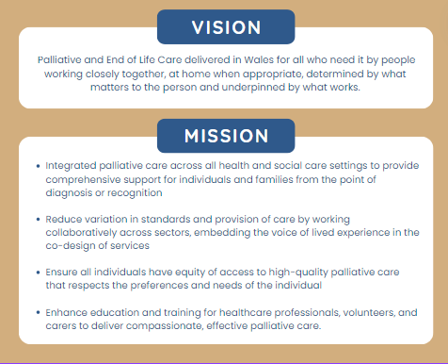

1.2 Strategic Programme Governance
The infographic below (Fig 2.0) demonstrates the current high level governance structure for the Programme,
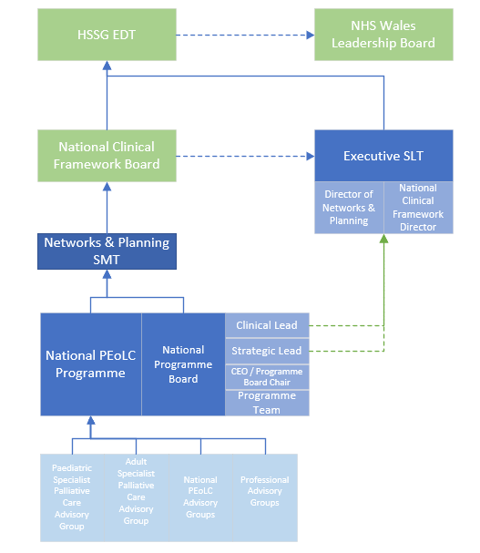

1.3 Strategic/Policy Drivers
The Quality Statement for Palliative and End of Life Care provides the strategic direction for the National Programme for Palliative and End of Life Care and clearly sets out the high standards required to deliver the outcomes and experiences the Welsh population expects.
Additional strategic and policy drivers pertinent to the National Programme are detailed below in Table 1.
Table 1: Strategic Policy Drivers for the National Programme for Palliative and End of Life Care
Strategy/Policy | Summary | How the PEoLC Programme will support
NHS Wales Planning Framework 2024 – 2027 | The NHS Wales Planning Framework 2024-2027 provides statutory guidance for NHS organisations in Wales, focusing on strategic planning for the next three years. The framework emphasizes integrated planning over market-driven approaches, highlights digital transformation opportunities, and aims to reduce health inequalities. Key priorities include promoting value-based healthcare, enhancing community care, and addressing specific needs of women and children. This approach aims to ensure sustainable, high-quality healthcare services that meet the evolving needs of the Welsh population. | - Identify digital technologies to improve palliative care delivery working with DHCW to enhance interoperability across providers and support the development of eHealth Records and the NHS Wales App.  - Ensure equitable access to palliative care for all demographics.  - Align with national priorities to efficiently allocate resources to high-impact services.
A Healthier Wales: Our Plan for Health and Social Care (June 2018) | "A Healthier Wales" outlines a long-term vision for a whole-system approach to health and social care, focused on health and well-being, illness prevention, and integrated, community-based services. The plan emphasises collaboration across health and social care sectors to support people in staying well and leading healthier lives. | The PEOLC Programme will provide the vision and long-term plan for palliative and end of life care in Wales:  - Promote models that connect palliative care with broader health and social care services.  - Enhance community-based palliative care to support individuals in their preferred settings.  - Encourage early interventions to improve the quality of life for those with life-limiting conditions
The Wellbeing of Future Generations (Wales) Act 2015 | This “Wellbeing of Future Generations (Wales) Act focuses on improving the social, economic, environmental, and cultural well-being of Wales, promoting long-term planning, prevention, and collaborative approaches. | - Develop sustainable palliative care services addressing long-term needs.  - Work with stakeholders across sectors to enhance service delivery.  - Include patient & carer voices in planning and delivering care services.
Prudent Healthcare:  Securing Health and Well-being for Future Generations (2023) | Prudent Healthcare aims to align health services with individual needs, empower patients, and reduce inappropriate variations in care | - Focus on co-production with service users and the public to ensure that services align with their values and preferences.  - Be informed by the development and consistent use of national PROMs, PREMs, FREMs, FROMs, EREMs & EROMs.  - Determine national standards of care, informed by evidenced based approaches, prioritising interventions that deliver the best outcomes for patients.
Wales Performance Framework 2024-25 | The Wales Performance Framework 2024-25 sets out the performance expectations for NHS Wales, focusing on delivering high-quality care, improving health outcomes, and ensuring sustainability. It includes key performance indicators and targets to measure progress across various health domains. | - Work to develop and enhance the core data set across all sectors, incorporating outcome and experience measures to provide a triangulated picture of palliative and end of life care services.  - Regularly assess and report on palliative care performance against the framework's indicators.  - Implement strategies to meet or exceed performance targets related to palliative and end-of-life care.  - Use performance data to drive continuous quality improvements in care delivery.
National Framework for the Delivery of Bereavement Care in Wales | This framework provides a structured approach to delivering bereavement care, ensuring that individuals and families receive timely, compassionate, and effective support following a loss. It aims to standardise bereavement services across Wales, ensuring equitable access and high-quality care. | - Implement the Framework's guidelines to ensure consistent bereavement care across all settings.  - Provide holistic support addressing emotional, psychological, and practical needs of bereaved individuals.  - Equip healthcare professionals with the necessary skills and resources to deliver effective bereavement support.
The Duty of Quality 2023 | The Duty of Quality Statutory Guidance requires NHS organisations to continuously improve the quality of services they provide. It emphasises accountability, transparency, and the use of evidence-based practices to enhance patient care. | - Implement continuous quality improvement processes for palliative and end-of-life care services.  - Maintain transparency in care delivery and performance reporting.  - Adopt evidence-based practices to ensure high standards of care and patient safety

1.4 Key NHS System Stakeholders
We have systematically broadened the stakeholder involvement in the Programme based on the priorities and vision of the Programme and the Quality Statement. We have now developed a maturing matrix of stakeholders with both professional representatives, third sector and people with lived experience. We have had collaboration from key professional groups to align their national groups with the Programme bringing together their expertise and the clinical focus needed to drive change and improvement and improve collaboration.
The leadership of the Programme Board and leadership team for PEoLC will provide oversight and governance along with the NHS Executive, Health Boards and Welsh Government

2. Identifying Annual Priorities (2024/5) towards the longer-term vision:

2.1 Identifying long term vision and outcomes
The PEoLC Programme has a shared a long-term vision which is set out in the Quality Statement for PEoLC. The annual priorities for the Programme are generated and informed by these high-level themes and standards. The following infographic outlines the Programme operational plan outline structure. To ensure we reflect the whole system for PEoLC we have focused on wide engagement and inclusion across settings. This is essential to ensure that PEoLC is considered in its entirety rather than fragmented into tasks across the health and social care system or across Networks and Programmes.
The infographic below (Fig 3) demonstrates the operational plan for the programme
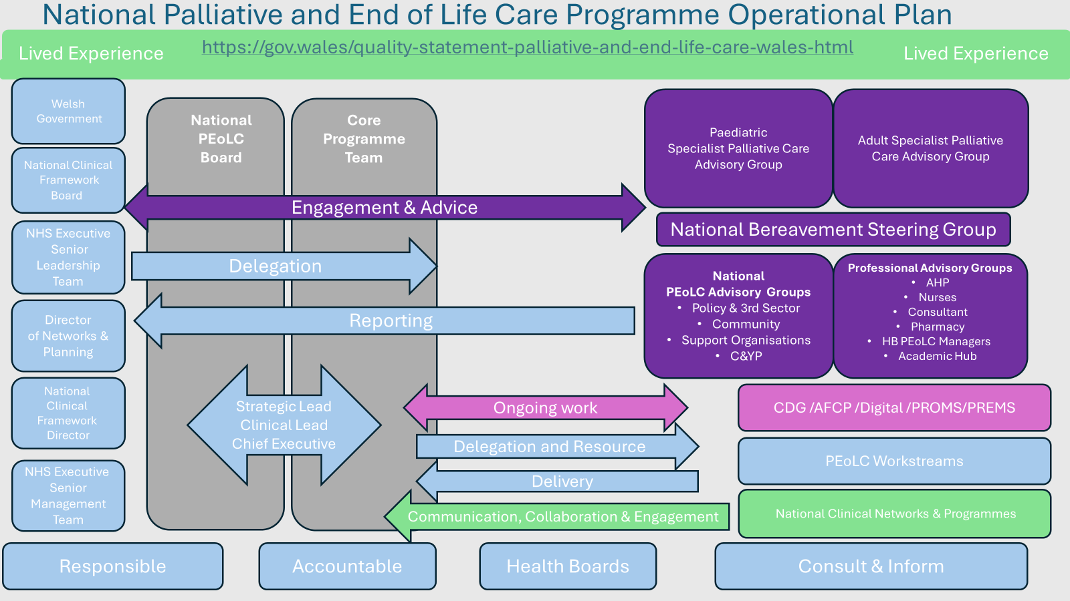

2.2 Identifying Priorities and Actions for 2024/5
The PEoLC priorities for 2024/25 are a set of actions which are twofold in nature, they support the Cabinet Secretary’s requests for improvement in particular areas of PEoLC work for completion in 2024/5 (which give rise to obligations predating the current structural arrangements), and they show what is necessary to ensure that PEoLC is fit to meet future need.

Priority: Strategic/ policy drivers | Quarter | Network actions | Measure (to be achieved by April 2025) | Collaborative working
- National PEoLC Service Specification for Wales | Q1-2  Q3  Q4 | - Work with the PEoLC advisory groups and palliative care leads within LHBs and third sector to determine what the core Palliative care services in Wales (encompassing the whole spectrum of specialist and generalist care for everyone, children and adults, with progressive life shortening illness) should look like.  - Develop a national service specification for PEOLC for Wales for both paediatric and adults to enable LHBs and voluntary sector providers to benchmark the key characteristics to improve and maximise their services  - Agree implementation process | Delivery of the Palliative and End of Life Care Service Specification document for Wales. | WG, LHBs, Third Sector Providers, PEoLC Advisory Groups, NHSWE
- Phase 3 Final Report for Welsh Government | Q3 | - Review research and collate evidence to underpin the recommendations of funding and resource needed for the Phase 3 Report.  - Undertake data analysis and modelling to predict future costs and workforce need for PEoLC in Wales.  - Work with the PEoLC advisory groups and palliative care leads within LHBs and third sector and NHSE to shape the narrative of the recommendations.  - Ensure the final report aligns with the service specification. | Delivery (by January 2025) of the completion PEoLC Phase 3 report to the Cabinet Secretary for HSS. | WG, LHBs, Third Sector Providers, NHSWE
- National Commissioning Framework for Hospices | Q1  Q2-4 | - Programme team to commission and work with the JCC (Joint Commissioning Committee) to develop plan and scope  - Support JCC with identifying funding streams; stakeholders; parallel work inc. hospice digital project, national service spec and bereavement  - Work with JCC on draft guidance to meet timelines  - Discuss with NHSE re consultation and implementation | Delivery of the National Hospice Commissioning Framework: March 2025 | WG, LHBs, Third Sector Providers, JCC, DHCW, NHSWE
- National Competency Framework for PEoLC workforce | Q1  Q2  Q3-4 | - Commission HEIW to develop workforce competency framework  - Fund and enhance Programme workforce to support the work over a 6-month period  - Ensure parallel work, e-learning competency training package VOED etc aligns with work  - Produce draft framework in collaboration with HEIW for wide consultation | Delivery of the Competency Framework: April 2025 (contingent on completion of HEIW's work on this without need for further consolidation by the programme team or stakeholders) | Adult and paediatric SPC Leads, HEIW, 6 goals, Networks, SPCP, Marie Curie Research Centre
- National Competency Framework for PEoLC workforce | Q4 | Establish the outline for the Programme's academic hub to lead on the implementation of training & education in line with the Competency Framework, the translation of research output into clinical practice across the service and supporting and commissioning original research in PEoLC.
- Improving Digital Health and Communication | Q1 -Q3  Q4 | In collaboration with Marie Curie Research Centre develop the delivery plan on the agreed core outcome set for adult PEoLC.  Develop the digital architecture for collecting and presenting outcomes. | The core outcome set is already available and ready to pilot in all LHB Palliative Care Services and can be used once the digital architecture is in place – ongoing shared work programme with DDTIV. | WG, LHBs, Third Sector Providers, DHCW, Welsh Risk Pool, Marie Curie Research Centre, DDTIV
- Improving Digital Health and Communication | Q2 - Q4 | Further develop the national palliative care patient experience survey to deliver phase 2 of the project: Engagement with Voluntary Hospices to utilise the all-Wales survey | Hospices are inviting patients to complete surveys and are receiving feedback reports.
- Improving Digital Health and Communication | Q4 | Develop a dashboard with Shared Services to present the patient experience data. | Reporting dashboard for patient experience has been drafted and will be available for services to use.
- Improving Digital Health and Communication | Q1 | Support the decommissioning of the CANISC Palliative Care record and the development and implementation of the new All Wales Palliative Care Record. | Transition from CANiSC to the new PCR completed, contingent on progress outside the programme.
- Improving Digital Health and Communication | Q3 | Support the development of a PEOLC activity Dashboard. | Reporting dashboard for PEoLC activity is agreed and will be available to use depending on CanISC replacement.
- Improving Digital Health and Communication | Q1 - Q4 | Coproduce with WG plans for delivering the e-AFCP | e-AFCP agreed and in development.
- Improving Digital Health and Communication | Q4 | In collaboration with DHCW digitise the multi-professional Care Decisions Guidance for the last days of life with access via the WCP. | The e-CDG is available to use with access via the WCP.
- Improving Care in the Last Days of Life | Q1 – Q4  Q3  Q1 - Q4 | - Collaborate with the six goals programme to develop the PEoLC prioritisation of calls through 111s call handling system.  - Develop system to improve outcomes including call handling and district nurse scheduling, VOED, access to medications  - Work to develop data analysis process | Sustainable plan in place with WAST  Utilisation of data into unscheduled care dashboard | WG, LHBs, Third Sector Providers, six goals, NHS Benchmarking Network
- Improving Care in the Last Days of Life | Q1 – Q4  Q3  Q1 - Q4 | Develop a plan within the Programme and in collaboration with stakeholders for the ongoing management, governance and resource needs of the Care Decisions Guidance. | Governance and resource needs are identified, and a clear plan agreed for ongoing management, review and reporting.
- Improving Care in the Last Days of Life | Q1 – Q4  Q3  Q1 - Q4 | NACEL – national Audit: provide clinical resource from within the team to support the national audit and feedback | Wales specific report produced
- Improving models of delivery of PEoLC across Wales | Q2- Q3 | REACT Project: work with 6 Goals and WG to review the Bradford Marie Curie REACT model of the Emergency Department and community support for people at the end of life.  The model has demonstrated value-based outcomes and the Programme, WG and 6 Goals will explore the learning and the transferability to Wales of such a model | Develop recommendations about transferability of model to Wales | Six goals; Welsh Gov, Programme Team, NHSWE
- Future Care Planning | Q1 - Q4 | - Provide strategic oversight from the programme of all aspects of anticipatory, future and advance care planning across Wales including Treatment Escalation Plans.  - Clinical AFCP Lead to review of the DNACPR policy, forms and patient information  - Consult with key stakeholders on proposed additions to the DNACPR policy. | Clinically led improvements to policy and developments | WG, LHBs, Third Sector Providers, 6 goals, NHS Benchmarking Network
- Improving the delivery of Bereavement services | Q1-Q4 | Implement National Bereavement Framework  - Work with National Bereavement Steering Group, LHB Bereavement Leads and Provider forums. Undertake the lead role in implementing the national bereavement framework for the delivery of bereavement care in Wales | All partners work towards the successful implementation on the Framework within their respective areas | WG, LHBs, Third Sector Providers
- Improving the delivery of Bereavement services | Q1-4  Q1-4 | Establish bereavement specific modules as part of National Bereavement Pathway for Wales  - Lead the development of a Children and Young People’s pathway to promote a consistent approach for accessing bereavement support across Wales  - Support the Wales Maternity and Neonatal Network and SANDS, the Pregnancy & Baby Loss charity in the development and implementation of Pregnancy and Baby  Loss pathways | - C&YP Pathway completed consultation process  - Pregnancy & Baby Loss pathway developed by M&NNN and SANDS | WG, LHBs, Third Sector Providers, NHS professionals, CAMHS, Schools and FEIs
- Improving the delivery of Bereavement services | Q1-4  Q1-2  Q2-4 | Support, monitor and evaluate the WG Bereavement Support Grant (BSG)  - Work with third sector bereavement providers in receipt of a BSG to improve co-ordination and support for bereaved people  - Support Welsh Government colleagues to secure bereavement funding for a further three years, 2025/28  - Assist in the definition, evaluation and approval of a new BSG scheme for 2025/28, including setting of targets and outcome measures for successful providers | - BSG final year progress evaluated and best practice shared  - Funding in place for 2025/28  - BSG scheme launched, applications received, evaluated and approved | WG, LHBs, Third Sector Providers,
- Improving the delivery of Bereavement services | Q1-4 | Ensure NHS organisations improve performance of Care after Death and Bereavement services  - Review NHS organisations’ returns as part of the Performance Framework. Draft responses and support any submissions to IQPD for escalation purposes  - Provide support and guidance to LHB Bereavement Leads and their colleagues within Bereavement Services to highlight best practice and improve performance, providing close liaison with the Medical Examiner Service | - NHS Organisations submit half yearly Performance Framework returns (April & October) and receive timely feedback on their performance and areas of focus to address | WG, LHBs, ME Service
- Improving the delivery of Bereavement services | Q3-Q4 | Support WG and Welsh police forces to implement a Charter for Those Bereaved by Public Tragedy  - Scope the Charter requirements following the workshop on 11 September 2024 focussing on lived experiences of families bereaved by public tragedies | - Guidance provided to WG. NHS organisations and others on implications of the Charter | WG, SW Police, Local Resilience Forums (LRFs), LHB Bereavement Leads
- Improving the delivery of Bereavement services | Q1-4 | Re-position Compassionate Cymru (C-C)  Support the re-positioning of the Compassionate Cymru steering group to become more of a reference/networking forum, working with Age Cymru in the establishment of a secretariat function for the network | - Secretariat function provided by Age Cymru and network operating effectively | WG, Age Cymru, Third Sector organisations, members of the  C-C Steering Group

2.3 Risks
Priority | Risk to Delivery | Mitigations
PRIORITY 2 (Phase 3 Final Report for Welsh Government) | There is a risk that the programme does not have the necessary data on true costs of PEOLC services across health and social care required to inform the Phase 3 Final Report for Welsh Government | Ensure timely appointments/access to appropriate skill set (business analyst) to support the gathering and analysis of the data.
ALL PRIORITIES | There is a risk that some of the priorities will not be delivered on time as they are outside the scope of the Programme and rely on the collaboration and wider priority setting of other organisations | Keep NHS Wales Executive team informed of progress and challenges to delivery  Ensure any supporting recruitment is carried out promptly
ALL PRIORITIES | There is a risk that the Programme workforce capacity impacts on the delivery | Ensure timely appointments to support workload
ALL PRIORITIES | Developing pressures in other programmes and unanticipated winter pressures | Refocus of workload

3. Key Enablers
The National Programme for Palliative and End of Life Care is complex with interdependencies across the NHS Wales Executive which are mapped in the table below:
Key Enablers
Programme/ Enabling function | Priority 1  National Service Specification | Priority 2  Phase 3 report for Government | Priority 3  National commissioning Framework for Hospices | Priority 4  National Competency Framework | Priority 5  Improving Digital Health and Communication | Priority 6  Improving Care in the Last Days of Life | Priority 7  Improving models of delivery of PEoLC across Wales | Priority 8  Future Care Planning | Priority 9  Improving the delivery of Bereavement services
Strategic Programme for Primary Care
Strategic Programme for Mental Health
Strategic Programme: Six goals for Urgent and Emergency Care
Strategic Programme for Planned Care
Digital, technology, innovation, and Value DTIV (NHS Executive)
Performance and Assurance (NHS Executive)
Financial Planning and Delivery (NHS Executive)
Quality, Safety, and Improvement (NHS Executive)
Workforce (HEIW)
Public Health Wales (Prevention)

