[Health Board
Hospital information/logos]

[Patient Demographics] [Name of consultant]

Your patient is starting a course of check point inhibitor immunotherapy as part of their cancer treatment.
Drug name: [ ]
Date of start of treatment: [ ]
Method of administration: IV / SC
Frequency of administration: [ ]
Intended duration of treatment: [ ]
GP/Admin In your primary care system please:
- Put this drug as a Hospital only drug along with an alert.
- Add a category 1 coding of:
EMIS – 5A86 ‘patient is receiving immunotherapy’
VISION - *8C3 ‘immunological therapy’ or *7L162 ‘intravenous immunotherapy’
- Where possible please prioritise this patient and allow on the day access to clinical team during treatment and for 18 months after stopping.
- Add the following alert/warning to their electronic notes:
“*WARNING: IMMUNOTHERAPY TREATMENT WITHIN LAST 18 MONTHS*
Do not delay review. Potential for serious autoimmune side effects, see letter dated [date of this letter]. If suspected toxicity refer to treating cancer centre”

Immune related reactions may be life threatening and can appear during the treatment course or typically up to 18 months after the treatment has ended. Early recognition of these side effects of immunotherapy is critical. The management of these side effects is complex and requires prompt specialist advice.

If you have any concerns please escalate urgently to clinical team using contact points listed below.

[Insert local contact information including link/QR code to local guidance as appropriate]

The following podcasts contain further useful information for you:
Introduction to immunotherapy for primary care & Immunotherapy – what does primary care need to know?


Immune related side effect | Signs and symptoms include
Pneumonitis | Breathing difficulties - cough, dyspnoea, , hypoxia  Radiographic changes e.g. focal ground glass opacities, patchy infiltrates
Colitis | Watery, loose or soft stools, abdominal pain, mucus or blood in stools
Hepatitis | Elevated transaminases, elevated bilirubin or jaundice, right hypochondrial pain, excessive tiredness
Endocrinopathies  including hypothyroidism, hyperthyroidism, adrenal insufficiency, hypophysitis and diabetes | Fatigue and weakness, headache, weight change, changes in mental state and mood, abdominal pain, hypotension, visual disturbances, excessive thirst, polyuria, generally feeling unwell
Rash | Rash and itching, blisters, ulcers, peeling
Nephritis or renal dysfunction | Asymptomatic abnormal kidney function, decreased volume of urine
Other adverse effects | Pancreatitis, uveitis, autoimmune neuropathic symptoms, Guillian-Barre syndrome, hypopituitarism, myaesthenic syndrome

Or
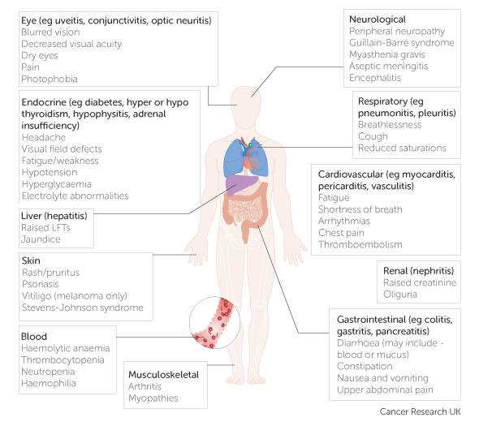

Version 1 Reviewed by: Dr Ricky Frazer Approved by: WCN IO Toxicity Group 05/12/2023

