
Clinical guidance for testing and treatment of patients with metastatic or unresectable FGFR-altered Urothelial Carcinoma
Authors: Diana Matthews (Advanced Oncology Pharmacist, Velindre Cancer Centre)
Holly Lewis (Clinical Scientist, AWMGS)
Mark Davies (Consultant Medical Oncologist, Swansea Bay UHB)
Jose Tapia (Medical Oncology Consultant, Velindre cancer Centre)
Joshua Dinsmore (Genetic Technologist, AWMGS)
Louise Harris (Clinical Oncology Consultant, Velindre cancer Centre)
Nicholas Gill (Consultant Urologist & Urology CSG Lead, Swansea Bay UHB)
Rhian White (Consultant Clinical Scientist, AWMGS)
Sian Morgan (Head of Laboratory, AWMGS)

Reviewed by:

Guideline version: 1.0 Date: 27 05 2025

Contents
1. Objective and Scope 3
2. FGFR2/FGFR3 testing guidance 3
2.1 Background 3
2.2. FGFR2/FGFR3 Testing Request Algorithm 3
2.3. Interpreting a result 4
2.4. FGFR2/FGFR3 test requesting progress 5
2.5. Histopathological sample preparation requirements for FGFR2/FGFR3 testing 6
3. Prescribing Information for Erdafitinib 6
3.1 Eligibility Guidance for treatment with Erdafitinib 6
3.2 Cautions of treatment with Erdafitinib 7
3.3 Baseline investigations and on-treatment monitoring Erdafitinib 8
3.4 Erdafitinib dosing and administration information 8
3.5 Management of Erdafitinib Toxicities 10
3.5.1 Hyperphosphatemia 10
3.5.2 Nail Disorders 11
3.5.3 Dry Mouth (Xerostomia) and Mucositis 12
3.5.4 Skin Toxicity 15
3.5.5 Eye Toxicity Associated with Vision Changes 16
3.5.6 Management of Dry Eye 18
3.6 Drug Interactions 18
4. Appendices 20
Appendix 1 20
Appendix 2 21
Appendix 3 Examples of Urothelial RNA NGS reports 22
5. References 27

Objective and Scope
Urothelial Carcinoma (UC) is currently the 10th most common cancer in the world, and patients with metastatic disease generally have a poor prognosis with a less than 5% overall survival at 5 years (1)
The aim of this document is to provide clinical staff with guidance on the FGFR3 genetic alterations testing pathway treating patients with unresectable or metastatic UC which are potentially eligible for treatment with Erdafitinib.

FGFR2/FGFR3 testing guidance

2.1 Background
NICE recommends the use of Erdafitinib for treating unresectable or metastatic UC with susceptible FGFR3 genetic alterations in adults after at least 1 line of treatment for unresectable or metastatic cancer that included a PD-1 or PD-L1 inhibitor. (2)
Platinum based chemotherapy is currently the main treatment available for unresectable or metastatic UC. If patients respond to this, they can go onto maintenance Avelumab until disease progression. However, almost half of newly diagnosed patients will not be suitable for a treatment containing a platinum agent. The rise of Immune Checkpoint Inhibitors (ICI) has provided an alternative for some of these patients, as long as they have a PD-L1 expression ≥5%.(3)
Despite all of this, the response of these patients to ICIs is low, around 30%, and after progression to ICIs therapy, the choice of treatment for these patients is very limited to the use of Paclitaxel, Docetaxel or Vinflunine, which lacks encouraging results. (4)
Around 30% of advanced or metastatic UC have alterations of the Fibroblast Growth factor Receptor (FGFR) gene, that can work as an oncogenic driver.
The THOR trial (5) was a confirmatory, phase 3, randomized trial enrolling adult patients diagnosed with metastatic or surgical unresectable urothelial cancer, harboring FGFR3/2 alterations (mutations and fusions), that have been previously treated.
The presence of FGFR alterations was done by using next generation sequencing, direct digital counting methods or Qiagen Therascreen FGFR Roto-Gene Q reverse-transcriptase-polymerase-chain reaction assay.
Two cohorts were represented in this trial:
- Erdafitinib versus chemotherapy in metastatic patients with FGFR-alterations, who progressed after at least 1 line of treatment that included an ICI (this corresponds to the current NICE TA)
- Erdafitinib versus Pembrolizumab in metastatic patients with FGFR-alterations, who are ICI naïve
The results of the trial for cohort 1 show a median overall survival (OS) of 12.1 months in the Erdafitinib group and 7.8 months in the chemotherapy group, with an estimated hazard ratio (HR) for death of 0.64 (95% CI, 0.47 to 0.88; p=0.005).
In terms of Progression Free Survival (PFS), 5.6 months in the Erdafitinib group versus 2.7 months in the chemotherapy group, with an HR for progression or death of 0.58 (95% CI, 0.44 to 0.78; p<0.001)

2.2. FGFR2/FGFR3 Testing Request Algorithm
Treating team identifies patient as a suitable candidate for FGFR2/FGFR3 testing

Treating team completes FGFR2/FGFR3 request form and emails to the pathology laboratory holding the tissue sample

Pathology laboratory prepares the sample/slides and sends them to All Wales Medical Genomics Service (AWMGS)

The test report is uploaded to the Welsh Clinical Portal (WCP) and a PDF file is emailed to the requesting member of the team and the treating consultant

2.3. Interpreting a result
- FGFR2 or FGFR3 gene fusion/ rearrangement identified (RNA NGS)
The main highlighted box of the report will represent a conclusion stating’ Based on the detection of an FGFR2 or FGFR3 gene fusion, the patient may respond to FGFR3 inhibitors and that an FGFR2 or FGFR3 gene rearrangement has been detected’
The report will give further information about the implications for treatment e.g. Patients with urothelial cancer harbouring an FGFR2/FGFR3 gene rearrangement have been reported to respond to treatment with an FGFR inhibitor. Erdafitinib is recommended as an option for treating unresectable or metastatic disease after systemic therapy in adults
The reverse of the report will give technical information including the FGFR2 and FGFR3 transcripts used in sequencing as well as information about the tests sensitivity and links to treatment using FGFR3 inhibitors.

- NTRK gene fusion/ rearrangement detected (RNA NGS)
The main highlighted box of the report will represent a conclusion stating, ‘Based on the detection of an NTRK fusion, this patient may respond to TRK inhibitors. This is followed by test results stating the exact NTRK gene fusion alongside its fusion partner and its specific breakpoints.
With regard to treatment the report includes the following; ‘In patient with tumours harboring an NTRK gene fusion, treatment with TRK inhibitors has been shown to be associated with high objective response rates’ and ‘TRK inhibitors are recommended for use as an option for treating NTRK fusion-positive solid tumours in adults and children if the disease is locally advanced or metastatic, or surgery could cause severe health problems and the patient has no other satisfactory treatment options’.
The reverse of the report will give the technical information including the NTRK1-3 transcripts used in sequencing as well as information about the tests sensitivity and links to treatment using TRK inhibitors.

- No FGFR or NTRK rearrangement (wildtype) (RNA NGS)
The main highlighted box of the report will represent a conclusion stating ’Based on the absence of a clinically actionable FGFR or NTRK fusion, this patient is unlikely to respond to FGFR or TRK inhibitors. No gene fusions involving FGFR2, FGFR3, NTRK1, NTRK2 or NTRK3 detected’
With regard to treatment the report includes the following: Based on the absence of an FGFR2 or FGFR3 fusion, current clinical evidence suggests that this patient would be
unlikely to benefit from treatment with inhibitors targeting: FGFR2 or FGFR3 [1].
Based on the absence of an NTRK fusion, current clinical evidence suggests that this patient would be unlikely to benefit from treatment with inhibitors targeting: NTRK1, NTRK2 or NTRK3.

- FGFR variant detected (DNA NGS)
The main highlighted box of the report will represent a conclusion stating: Based on the presence of a clinically actionable FGFR2/FGFR3 variant, this patient may respond to FGFR inhibitors. FGFR2: c.# p.# detected/ No variants detected/ Analysis failed FGFR3: c.# p.# detected/ No variants detected/ Analysis failed
With regard to treatment, the report includes the following: Patients with urothelial cancer harbouring a clinically actionable FGFR2/FGFR3 variant have been reported to respond to treatment with FGFR inhibitors. Erdafitinib is recommended as an option for treating unresectionable or metastatic urothelial cancer with a clinically actionable FGFR2/FGFR3 mutation that has progressed after therapy.
Any variants of unknown clinical significance will be listed in the technical information.
There will also be a comment relating to the coverage of the genes and if any potential gaps in coverage are included.
The reverse of the report will give technical information including the FGFR2 and FGFR3 transcripts used in sequencing as well as information about the tests sensitivity and links to treatment using FGFR3 inhibitors.

- No FGFR2/ FGFR3 variants detected (wildtype) (DNA NGS)
The main highlighted box of the report will represent a conclusion stating: ‘Based on the absence of a clinically actionable FGFR2/FGFR3 variant, this patient is unlikely to respond to FGFR inhibitors FGFR2: No variants detected/ Analysis failed FGFR3: No variants detected/ Analysis failed’
With regard to treatment, the report includes the following: No clinically actionable variants have been detected in FGFR2 or FGFR3. Based on the absence of an actionable FGFR2 or FGFR3 variant, current clinical evidence suggests that this patient would be unlikely to benefit from treatment with inhibitors targeting: FGFR2/FGFR3.
Any variants of unknown clinical significance will be listed in the technical information.
There will also be a comment relating to the coverage of the genes and if any potential gaps in coverage are included.
The reverse of the report will give technical information including the FGFR2 and FGFR3 transcripts used in sequencing as well as information about the tests sensitivity and links to treatment using FGFR3 inhibitors.

2.4. FGFR2/FGFR3 test requesting progress
All requests should be made using the appropriate All Wales Medical Genomics Service (AWMGS) request form which is available at: http://www.medicalgenomicswales.co.uk.
Requests should not be made directly to the AWMGS laboratory as samples are not stored here and histopathology services are unavailable in this laboratory.
In order to reduce turnaround times, it is recommended that the form is then emailed to the local pathology laboratory storing the diagnostic specimen which is to be tested. The majority of laboratories now have generic emails addresses, the accounts for which are checked on a daily basis. If a generic address is not available, the request should be sent to a named individual at the local pathology laboratory who knows to expect the request and initiate the required sample preparation thus avoiding unnecessary delays.
• Referring clinician to contact histopathology laboratory where the tissue is stored and send a completed AWMGS request form indicating the requirement for FGFR3 testing.
• The histopathology laboratory will retrieve the histological specimen and perform slide cutting and tumour assessment.
• The pathology laboratory should complete the remaining fields on the request form and send a paper copy of the form with the prepared slides directly to the AWMGS laboratory within a 5 working day turnaround time.

2.5. Histopathological sample preparation requirements for FGFR2/FGFR3 testing
The local pathology laboratory housing the specimen should prepare the sample as follows before sending the slides to AWGL with the completed request form:
DNA NGS requirements | 6 x 10µm or 12 x 5 µm (60 µm) sections on charged/adhesion slides
RNA NGS requirements | 5 x 10µm or 10 x 5 µm (50 µm) sections on charged/adhesion slides

Prescribing Information for Erdafitinib

3.1 Eligibility Guidance for treatment with Erdafitinib
Histologic demonstration of transitional cell carcinoma of the urothelium. Minor components (<50% overall) of variant histology such as glandular or squamous differentiation, or evolution to more aggressive phenotypes such as sarcomatoid or micropapillary, are acceptable.
Stage IV disease (metastatic or surgically unresectable, cT4b, N+, or M+ cancer).
Documented progression of disease, defined as any progression that requires a change in treatment.
Progression during or after previous systemic therapy that included an anti–PD-1 or anti–PD-L1 agent. Patients had received no more than two previous lines of therapy. Subjects who received neoadjuvant or adjuvant chemotherapy and showed disease progression within 12 months of the last dose are considered to have received systemic chemotherapy in the metastatic setting.

- Subjects must meet appropriate molecular eligibility criteria. Tumors must have at least 1 of the following translocations: FGFR2-BICC1, FGFR2-CASP7, FGFR3-TACC3, FGFR3-BAIAP2L1; or 1 of the following FGFR3 gene mutations: R248C, S249C, G370C, Y373C.
- Patients without potential corneal or retinal abnormality likely to increase the risk of eye toxicity:
a) History of central serous retinopathy (CSR) or retinal vascular occlusion (RVO)
b) Active wet, age-related macular degeneration (AMD)
c) Diabetic retinopathy with macular edema (non-proliferative)
d) Uncontrolled glaucoma (per local standard of care)
e) Corneal pathology such as keratitis, keratoconjunctivitis, keratopathy, corneal
abrasion, inflammation or ulceration.

3.2 Cautions of treatment with Erdafitinib
- Prior to initiating Balversa, a baseline ophthalmological exam including an Amsler grid test, fundoscopy, visual acuity and, if available, an optical coherence tomography (OCT) should be performed. Perform monthly ophthalmological examinations including an Amsler grid test during the first 4 months of treatment and every 3 months afterwards, and urgently at any time for visual symptoms.

- Erdafitinib can cause ocular disorders, including central serous retinopathy (CSR) (a grouped term including retinal pigment epithelial detachment (RPED)) resulting in visual field defect. The overall incidence of central serous retinopathy was higher in patients ≥65 years of age (33.3%) compared with patients <65 years of age (28.8%). Events of RPED were reported more frequently in patients ≥65 years of age (6.3%) compared with patients <65 years of age (2.1%). Close clinical monitoring is recommended in patients aged 65 years and older as well as with patients that have clinically significant medical eye disorders, such as retinal disorders, including but not limited to, central serous retinopathy, macular/retinal degeneration, diabetic retinopathy, and previous retinal detachment.

- All patients should receive dry eye prophylaxis or treatment with ocular demulcents (for example artificial tear substitutes, hydrating or lubricating eye gels or ointment) at least every 2 hours during waking hours.

3.3 Baseline investigations and on-treatment monitoring Erdafitinib

Investigation |  | Baseline | On-treatment
Blood test | FBC | Yes | Yes
Blood test | RLB, including phosphate and calcium levels | Yes | Yes
Blood Pressure |  | Yes | Yes
12-lead ECG |  | Yes | As clinically indicated
Ophthalmologic assessment | Amsler Grid Test | Yes | Yes
Ophthalmologic assessment | Ophthalmologic referral | At clinician discretion | As clinically indicated
Imaging (CT-TAP) |  | Yes | Every 3-4 months or otherwise as clinically indicated
Toxicity Assessment |  | Yes | Yes

3.4 Erdafitinib dosing and administration information

Drug/Dosage | Erdafitinib is available as 3mg, 4mg or 5mg film-coated tablets  The recommended starting dose is 8mg once a day with phosphate levels checked at days 14 and 21. If the phosphate level remains <2.91mmol/L, and no Grade 2 toxicities the dose can be increased to 9mg once a day.
  Current Dose | 1st dose reduction | 2nd dose reduction | 3rd dose reduction | 4th dose reduction | 5th dose reduction
  9mg | 8mg | 6mg | 5mg | 4mg | STOP
  8mg | 6mg | 5mg | 4mg | STOP
Administration | The tablets should be swallowed whole with or without food at about the same time each day.  Continuous administration until progression of the underlying disease or unacceptable toxicity  If a patient misses a dose of Erdafitinib, they should take their next normal dose at its scheduled time.  Grapefruit or Seville oranges should be avoided while taking Balversa due to strong CYP3A4 inhibition
Anti-emetics | Erdafitinib has low emetogenic potential.
Common side effects (>10% patients) | hyperphosphataemia, hyponatraemia, decreased appetite, dysgeusia, epistaxis, diarrhoea, stomatitis, dry mouth, constipation, nausea, vomiting, abdominal pain, paronychia, onycholysis, onychomadesis, nail dystrophy, nail disorder, nail discolouration, palmar-plantar erythrodysaesthesia syndrome, alopecia, dry skin, asthenia, fatigue, anaemia, weight decreased, blood creatinine increased, alanine aminotransferase increased, aspartate aminotransferase increased
Occasional side effects (1-10%) | Hyperparathyroidism, hypercalcaemia, hypophosphataemia, ulcerative keratitis, keratitis, conjunctivitis, xerophthalmia, blepharitis, lacrimation increased, nasal dryness, dyspepsia, onychalgia, onychoclasis, nail ridging, skin fissures, pruritus, skin exfoliation, xeroderma, hyperkeratosis, skin lesion, eczema, rash, acute kidney injury, renal impairment, renal failure
Rarer toxicities | vascular calcification, nail bed bleeding, nail discomfort, skin atrophy, palmar erythema, skin toxicity, nail bed bleeding, nail discomfort, skin atrophy, palmar erythema, skin toxicity

3.5 Management of Erdafitinib Toxicities

3.5.1 Hyperphosphatemia
Grading & management of Hyperphosphatemia
Grade 1 | Erdafitinib Dose | Symptom Management
mmol/L | No change | Restrict phosphate intake to 600-800mg/day
Grade 2
2.25-2.90 mmol/L | No change  or  One level dose reduction if Grade 2 hyperphosphatemia for 2 months or longer or if clinically indicated | Restrict phosphate intake to 600-800mg/day  and/or  Sevelamer carbonate 800 – 1600mg TDS until resolved to grade 1
Grade 3
2.91-3.20 mmol/L or asymptomatic soft tissue calcification with any phosphate level | Withhold Erdafitinib and perform weekly bloods until resolved to ≤ grade 1, then restart at the same dose  or  One level dose reduction if Grade 3 hyperphosphatemia for 1 month or longer or if clinically indicated | Restrict phosphate intake to 600-800mg/day  and/or  Sevelamer carbonate 1600mg TDS until resolved to grade 1
Grade 4
> 3.20 mmol/L or symptomatic soft tissue calcification with any phosphate level | Withhold Erdafitinib and perform weekly bloods until resolved to ≤ grade 1, then restart at the first level of dose reduction  Grade 4 hyperphosphatemia for more than 2 weeks discontinue Erdafitinib permanently | Clinical management as appropriate

For significant deterioration of baseline renal function or grade 3 hypercalcemia (corrected calcium > 3.1mmol/L) discontinue Erdafitinib permanently and clinically manage symptoms as indicated

3.5.2 Nail Disorders
General Prophylaxis:
Good hygienic practices, keep fingers and toes clean
Keep nails trimmed but avoid aggressive manicuring
Use gloves for housecleaning and gardening to minimize damage and prevent infection
Nail polish and imitation fingernails should not be worn until the nails have grown out and returned to normal
Wearing comfortable shoes (wide sized shoes with room for the toes)
Grading & Management of Nail Discoloration/Loss/Ridging/Paronychia
Grade 1 | Erdafitinib Dose | Symptom Management
Nail discoloration, asymptomatic  separation of the nail bed from the nail plate or nail loss | No change | General prophylaxis measures  Consider adding a nail strengthening polish
Grade 2
Nail/finger tips pain, symptomatic  separation of the nail bed from the nail plate or nail loss; limiting instrumental ADL | Consider withholding Erdafitinib  If first occurrence and it resolves to  ≤ grade 1 or baseline within 2 weeks,  restart at same dose.  If recurrent event or takes >2 weeks to  resolve to ≤ grade 1 or baseline, then  restart at the first level of dose reduction | Manage as per Grade 1  Check for signs of infection and if required treat as per local antimicrobial guidelines
Grade 3
Severe nail finger tips pain, symptomatic separation of the nail  bed from the nail plate or nail loss;  significantly limiting instrumental ADL | Withhold Erdafitinib until resolved to ≤ grade 1,  then  restart at the first level of dose reduction | Use a dilution of 1:1 of water and white vinegar, and soak the fingers and/or toes for 15min every day.  Consider referral to dermatology
Grade 4
Life-threatening consequences,  urgent intervention indicated | Discontinue permanently

3.5.3 Dry Mouth (Xerostomia) and Mucositis
General Prophylaxis:
- Good oral hygiene
- Use a soft toothbrush
- Avoidance of spicy, acidic, hard, and hot food and beverages
- Use of mild-flavored toothpastes (e.g. children toothpaste) and preventative mouthwashes

Grading & management of Dry Mouth (Xerostomia)
Grade 1 | Erdafitinib Dose | Symptom Management
symptomatic (eg, dry or  thick saliva) without significant  dietary alteration | No change | Sodium bicarbonate rinse: 1 teaspoon added to a glass of saline solution or water and used as a mouthwash four times a day
Grade 2
moderate symptoms; oral  intake alterations (eg, copious water,  other lubricants, diet limited to  purees or soft, moist foods); | No change | Sucking crushed ice or frozen tonic water  Yellow paraffin for dry lips: apply liberally and as needed  Saliva replacement: apply liberally and as needed
Grade 3
Inability for adequate  Oral intake; tube feeding or TPN indicated | Withhold Erdafitinib until resolved to ≤ grade 1,  then  restart at the first level of dose reduction | For inpatient management
Grade 4
life-threatening  consequences, urgent intervention indicated | Discontinue permanently

Grading & management of Mucositis
Grade 1 | Erdafitinib Dose | Symptom Management
Asymptomatic or mild symptoms; intervention not indicated | No change | Salt water rinses – These can be prepared at home using 1 teaspoon of salt in a glass of tepid water and use as a mouth wash four times a day
Grade 2
Moderate pain or ulcer that does not interfere with oral intake; modified diet indicated | First occurrence: Withhold Erdafitinib and if resolves to ≤ grade 1 within 2 weeks, restart at same dose  Recurrent, or first occurrence lasting ≥ 2 weeks: Withhold Erdafitinib and when resolved to ≤ grade 1, restart at the first level of dose reduction | Benzydamine mouthwash 0.15%: use 15mls every 1.5-3h when required (can be diluted with water)  Gelclair sachets: use one sachet 4xday  Bonjela: use as required
Grade 3
Severe pain; interfering with oral intake | Withhold Erdafitinib and when resolved to ≤ grade 1, restart at the first level of dose reduction with very close monitoring | Caphosol: Mix 1 blue (Caphosol A) and 1 clear ampule (Caphosol B) and use as a mouthwash 2-10x /day  Soluble paracetamol 1g 4 x day as mouthwash  OR  Soluble co-codamol 2x 30/500mg 4 x day as mouthwash
Grade 4
life-threatening  consequences, urgent intervention indicated | Discontinue permanently

3.5.4 Skin Toxicity
General prophylaxis:
- Avoid unnecessary exposure to sunlight and excessive use of soap.
- Avoid bathing in excess; use tepid rather than hot water.
- Pat the skin dry instead of rubbing it
- Use moisturizers regularly; apply thick, alcohol-free and oil-in-water based emollient cream on exposed and dry areas of the body.
- Avoid perfumed products, bubble bath, perfumed soaps, and take breaks from shaving.
- Use broad spectrum sunscreen with a skin protection factor (SPF) ≥30.
- Wear cotton clothes next to skin rather than wool, synthetic fibers, or rough clothing.
- Do not use products containing sodium lauryl sulphate (SLS), in the presence of eczema
- Bath and shower emollients offer no advantages over emollients. Patients can use any of their normal creams or ointment above as a soap substitute in the bath/shower; except 50:50 (since it may not lather well).
- Urea containing moisturizers should be reserved for the treatment of skin that is scaling, not as a regular emollient

Grade 1 | Erdafitinib Dose | Symptom Management (7)
Dry skin covering less  than 10% body surface area (BSA)  and no associated erythema or  pruritus | No change | Wash with a soap substitute in the bath. Apply moisturiser after bathing while the skin is still damp. Apply moisturiser 30 minutes prior to other treatments. Apply as required throughout the day  Suggestions: Aveeno cream,  Zerocream, Cetraben Cream, E45 Cream
Grade 2
Dry skin covering 10 to  30% BSA and associated with  erythema or pruritus with limited  instrumental activities of daily  living (IADL) | No change | Wash with a soap substitute in the bath, if very dry try a more greasy moisturiser/soap substitute. Apply moisturiser after bathing while the skin is still damp. Apply moisturiser 30 minutes prior to other treatments Apply moisturiser 3 – 4 times per day  Suggestions: Epimax Cream, Zerobase Cream, Zerodouble Gel, Doublebase Gel, Diprobase Cream, oilatum Cream, Unguentum M Cream
Grade 3
Dry skin covering >30%  BSA and associated with pruritus;  limiting self-care activities of daily  living (ADL) | Withhold Erdafitinib and when resolved to ≤ grade 1, restart at the first level of dose reduction | Wash with a greasy moisturiser/soap substitute. Once skin has cooled apply a greasy moisturiser. Apply moisturiser 30 – 60 minutes prior to other treatments. Apply moisturiser 3 – 4 times daily. If required tubegauze suits during the day and/or at night.  Suggestions: Zeroderm Ointment, Epaderm Ointment, Hydromol Ointment, WSP:LP (50:50)
Grade 4
Dry skin with life-threatening  consequences, urgent  intervention indicated | Discontinue permanently

3.5.5 Eye Toxicity Associated with Vision Changes
Any new and clinically significant symptoms, such as but not limited to, blurred vision, partial or complete loss of vision, double vision, floaters or colour spots or halos around light, change in colour or night vision, photophobia, ocular pain or stinging sensation, or foreign body sensation should be further evaluated and managed per the guidelines below.
Amsler Grid: For any positive Amsler grid test, the subject should be referred for a full ophthalmologic examination.
Grade 1 | Erdafitinib Dose | Symptom Management
Asymptomatic  or mild symptoms;  clinical or diagnostic  observations only  Or  abnormal Amsler  grid test | Consider withholding Erdafitinib until eye examination is done and restart at the next level reduction, if appropriate  Dose escalation can be considered if no recurrence, with close monitoring. | Referral to ophthalmology for ophthalmological examination
Grade 2
Moderate;  minimal, local  or non-invasive  intervention indicated;  limiting age appropriate  instrumental ADL | Withhold Erdafitinib  If there is no evidence of drug related corneal or retinal pathology on  ophthalmologic examination, and  symptoms have resolved, restart at the next level of dose reduction | Referral to ophthalmology for ophthalmological examination and follow up if restarting treatment
Grade 3
Severe or  medically significant  but not immediate sight  threatening;  hospitalization or  prolongation of existing  hospitalization  indicated; disabling; limiting self-care ADL | Withhold Erdafitinib  If patient is getting benefit from the treatment AND only after ophthalmological assessment is agreed that the benefit outweighs the risk, restart Erdafitinib at the second level of dose reduction with close monitoring. | Referral to ophthalmology for ophthalmological examination and follow up if restarting treatment
Grade 4
Sight  threatening  consequences; urgent  intervention indicated;  blindness (20/200 or  worse) in the affected  eye | Discontinue permanently | Urgent referral to ophthalmology for ophthalmological examination

3.5.6 Management of Dry Eye
General considerations: Avoid unnecessary exposure to sunlight, use sunglasses in bright light.
Prophylactic management: Frequent use of artificial tear substitutes is strongly recommended.
Reactive management:
- Withhold erdafitinib for Grade 3 toxicity
- Artificial tear substitutes if not started, every 4 to 6 hours
- Hydrating /lubricating eye gels and ointments
- Severe treatment-related dry eye should be evaluated by an ophthalmologist.

3.6 Drug Interactions
Contra-indicated Concomitant Medications
- Medications known to increase serum levels of calcium (thiazide diuretics, vitamin A supplements, vitamin D supplements, calcium dietary supplements, calcium antacids, lithium, estrogens, anti-estrogens). Vitamin D and calcium supplements may be given if clinically indicated (in the setting of low serum vitamin D and calcium levels). Medications known to have calcium as an excipient should be avoided unless no alternatives exist.
- Medications known to increase serum levels of phosphate, such as potassium phosphate supplements (oral or IV), vitamin D supplements, antacids, and phosphate-containing enemas and laxatives (oral/rectal) thought to increase serum phosphate levels. Medications known to have phosphate as an excipient should be avoided unless no alternatives exist.
Precautions for Concomitant Medications

- Erdafitinib is metabolized by cytochrome CYP3A4 and CYP2C9.
Co-administration with a moderate CYP2C9 or strong CYP3A4 inhibitor will increase exposure to Erdafitinib, which can result in the increase of its toxicity. If co-administration of Erdafitinib with moderate CYP2C9 or strong CYP3A4 inhibitors is essential, reduce the dose of Erdafitinib to the next lower dose based on tolerability. (E.g. Itraconazole, Ketoconazole, Posaconazole, Voriconazole, Fluconazole, Miconazole, Ceritinib, Clarithromycin, telithromycin, elvitegravir, ritonavir, paritaprevir, saquinavir, nefazodone, nelfinavir, tipranavir, lopinavir, amiodarone, piperine)

Co-administration with a strong/moderate CYP3A4 inducer will reduce exposure to Erdafitinib, which can result in loss of efficacy. If co-administration of Erdafitinib with moderate/strong CYP3A4 inducers is essential, consider increasing the dose of Erdafitinib gradually by 1mg, based on tolerability and as long as not exceeding 9mg. (E.g. strong CYP3A4 inducers: apalutamide, enzalutamide, lumacaftor, ivosidenib, mitotane, rifapentine, rifampicin, carbamazepine, phenytoin, and St. John's wort; E.g. moderate inducers: dabrafenib, bosentan, cenobamate, elagolix, efavirenz, etravirine, lorlatinib, mitapivat, modafinil, pexidartinib, phenobarbital, primidone, repotrectinib, rifabutin, sotorasib, telotristat ethyl)

- Erdafitinib is a P-Glycoprotein (P-gp) inhibitor.
If Erdafitinib is administered with drugs that are substrates of P-gp, there is the potential for increase of their systemic exposure. Oral narrow therapeutic index P gp substrates (such as colchicine, digoxin, dabigatran, and apixaban) should be taken at least 6 hours before or after Erdafitinib to minimise the potential for interactions.

Appendices

Appendix 1
Prescribing information for Erdafitinib
*According to protocol published online: and SPC
https://www.nejm.org/doi/suppl/10.1056/NEJMoa2308849/suppl_file/nejmoa2308849_protocol.pdf

Appendix 2



Appendix 3 Examples of Urothelial RNA NGS reports
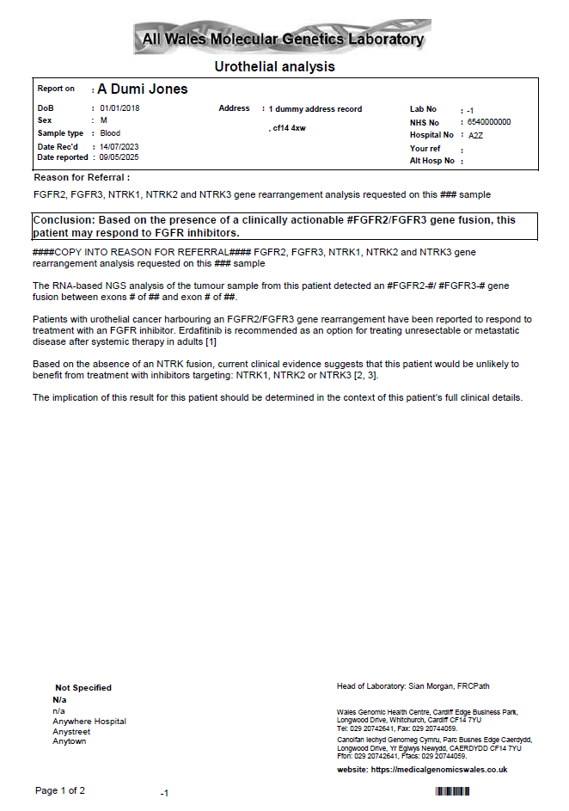
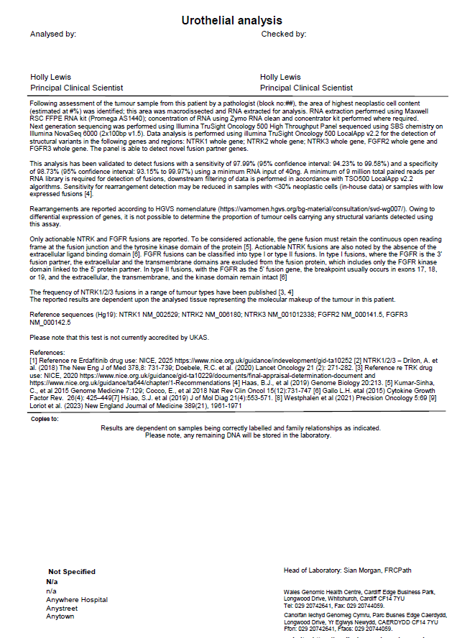
- FGFR2/FGFR3 gene rearrangement detected

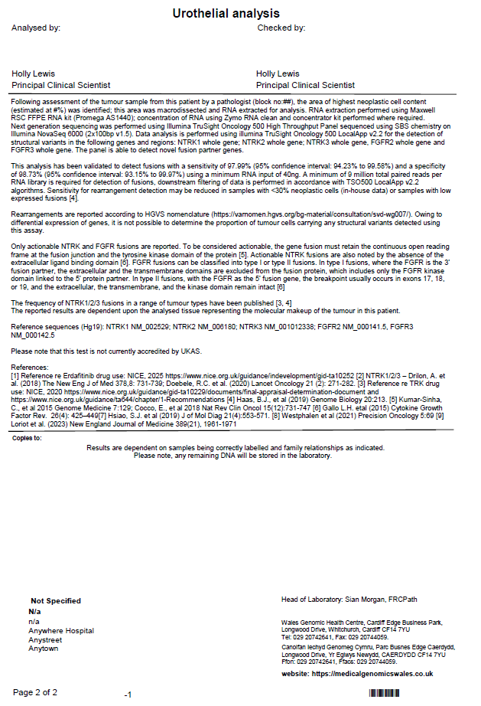
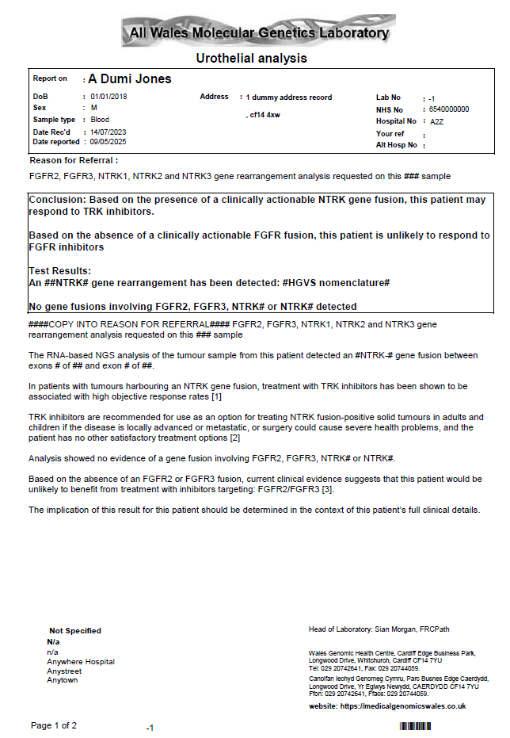
- NTRK1/ NTRK2/ NTRK3 gene rearrangement detected

- No NTRK or FGFR gene rearrangement detected
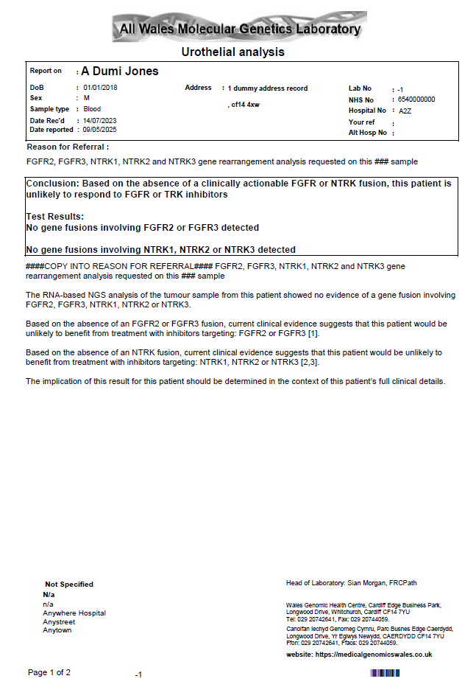
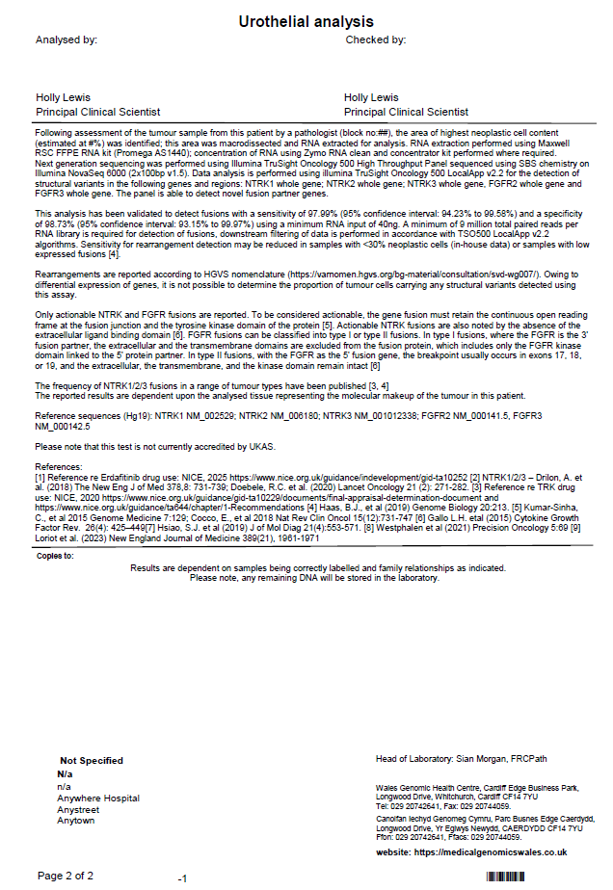

Appendix 4 Examples of Urothelial DNA NGS reports
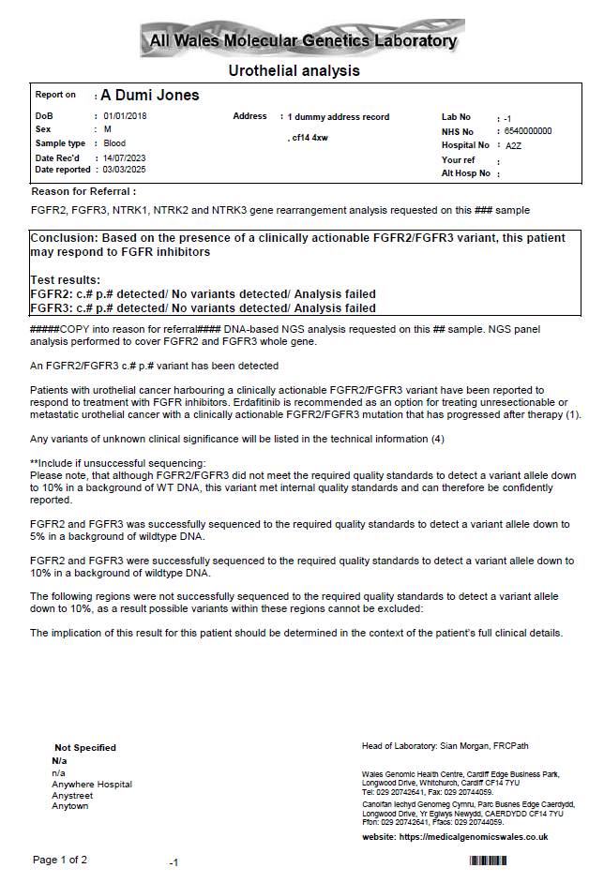
- FGFR mutation detected
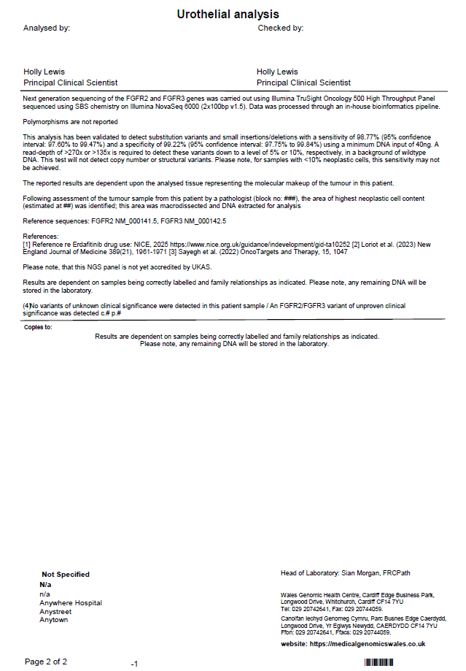

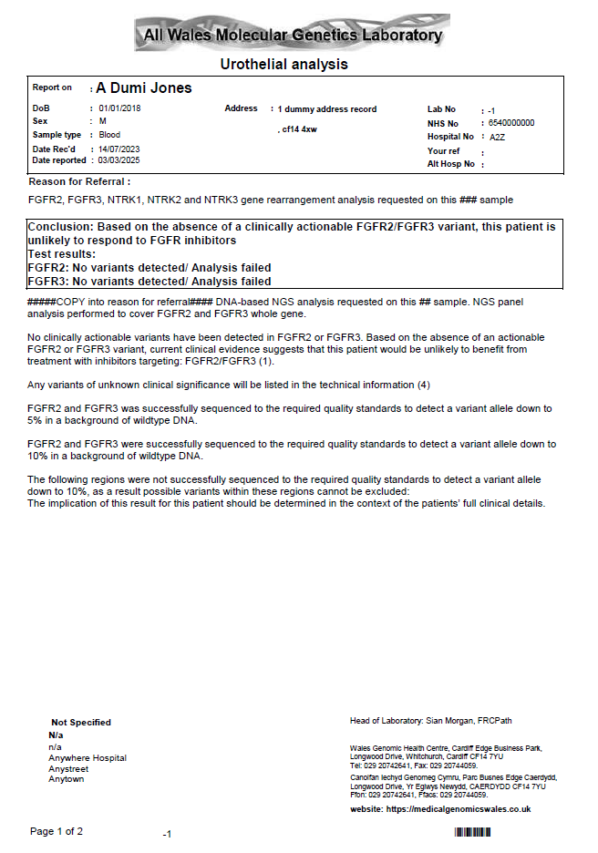
- No FGFR mutation detected (wildtype)
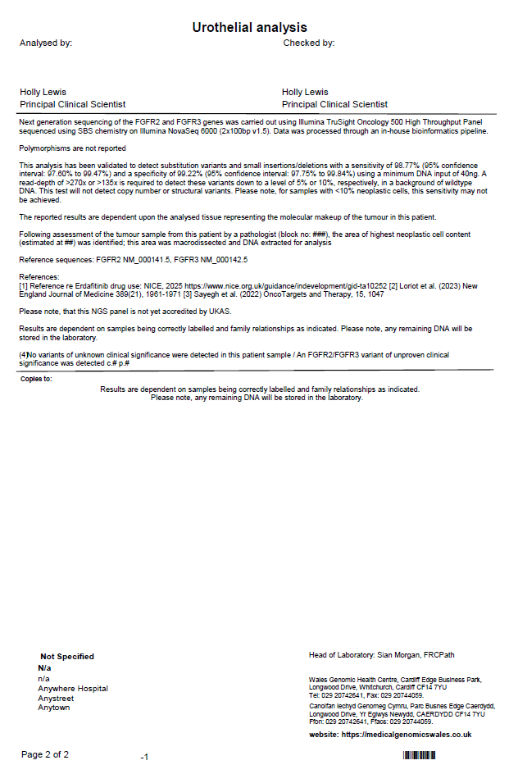

5. References
(1)Soares, A. et al (2024) “Management of Metastatic Urothelial Carcinoma in Emerging Markets (EM): An Expert Opinion”, Clinical Genitourinary Cancer, Volume 22 (2), pp. 467-475 Available at: https://doi.org/10.1016/j.clgc.2024.01.001
(2) National Institute for Health and Care Excellence (NICE) (2025) Erdafitinib for treating unresectable or metastatic urothelial cancer with FGFR3 alterations after a PD-1 or PD-L1 inhibitor. TA 1062. Available at: https://www.nice.org.uk/guidance/TA1062 (Accessed 14 May 2025)
(3) Roviello, G., Santoni, M., Sonpavde, G.P. et al. (2024) “The evolving treatment landscape of metastatic urothelial cancer”. Nat Rev Urol 21, 580–592. Available at: https://doi.org/10.1038/s41585-024-00872-0
(4) Yu SH, Kim SS, Kim S, Lee H, Kang TW. (2024) “FGFR3 Mutations in Urothelial Carcinoma: A Single-Center Study Using Next-Generation Sequencing.” J Clin Med. 13(5):1305. doi: 10.3390/jcm13051305. PMID: 38592174; PMCID: PMC10931944
(5) Yohann Loriot, M.D., Ph.D., Nobuaki Matsubara, et al. (2023) “Erdafitinib or Chemotherapy in Advanced or Metastatic Urothelial Carcinoma”, N Engl J Med; 389(21), pp. 1961-1971 Available at: https://www.nejm.org/doi/full/10.1056/NEJMoa2308849 (Accessed 14 May 2025)
(6) Janssen-Cilag Ltd (2025) Erdafitinib film-coated tablets SmPC. Available at: https://www.medicines.org.uk/emc/search?q=erdafiti (Accessed 14 May 2025)
(7) Dorset CCG (2021) Emollient comparison chart, Available at: https://www.nhsdorset.nhs.uk/Downloads/aboutus/medicines-management/Other%20Guidelines/Emollient%20comparison%20chart%202021.pdf (Accessed 06 May2025)

