NHS Wales Health Collaborative
Service Specification

Critical Care Rehabilitation and Recovery Services

March 2023

NHS Wales Critical Care Rehabilitation & Recovery
Service Specification
Adult Critical Care Services

Service | Adult General Critical Care Services
Version | 1.0
Author | Rehabilitation Task & Finish Group, NHS Wales Critical Care Network
Consultees
Provider | NHS Wales
Published
Review | One year after publication

1. Purpose

  - Aims
Rehabilitation Services in Wales are provided in line with the All Wales Rehabilitation Framework. The aim of this document is to describe the service specification for rehabilitation services for patients admitted to adult critical care, both in Wales and who are repatriated home from critical care services elsewhere.

Adult general critical care services are planned and delivered by health boards across NHS Wales. All health boards except Powys Teaching Health Board and Velindre NHS Trust provide critical care services for their population.

1.2 Scope
This service specification relates to the provision of rehabilitation within adult general critical care services in Wales. The specification can be applied to specialist adult critical care areas at the discretion of health boards planning those services where specifications do not otherwise exist or patients would benefit from equitable quality of provision. This specification is not applicable to high care areas provided by other services such as Post-Operative/Anaesthetic Care Units, Long-term Ventilation or Extended Recovery Units.

This specification includes recommendations for adult critical care units, with recommendations for integration of care and / or handover between services, and the provision of critical care recovery clinics. Rehabilitation provided in other settings, including community rehabilitation or specialist (tertiary rehabilitation) will be provided in line with the service specifications in place for those services.

1.3 Objectives
- To provide high quality and consistent rehabilitation and recovery services to critically ill patients across NHS Wales
- To ensure provision of sufficient capacity to meet the needs of these patients
- To ensure that critical care services meet requirements and standards set out by NHS, professional bodies, National Institute of Health and Care Excellence (NICE), Intensive Care Society (ICS) and Faculty of Intensive Care Medicine (FICM)) for safe and effective rehabilitation services
- To set out a clear standard for provision of rehabilitation for patients requiring critical care services in Wales or patients or returning to Wales following critical illness.

2. Service Delivery

2.1 Care pathway

Rehabilitation is delivered as a whole pathway, across the recovery continuum and relies on input from a range of clinical services both within hospital and in the community (see figure 1). The focus of this specification refers to rehabilitation within critical care (including Intensive Care (ICU), High Dependency (HDU), or units where ICU and HDU beds are co-located) and ICU recovery clinic.
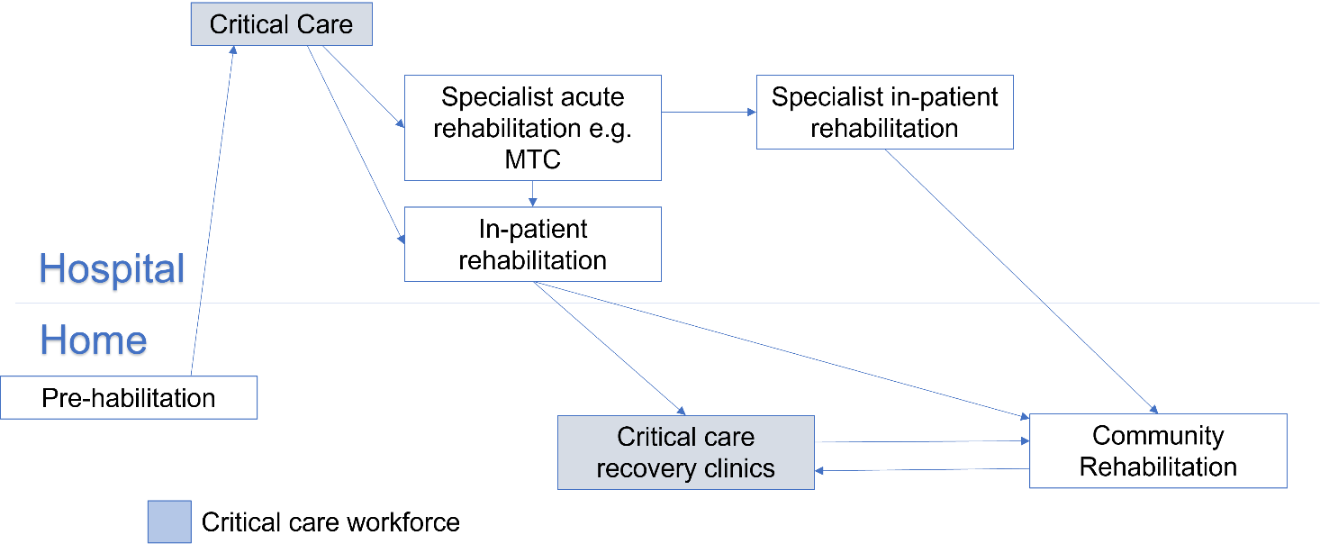

2.2 Critical Care

The rehabilitation needs of all patients must be assessed within three days of admission to critical care (or on discharge if sooner) and a rehabilitation plan outlined by all relevant allied health professions as clinically indicated (GPICS-2 standard 3.6.1).

Patients who stay in critical care for more than three days and are at risk of ongoing morbidity must have a comprehensive assessment of physical, cognitive, psychological and other non-physical needs (NICE GC83), including recognition of pre-admission functional status, current medical status and ongoing rehabilitation needs. This must be formally documented and completed in conjunction with the wider multi-professional team.

The critical care workforce must have sufficient capacity to meet patients’ rehabilitation needs and be compliant with existing national guidelines (GPICS-2, NICE CG83 and NICE QS158). This must include the provision of services by dietetics, occupational therapy, physiotherapy, psychology and speech & language therapy.

Rehabilitation needs must be formally assessed through the use of validated outcome measures (see section 3) and the Rehabilitation Complexity Score.

2.3 Discharge from Critical Care

Adults at risk of ongoing physical or psychosocial morbidity must have an individualised rehabilitation plan documented in their formal handover of care when transferred from critical care to a general ward. All members of the care team must be aware of this. Patient involvement in setting this rehabilitation plan should occur as soon as feasible and appropriate (GPICS-2 standard 3.6.6). Patients at risk of ongoing physical or psychosocial morbidity and with a length of stay of more than 7 days (or earlier if deemed clinically required) must have an individualised rehabilitation plan. This rehabilitation plan should also be available to all appropriate healthcare staff and to primary care.

2.4 Acute Care including specialist rehabilitation

The provision of wider acute care including rehabilitation is outside of the remit of critical care services. In accordance with the All Wales Rehabilitation Framework, all Health Boards have a responsibility to ensure the adequate provision of rehabilitation services to meet their population’s needs. Rehabilitation outcomes must be evaluated and as a minimum this must include the completion of relevant outcome measures and ongoing use of the individual rehabilitation plan (see section 3).

2.5 Community
Health boards’ services should be provided in line with the individual’s goals and needs, with the appropriate support and intervention in a holistic manner, with access to all required members of the multi-professional team. The stepped model of rehabilitation identified in the All-Wales Rehabilitation Framework should direct the delivery of health boards’ rehabilitation services. Access to rehabilitation should be determined by the needs of the person, not their condition. This includes post critical care patients’ access to specialist bedded or community rehabilitation. Additionally, all health boards should ensure effective access to patient self-management information in a format that is accessible to them (e.g., Keeping Me Well).

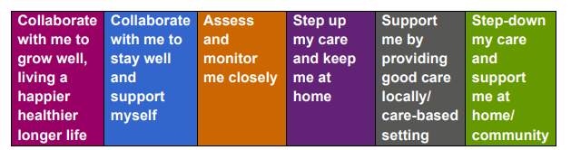

Third sector organisations will play an increasingly important role in supporting recovery from prolonged admission to critical care and for those with ongoing complex needs. All health and care partners must use available options to collaborate with third sector, including the development of support groups for people with similar lived experience to support each other in their recovery.

2.6 Critical Care Recovery Clinics

Critical illness can be a pivotal moment for some patients, resulting in a significant change in behaviour with likely increased engagement with healthcare professionals along the recovery continuum. Critical care recovery clinic provides an opportunity for the multi-disciplinary team to evaluate recovery following critical illness and to address any ongoing medical and rehabilitation needs (including physical, psychological, and cognitive), including providing expertise and advice to current care teams. It must also be recognised that although the patient themselves may not benefit from input from post ICU recovery services, their relative or carer may benefit enormously (Life After Critical Illness, FiCM). This input must be aligned to the stepped approach within the All-Wales Rehabilitation Framework. For example, input may include signposting to further support and information (e.g., keeping me well), the provision of advice and / or exercise, or onward referral to rehabilitation services (e.g., MSK service, community rehabilitation services, long-covid rehabilitation etc).

For some patients, their multidisciplinary needs may already be adequately met within their existing holistic specialist services (e.g., transplant, cystic fibrosis, dialysis, stroke neurorehabilitation, cardiac rehabilitation, sickle cell disease and major trauma) and / or via community rehabilitation and recovery services. These patients should still be able to access critical care recovery clinics if felt beneficial (either by the patient or the multi-disciplinary team) however the clinic may be tailored to suit needs e.g., may only require input from consultant intensivist.

Based on the above, all patients admitted to critical care for more than 72 hours must be assessed for the need to attend a critical care recovery clinic, with all those deemed clinically relevant receiving an appointment within 12 weeks of discharge from hospital (GPICS v2, NICE CG83). The appointment must be booked through an appointments system with a record for invitation and attendance. Critical care recovery clinics must involve a consultant in intensive care medicine, a critical care nurse, a critical care therapist (any of dietitian, occupational therapist, physiotherapist, or speech & language therapist) and a clinical psychologist. Additionally, the clinic must have access to / ability to refer to other health care professionals as needed (see section 5).

For all those who attend critical care recovery clinic the following outcomes must be used: Community PICUPS, EQ-5D-5L, Trauma Screen (TSQ), 6MWT (face-to-face only). All health boards must ensure there are mechanisms for communication between critical care recovery clinics, primary and secondary care and where needed, specialist care.

Where a patient attending critical care follow-up clinic is already receiving community-based rehabilitation and recovery input, it is vital that there is two-way communication between the critical care recovery clinic team and the local service. In this instance the purpose of input from critical care clinicians is not to decide on potential rehabilitation interventions, but to provide consultancy to help support best outcomes.

There is additional guidance on the provision of critical care recovery clinics within the Faculty of Intensive Care Medicine ‘Life after critical illness’ guide (laci_life_after_critical_illness_2021.pdf (ficm.ac.uk)).
3. Quality and Performance Indicators

3.1 Critical Care

The following tables provide recommended outcome measures for completion within critical care. As an expected standard, the post intensive care unit presentation screen (PICUPS) and the Rehabilitation Complexity Score (RCS) must be completed within the first 72 hours of admission and at point of critical care discharge. Both the PICUPS and RCS should be completed by the most appropriate healthcare profession in conjunction with the wider multi-professional team. The EQ-5D-5L may also be used to provide consistency across the rehabilitation pathway. Examples of some additional professional-specific outcome measures are shown below. These other measures are suggested specific critical care measures that will aid assessment of ongoing function and to assess the impact of AHP services within critical care.
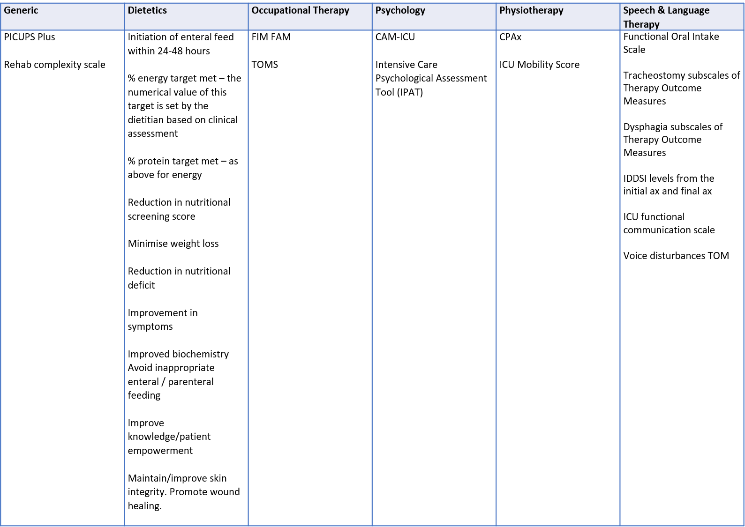

The introduction of the Welsh Intensive Care clinical information system (WICIS) will allow for sharing of patient outcome data for national evaluation. As an interim, all UHBs are encouraged to electronically collect a minimum dataset (PICUPS and RCS) which can be shared with the NHS Wales Critical Care and Trauma Network, and services receiving patients for ongoing evaluation and analysis.

3.2 In Hospital Provision of Rehabilitation Plan

All patients at risk of physical morbidity with a length of stay of 7 days or more will have an individualised rehabilitation plan. The rehabilitation plan must be based on a comprehensive assessment incorporating a thorough baseline status review, physical and non-physical morbidity (sleep, cognition, delirium, and communication). This plan should be continually updated by the MDT (or a designated key worker) during the critical care stay and must, where possible, be developed in conjunction with the patient with their current rehabilitation goals. The rehabilitation plan should be provided to the patient at the earliest opportunity and must be provided, at the latest, at point of critical care discharge. The rehabilitation plan must, as a minimum, provide: a clear statement of goals/ needs for this individual; a clear summary of specific areas of complexity, relevant to their critical journey (i.e., identify areas which may not be frequently seen by receiving staff/ services); outline of provision already given as potential options to maintain continuity; and identification of named critical care rehabilitation link who can be contacted for specific, detailed discussion. For audit purposes, all rehabilitation plans should include pertinent information including diagnosis and critical care length of stay. There must also be local processes to ensure compliance with completion and provision on training for use as necessary.

3.3 Critical Care Recovery clinics

As previously stated, critical care recovery clinics provide an opportunity to evaluate recovery since critical care discharge, and for those not already receiving community-based rehabilitation (or those who have completed community-based rehabilitation), to assess and identify ongoing rehabilitation needs.

Based on the above, the following outcome measures are recommended for use within critical care recovery clinics:
- Community PICUPS
- EQ-5D-5L
- Trauma Screening Questionnaire

Each health board critical care service may choose to use additional outcome measures based on local opinion and perceived benefit. This may include the completion of the six-minute walk test (6MWT) or profession-specific measures.

3.4 Utilisation of PROMS / PREMS

Patient reported outcome measures (PROMs) and patient reported evaluation measures (PREMs) must be used across the recovery pathway. As a minimum, all health boards must use the community PICUPS, EQ-5D-5L and a psychological trauma scale. Patients should be encouraged to complete PROMS at the following time points:
- Discharge from hospital
- Prior to, or during, critical care follow-up clinic (3 months post-hospital discharge)
- At 6 months post-hospital discharge
- At 12 months post-hospital discharge

Ideally PROMS / PREMS will be collected electronically, acknowledging all health boards and health & care partners may use different systems. PROMS / PREMS data should be collected at a health board and national level, with the NHS Wales Critical Care and Trauma Network responsible for the national dataset (to be arranged with Value Based Health and Care team).

PROMs may have potential to be used as a screening tool for deciding which patients do, or do not, need to attend critical care follow-up clinic, whether that needs to be in person or remotely, and the timing of that appointment. Additionally, the results of the PROMs may be used to identify the patient’s needs and likely professions required at follow-up clinic.

In addition to the above, all health boards should consider the use of patient diaries and the process for completion and return to patients and their families. Furthermore, all health boards should complete patient stories to capture the ‘lived experience’ of those recovering from critical illness and the impact of the rehabilitation provided. These patient stories should be presented at relevant critical care meetings e.g., clinical governance or quality & safety meetings, as well as appropriate NHS Wales Critical Care and Trauma Network meetings.

4. Audit & Service Evaluation

All health board critical care units must complete regular audits regarding the provision of rehabilitation. These audits must be based on nationally recognised guidelines including NICE CG83 (rehabilitation after critical illness), NICE QS158 (standards for rehabilitation after critical illness) and GPICS2, as well as NHS Wales specific guidelines, such as this document.

These audits must be completed by clinicians working within critical care units and should be reported to the critical care team via local systems e.g., quality and safety meetings. It is acknowledged that these national guidelines also capture services outside of critical care e.g., provision of rehabilitation on wards and community. It would be ideal for this data to be captured, however this falls outside of the scope of this specification and would be for local services to consider.

5. Education

All health boards must ensure that all health care professionals involved in the care of patients recovering from critical illness, have access to education on rehabilitation. This must be available across the entire critical care pathway including primary care and community staff. As a minimum, the education package must include the physical and psychosocial consequences of critical illness, and long-term effects on respiratory function. This education programme must be developed in collaboration with relevant stakeholders from the Welsh Rehabilitation Network, HEIW and the National AHP rehabilitation lead. Additionally, it must be aligned with existing professional competencies e.g., ICS AHP framework, CC3N Step Competency Framework.

6. Workforce

The critical care workforce must be sufficient to deliver both rehabilitation within critical care and provision of critical care recovery clinics, whilst ensuring ability to be involved in non-clinical activities e.g., research, quality improvement, clinical governance. It is acknowledged that recommendations for workforce have been previously provided by the Guidelines of Provision of Intensive Care Services (GPICS v2) and the British Society of Rehabilitation Medicine, however, these are rarely complied with, particularly in relation to AHPs, due to significant existing shortfall, and recruitment challenges. Therefore, based on this, and the need to ensure the workforce meets the needs of NHS Wales critical care services, the following are recommended for AHPs in critical care (excluding ICU recovery clinics). These workforce ratios consider AHP involvement in the provision of rehabilitation within critical care, as well as delivery of services for holistic patient management e.g., respiratory interventions delivered by physiotherapy. For medical and nursing, existing GPICS recommendations must be adopted.

Profession | Staff : Bed Ratio 2022-2023 | Staff : Bed Ratio  2024 and beyond
Dietetics | 1: 15 | 1: 10
Occupational Therapy | 1: 15 | 1: 10
Physiotherapy | 1: 6 | 1: 4
Psychology | 1: 30 | 1 : 20
Speech & language therapy | 1: 15 | 1: 10

Support workers e.g. health care support workers, rehabilitation assistants, therapy specific assistants, are a vital component of the workforce and should be in addition to the recommendations above. Specific guidance for utilisation of health care support workers must be made by individual health boards based on their specific service needs and service set-ups. The potential role of therapy support workers / rehabilitation technician roles is highlighted in Informing the Future Workforce for Critical Care Services (HEIW, 2022).

All health boards must also establish referral routes and any additional workforce groups for other allied health professional staff e.g., orthotists and prosthetists, whose input may be required for specific patients.

Critical Care Recovery Clinic:

Additional sessional commitment is required for the provision of critical care recovery clinics. Each health board must ensure the delivery of these clinics with total staffing requirements dependant on the number of patients accessing the clinic.

Profession | Requirement
Medical (Consultant ICM) | 1 session per 4 patients
Nursing | 1 session per 4 patients
Psychology | 1 session per 4 patients
Dietetics | 1 session (3.5 hours) per 6 patients with at least one profession present*
Occupational Therapy
Physiotherapy
Speech & language therapy

*It is acknowledged that not all therapy professions need to be present for all critical care recovery clinics.

The whole-pathway approach to rehabilitation, as recommended in the All-Wales Rehabilitation Framework and aligned with WHSSC specialist rehabilitation services specification, must be implemented. Effective repatriation agreements are essential to ensure that patients can be transferred to the right level of care and location for them at the right time. This must include cross border agreements for critical care patients who are returning to Wales following care outside Wales. Transfer to rehabilitation in other wards, bedded units, intermediate care or home-based community rehabilitation must be undertaken in a timely manner with full transfer of information, including the individual’s rehabilitation plan.

6. Opportunities for development / Ongoing local pilots

In addition to the recommendations stated, there is clear opportunity to further develop the rehabilitation services provided to those recovering from critical illness. These include, but are not limited, to the following:
- Novel models for providing acute rehabilitation following discharge from critical care: A small pilot within one UHB demonstrated that increasing physiotherapy in the immediate post critical care period (provided by the critical care physiotherapy team in conjunction with existing ward physiotherapy staff) resulted in reduced post critical care length of stay and improvements in physical function. Further projects must explore the effectiveness of providing holistic rehabilitation in this post critical care discharge period and its effect on outcomes
- Development of rehabilitation co-ordinators: Rehabilitation co-ordinator roles should be expanded to include all patients requiring complex support, regardless of whether they come via MTN, critical care or other routes, to co-ordinate the quality of rehabilitation along the whole recovery pathway.
- Post-hospital discharge support groups e.g., ICU Steps. All existing post-hospital discharge support groups were postponed at the start of the coronavirus pandemic. UHBs should now consider starting or re-starting in accordance with current COVID-19 guidance.

7. Applicable service standards

7.1 Welsh Government strategic documents
WHC 2016(041) Revised guidelines for transfer of the critically ill adult
Care of the Critically Ill: quality statement
Task and Finish Group on Critical Care: Final Report July 2019
A Healthier Wales
All Wales Rehabilitation Framework

7.2 NICE
2009 NICE Clinical Guideline 83: Rehabilitation after Critical Illness
2017 NICE Quality Standard Rehabilitation after Critical Illness in Adults
2019 NICE Clinical Guideline 103: Delirium: diagnosis, prevention and management

7.3 Other sources
Critical Care Minimum Data Set
FICM Guidelines for the Provision of Intensive Care Standards Version 2
ICS PICUPS assessing early rehabilitation needs following intensive care treatment
LACI Position Statement & Provisional Guidance
Informing the Future Workforce for Critical Care Services

8.0 Key Standards

Critical Care
CC1 | The rehabilitation needs of all patients must be assessed within three days of admission to intensive care (or on discharge if sooner), utilising available screening tools e.g., PICUPS and the rehabilitation complexity scale (RCS)
CC2 | All patients to have a rehabilitation plan outlined by all relevant therapy professions as clinically indicated
CC3 | Patients who stay in critical care for more than three days and are at risk of morbidity must have a comprehensive assessment of physical and non-physical needs
CC4 | The critical care workforce must have significant capacity to meet patients’ rehabilitation needs and to be compliant with existing national guidelines

Critical Care Discharge
DC1 | Adults at risk of ongoing physical or psychosocial morbidity must have an individualised rehabilitation plan documented in their formal handover of care when transferred from critical care to a general ward or community team
DC2 | Patient involvement in setting this rehabilitation plan should occur as soon as feasible and appropriate
DC3 | Those patients at risk of physical and non-physical morbidity and with a critical care length of stay of greater than 7 days (or less if deemed clinically necessary) must be provided with a rehabilitation plan detailing ongoing rehabilitation needs and plan to meet those needs
DC4 | At point of critical care discharge all patients must have completed PICUPS and rehabilitation complexity scale

Acute Care including specialist rehabilitation
AC1 | All health boards must ensure the adequate provision of rehabilitation services to meet the patients need in accordance with the All-Wales Rehabilitation Framework.
AC2 | Regular audits must be completed exploring the provision of rehabilitation (as guided by PICUPS) and compliance with clinical guidelines e.g., NICE CG83. These audits must be conducted by critical care workforce and used to inform future services.

Community
CO1 | In accordance with the All-Wales Rehabilitation Framework, all health boards must review their existing community services and the ability to provide support and intervention for patients discharged from hospital following a stay in critical care
CO2 | All health boards must ensure adequate access to patient-facing information either in written or digital form. These resources must support patient recovery or aid those recovered from critical illness to keep well, within their home environment

Critical Care Recovery Clinic
FU1 | All patients admitted to critical care for >72 hours must be assessed for requiring critical care follow-up clinic, with all patients deemed clinically appropriate receiving an appointment within 12 weeks of discharge from hospital
FU2 | The appointment must be booked through an appointments system with a record for invite and attendance
FU3 | Critical care follow-up must involve a consultant in intensive care medicine, a critical care nurse, critical care therapist (any of dietician, occupational therapist, physiotherapist, or speech & language therapist) and a clinical psychologist
FU4 | For all those who attend follow-up clinic the following outcomes must be used: Community PICUPS, EQ-5D-SL, Trauma Screen (TSQ), 6MWT (face-to-face only)

Education
ED1 | All health boards must ensure access to education on rehabilitation which must be available to all professions and across the entire critical care recovery pathway including access for general practitioners and community staff
ED2 | As a minimum, the education package must include the physical and psychosocial consequences of critical illness, and long-term effects on respiratory function

Appendix 1
Useful Abbreviations

WHC | Welsh Health Circular
HEIW | Health Education and Improvement Wales
FICM | Faculty of Intensive Care Medicine
NICE | National Institute of Health and Care Excellence
ICS | Intensive Care Society
WICS | Welsh Intensive Care Society
RCOA | Royal College of Anaesthetists
ICNARC | Intensive Care National Audit and Research Centre
PROM | Patient Reported Outcome Measure
LACI | Life After Critical Illness
PICUPS | Post intensive care unit presentation score
TSQ | Trauma Screening Questionnaire
RCS | Rehabilitation Complexity Score
6MWT | 6-minute walk test
PREMS | Patient reported experience measures

