

PAEDIATRIC AND ADULT FAECAL CALPROTECTIN PATHWAY FOR WALES

Author:
Dr Clare Tibbatts Clinical lead for IBDIN
Dr Amar Wahid Paediatric lead
Dr Claire Thomas Child Health Network Clinical Lead
Based on previous NHSWC version by Dr B Hawthorne
Date: Nov 2024 | Version: 3.0
Purpose and Summary of Document:

A recommended policy for the use of faecal calprotectin testing in primary care in Wales to aid the diagnosis (and monitoring) of inflammatory bowel disease in order to provide:

- uniformity of use across all Welsh Health Boards
- appropriate criteria for patients who should be tested
- recommended wording for electronic requesting, and laboratory reports

Table of Contents
1.0 | INTRODUCTION | 2
2.0 | appropriate use of faecal calprotectin | 2
2.1 | SUSPECTED IBD | 2
2.1.1 | AGE | 2
2.1.2 | SYMPTOM DURATION | 3
2.1.3 | NSAID USE | 3
2.1.4 | OTHER DIAGNOSES | 3
2.1.5 | INTERMEDIATE VALUES | 3
2.1.6 | HIGH VALUES | 3
2.2 | MONITORING OF IBD (SECONDARY CARE) | 4
3.0 | FCP REFERRAL CRITERIA | 4
4.0 | FAECAL CALPROTECTIN PATHWAYS | 6
4.1 | ADULT | 6
4.1 | PAEDIATRIC | 7
5.0 | References | 8

Abbreviations

CRP C-reactive protein
FCP Faecal calprotectin
FIT Faecal immunochemical test
GPHP GP Health Pathways
IBD Inflammatory Bowel Disease (Ulcerative Colitis or Crohn’s)
IBS Irritable Bowel Syndrome
NEP National Endoscopy Programme
NSAID Non-steroidal anti-inflammatory drug
UHB University Health Board

1.0 Introduction
Faecal calprotectin (FCP) is widely accepted as an accurate measure of gut inflammation with greater accuracy when compared to blood tests for inflammation, and is recommended by NICE. There is a need to ensure that the test is available in primary care throughout Wales and used appropriately, and there are varying criteria used to accept an FCP sample in different University Health Boards (UHBs), and often confusion about who is eligible for testing. With the introduction of Faecal Immunochemical Testing (FIT) there is a need for clarity in choice of test.
There remain significant delays in diagnosis of Crohn’s disease and ulcerative colitis, known together as inflammatory bowel diseases (IBD) in the UK, and the use of FCP to distinguish between other diagnoses and IBD is invaluable in identifying patients who should undergo a direct colonoscopy to make a diagnosis.

Appropriate use of faecal calprotectin

2.1 Suspected IBD
In patients with lower gastrointestinal symptoms, it is common to need to clarify whether patients have IBD, IBS, colorectal cancer or other diseases. FCP has a high negative predictive value, meaning that a normal test makes IBD extremely unlikely.

2.1.1 Age
Paediatric patients under 6 years should not be tested in primary care as some healthy children have higher FCP levels, so if very early onset IBD is strongly suspected, then referral for evaluation to a paediatric gastroenterologist is recommend^{2,}. For children aged 6-16, FCP can be used in a similar way to adults.
In older patients, colorectal cancer becomes an increasingly important consideration, and FIT test is a more appropriate faecal marker to use. There are four studies where both FIT and FCP are used showing very similar accuracy in diagnosis of both colorectal cancer and IBD,,,. Although there is insufficient evidence on which to base a precise age, a cut-off of aged 50 is appropriate, above which FIT should be used. Below this age, FIT should be used where colorectal cancer is suspected according to NICE NG12 symptoms, or low risk colorectal cancer symptoms (DG30), as recommended in the Wales National Framework for the Implementation of FIT in the symptomatic service. If the clinical suspicion is IBD or IBS then FCP should be used.

Symptoms and duration
Other conditions such as infections, diverticulitis, medications or ischaemia will give a raised FCP level, so it is best to avoid use of FCP in those with a symptom duration of less than 4 weeks or where other conditions are highly suspected.

NSAID use
Gut inflammation is common in patients using non-steroidal anti-inflammatory drugs (NSAIDs), so patients should not be tested if they have used these drugs within the previous 4 weeks. Patients with a raised FCP and normal ileocolonoscopy and small bowel radiology will often have a video capsule endoscopy. A diagnosis of Crohn’s should not be based on minor mucosal erosions, as up to 20% of the population have these lesions and occult NSAID use is common.

Other diagnoses
In children, you may receive ‘false positive’ results in young people with constipation.
It is important to note that FCP is not reliably elevated in untreated coeliac disease, microscopic colitis or bile salt malabsorption.

Intermediate values
10-15% of adult patients with IBS will have a mildly elevated FCP value. In order to ensure that the result can be used with the best discriminatory value, an intermediate range cut-off should be defined, to aid interpretation of the test result. This may be provided by the manufacturer initially but should be confirmed or amended, based on audit data from the local population test results and clinical outcomes. The intermediate/high threshold is generally between 100 and 250 for most assays. If a result is intermediate, then a repeat test increases the specificity, with referral only if the 2nd value is intermediate or high. PPI use can also elevate FCP levels, but the increase is modest,.

Calprotectin thresholds (ug/g stool) vary according to assay used; currently all Health Boards in Wales which analyse FCP use the same assay:

Assay | Low | Intermediate | High
FCalTurbo | 0-100 | 100-250 | >250

High values
There is no significance in very high levels of FCP (600-2000 or more) compared to a high level of 600, and little benefit from doing dilutions to ascertain exact levels above 600. Variation at very high levels is often related to stool water content, extent of inflamed gut, and assay used, and is of little or no clinical significance. When using FCP to monitor response to therapy, only a significant fall to levels below 300 is of significance, but not all patients with a clinical remission will have completely normal values. Serial measurements over time, correlated with clinical symptoms can be helpful.

Monitoring of IBD (secondary care)
FCP is useful in patients with an established diagnosis of IBD in certain situations:
a) when it is unclear if symptoms are due to active inflammation (requiring drug therapy) or other causes such as co-existing IBS, or bile salt malabsorption;
b) in order to monitor response to therapy by comparing FCP before and after starting treatment;
c) in assessing whether there is subclinical disease activity that requires escalation of therapy;
d) in assessing future risk of disease flares, (for example to decide whether therapy could safely be withdrawn from patients in symptomatic remission).
FCP use in known IBD should be done in secondary care (although occasionally may need to be done in primary care on the recommendation of the hospital IBD team).

FCP referral criteria
The e-test request form should include the following:
“Faecal calprotectin is indicated for investigation of lower GI symptoms, where IBD is suspected in patients aged 6-50, or assessment of known IBD for inflammatory activity”

Tick reason for request:-
Suspected IBD in patient age 6-50
Known IBD to assess inflammatory activity
FCP reporting text

Result | Interpretation
<100 ug/g | Inflammatory bowel disease unlikely, consider other causes of diarrhoea including irritable bowel syndrome.
100-250 ug/g | If first raised result, consider repeat in 4 weeks if symptoms remain, withholding NSAIDs and PPIs during this time if possible. If confirmed follow FCP pathway.
>250 ug/g | Consistent with GI inflammation (not specific to IBD), follow FCP pathway.

1 | Liquid sample - result may be artefactually low. Consider repeat to confirm when a more formed stool has been passed. NB high results do not need to be repeated and should be considered abnormal. | Selectable
2 | Unable to extract from sample. Suggest repeat stool collection. | Selectable (and entered with “NA” )
3 | Sample visibly bloodstained. Calprotectin concentrations in blood are much higher than in faeces and blood in faecal samples can cause significant elevation in faecal calprotectin results.  PR bleeding is a red-flag symptom, and referral to endoscopy would be indicated regardless of result unless known benign cause. | Selectable
4 | Faecal calprotectin is not recommended for investigating change in bowel habit in patients >= 50 years of age. Patients in this group should be investigated following NICE NG12 or equivalent local guidelines. Sample has been stored for 1 month. Please contact the laboratory if this request originated from secondary care. | CONDITIONAL autocomment  Condition: Patient being >=50 years old and from primary care.
5 | Faecal calprotectin testing is a sensitive marker of bowel inflammation and can be raised due to causes other than IBD, therefore can only be requested by paediatric specialist in this group. Sample has not been assayed but will be stored for 3 months and analysed if indicated by secondary care. Please contact the laboratory if this request originated from secondary care. | CONDITIONAL autocomment Condition: Patient being <6 years old and from primary care

4.0 Faecal Calprotectin Pathways

4.1 Adult
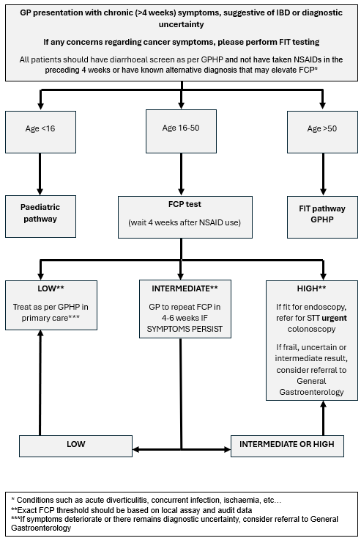

4.2 Paediatric
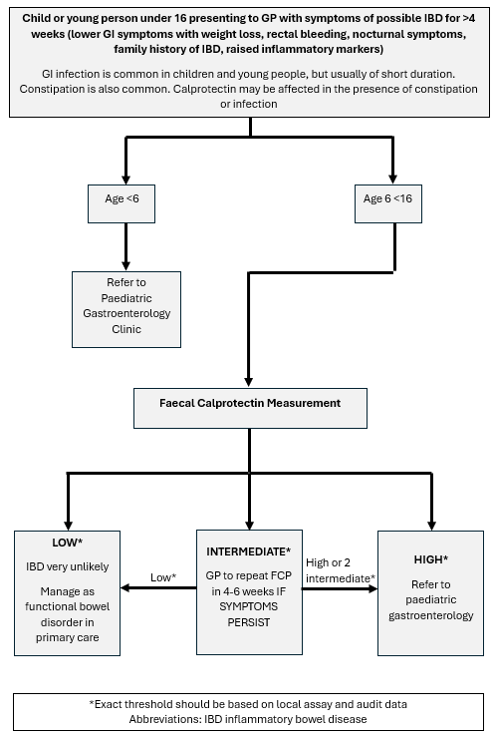

5.0 References Lamb CA, Kennedy NA, Raine T, et al. British Society of Gastroenterology consensus guidelines on the management of inflammatory bowel disease in adults. Gut. 2019;68(Suppl 3):s1-s106.
Health NIf, Excellence C. Faecal calprotectin diagnostic tests for inflammatory diseases of the bowel: NICE diagnostics guidance [DG11]. In:2013.
Orfei M, Gasparetto M, Hensel KO, Zellweger F, Heuschkel RB, Zilbauer M. Guidance on the interpretation of faecal calprotectin levels in children. PloS one. 2021;16(2):e0246091.
Mowat C, Digby J, Strachan JA, et al. Faecal haemoglobin and faecal calprotectin as indicators of bowel disease in patients presenting to primary care with bowel symptoms. Gut. 2016;65(9):1463-1469.
Elias SG, Kok L, de Wit NJ, et al. Is there an added value of faecal calprotectin and haemoglobin in the diagnostic work-up for primary care patients suspected of significant colorectal disease? A cross-sectional diagnostic study. BMC medicine. 2016;14(1):1-11.
Widlak M, Thomas C, Thomas M, et al. Diagnostic accuracy of faecal biomarkers in detecting colorectal cancer and adenoma in symptomatic patients. Alimentary pharmacology & therapeutics. 2017;45(2):354-363.
Högberg C, Karling P, Rutegård J, Lilja M. Diagnosing colorectal cancer and inflammatory bowel disease in primary care: The usefulness of tests for faecal haemoglobin, faecal calprotectin, anaemia and iron deficiency. A prospective study. Scand J Gastroenterol. 2017;52(1):69-75.
Tibble JA, Sigthorsson G, Foster R, et al. High prevalence of NSAID enteropathy as shown by a simple faecal test. Gut. 1999;45(3):362-366.
Pennazio M, Spada C, Eliakim R, et al. Small-bowel capsule endoscopy and device-assisted enteroscopy for diagnosis and treatment of small-bowel disorders: European Society of Gastrointestinal Endoscopy (ESGE) Clinical Guideline. Endoscopy. 2015;47(04):352-386.
Capone P, Rispo A, Imperatore N, Caporaso N, Tortora R. Fecal calprotectin in coeliac disease. World journal of gastroenterology: WJG. 2014;20(2):611.
Ahmad OF, Akbar A. Overview of microscopic colitis. British Journal of Hospital Medicine. 2020;81(10):1-7.
Turvill J, Turnock D, Holmes H, et al. Evaluation of the clinical and cost-effectiveness of the York faecal calprotectin care pathway. Frontline gastroenterology. 2018;9(4):285-294.
Lundgren D, Eklöf V, Palmqvist R, Hultdin J, Karling P. Proton pump inhibitor use is associated with elevated faecal calprotectin levels. A cross-sectional study on subjects referred for colonoscopy. Scand J Gastroenterol. 2019;54(2):152-157.
Poullis A, Foster R, Mendall MA. Proton pump inhibitors are associated with elevation of faecal calprotectin and may affect specificity. Eur J Gastroenterol Hepatol. 2003;15(5):573-574.
Brookes MJ, Whitehead S, Gaya DR, Hawthorne AB. Practical guidance on the use of faecal calprotectin. Frontline Gastroenterology. 2018;9(2):87-91.

