TERMS OF REFERENCE

Clinical Implementation Network: Bone Health

Clinical Implementation Network | Bone Health Clinical Implementation Network (CIN)
Chair | Bone Health Clinical Lead, Inder Singh
CIN Network Team Lead | Rebecca Williams, Network Support Manager
MSK Strategic Network Background | The Strategic Clinical Network for MSK Health (Strategic Network) will combine the resources within the NHS Executive with the multiprofessional community to provide strategic direction and support to drive quality improvement in services for MSK Health. The Strategic Network will focus on creating a clinical consensus on high value pathways and supporting implementation and evaluation within a quality improvement process.  As highlighted in Figure 1 below, the Bone Health CIN is one of four working groups within the Musculoskeletal Strategic Network.  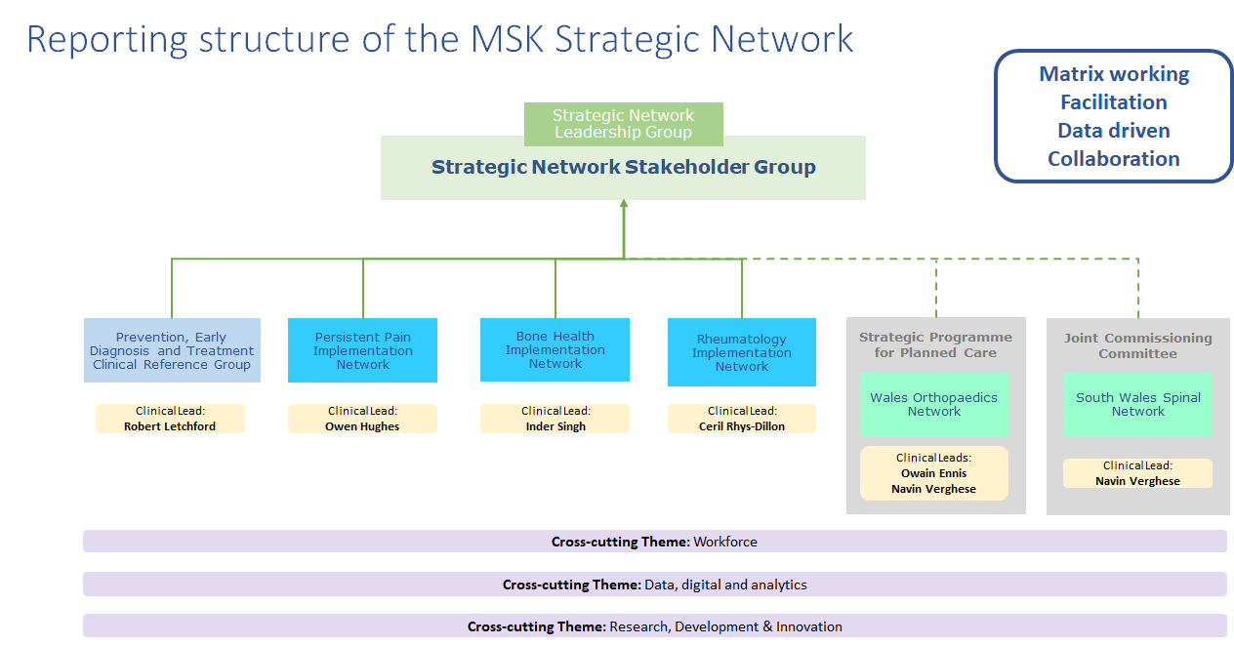Figure 1: Architecture of the working groups within the MSK Strategic Network  The Bone Health CIN will work alongside:  - the MSK Strategic Network (Strategic Network) Clinical Implementation Networks (Persistent Pain, Rheumatology) the Prevention, Early Diagnosis and Treatment Clinical Reference Group (CRG), and collaborative partners (South Wales Spinal Network and Welsh Orthopaedic Network),  - the Six Goals Transformation Programme,  - the Strategic Network cross-cutting themes, and  - other Strategic Networks and Directorates within the NHS Executive.  This matrix working is essential to ensure quality improvement of pathways of care for people with MSK conditions from a whole system perspective.
CIN Aims | The aims of the Bone Health CIN are:  - Enable achievement of the MSK Quality Statement and MSK Framework.  - Enable achievement of a workplan that is aligned to the Quality Statement for Osteoporosis and Bone Health.  - To define the relevant National Pathways and Service Specifications, for Bone Health in Wales.  - To be informed by evidence-based best practice.  - To be informed by real-time data provided by the services.  - To define and create data standards on an all-Wales basis.  - When defining the contribution to National Pathways and Service Specifications, to consider the impact of intended/recommended changes to NHS Wales services and ensure that these are captured as part of the recommendation (where appropriate), so that Health Boards and Commissioners of services are informed, and appropriate planning can take place.  - To provide a consensus view for Wales on matters relating to the Osteoporosis and Bone Health.  - To consider all aspects of services in a 3, 5 and 10-year setting.  - To act as the national experts in Osteoporosis and Bone Health.  - To respond to collaborative requests from the wider Strategic MSK Network and other Strategic Networks.  - To inform planning priorities for quality improvement, from the perspective of Osteoporosis and Bone Health services and elements of management that can and should be addressed by other generalist or specialist services.  - To provide specialist advice to the Strategic Network Clinical Leadership Group.  - To provide a consistent national approach.  - To support care providers (including independent contractors) Health Boards, NHS Trusts, and Special Health Authorities in the transformation of strategy to reality.
CIN scope | The key principles of the CIN scope have been considered to ensure an optimum approach. These are to provide:  - National pathway(s) that are evidence-based, best working practice solutions, so that the Welsh NHS clinical service(s) can deliver against demand in the most effective and appropriate manner.  - Solution(s) that deliver safe and effective clinical outcomes for service users.  - Solution(s) that facilitate increased recruitment and retention of skilled workforce that result in appropriate skill mix at local sites.  - Solution(s) that offer value for money.  - Solution(s) that utilise the most effective technology and/or digital offerings.  - Solution(s) that deliver appropriate training and development of staff.  - Solution(s) capable of answering research, development, and innovation needs.
Key objectives and deliverables | - To define and agree an annual workplan, which will include objectives that answer the above Aims and Scope.  - Develop consistent and relevant data sources, review of relevant evidence-bases and identification of relevant pathways.  - To deliver a list of priority national optimal pathways that shall be considered by the CIN over a 3-, 5- and 10-year period.
Membership | It is anticipated that the following membership will be involved in the Bone Health CIN:  - Osteoporosis Clinical Lead from each Health Board (x7)  - AHP Lead (x1)  - Paediatric Clinical Lead (x1)  - Six Goals Transformation Programme Representative (x1)  - Clinical Nurse Specialist (x1)  - Pharmacy Representative (x1)  - HEIW Representative (x1)  - A professional lived experience group member (x1)  - Royal Osteoporosis Society Representative (x1)  Each member must be able to speak on behalf of the group they are representing and have mechanisms for communicating with the wider stakeholders that sit within their organisation.  Attendance shall be monitored and any member failing to attend consecutively three time in a row, shall be removed from the list of members.
Key responsibilities of members | - Attend and constructively contribute to each meeting.  - Develop, agree, and work toward achieving the CIN priorities.  - Ensure that communication and engagement with their respective organisation/professional group is carried out effectively.
Decision Making | - The Chair must ensure that CIN group decisions and recommendations are taken in an open, balanced, objective, and unbiased manner.  - In turn, individual members must demonstrate, through their actions, that their contribution to the decision-making is based upon the best interests of the NHS in Wales.  - Decisions will be made with the attendees that are present at the meeting, therefore each member must put forward a deputy or must communicate with Chair in advance of meeting.
Reporting and Governance | - The CIN will be accountable to the MSK Strategic Network Clinical Leadership Group, which in turn is accountable to the National Clinical Framework (NCF) Implementation Board (Board).  - As such, the Chair of the CIN (or nominated deputy) shall attend and formally report to the Strategic Clinical Leadership Group on the activities and progress of the CIN. This includes updates on activity, risks, and issues (against the agreed workplan), the submission of action logs and written reports, as requested.  - The Chair shall bring any significant matters under consideration by the Strategic Clinical Leadership Group to attention of the CIN.  - The CIN may be requested by the Strategic Clinical Leadership Group to carry out a specific piece of work of strategic relevance.  - The CIN has responsibility to make evidence-based decisions on national optimal pathways and service specifications for the national MSK Services. However, prior to action, these recommendations are to be supported by the Strategic Clinical Leadership Group and then ratified by the NCF Implementation Board via regular updates or exception reports (TBD).  - Clinical responsibility and delivery reside, as always, with the patient facing statutory organisations of NHS Wales.
Meeting dates | Meetings will initially be held bimonthly to establish CIN work program, after which meetings will be held at larger intervals to support the MSK Business Calendar and clinical commitments. Meetings will include an agenda and action log, circulated one week in advance.
Quorum | - Decisions will not be deferred and will be made with the attendees that are present at the meeting.
Review | - This ToR shall be reviewed by the CIN, one year following approval of this version.

English | Welsh Translation
Reporting Structure of the Musculoskeletal Strategic Network
Strategic Network Leadership Group
Strategic Network Stakeholder Group
Matrix working
Facilitation
Data driven
Collaboration
Prevention, Early Diagnosis and Treatment Clinical Reference Group
Persistent Pain Implementation Network
Bone Health Implementation Network
Rheumatology Implementation Network
Clinical Lead / Clinical Leads
Strategic Programme for Planned Care
Joint Commissioning Committee
Wales Orthopaedic Network
South Wales Spinal Network
Cross cutting theme
Workforce
Data, digital and analytics
Research, development and innovation

