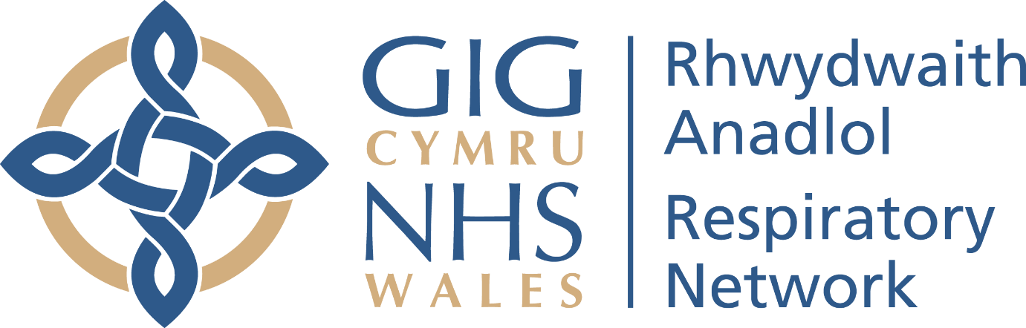

Celebrating Successful Collaboration in NHS Wales
Respiratory Matters Webinar | 24 March 2026
Time stamp | Subject and key discussion points | Speaker
00:00 | Welcome and purpose of the session  - Why collaboration matters for delivering sustainable respiratory services  - How the Respiratory Network is working across clinical, digital, transformation and industry partners | Joanne Oliver – Respiratory & Diabetes Network Manager
04:20 | Clinical leadership and collaboration in action  - The value of partnership working in a constrained NHS system  - How collaboration has accelerated progress on the Community Breathlessness Pathway  - Learning from non-promotional industry partnerships and shared expertise | Anthony Gibson – Clinical Lead, Respiratory Network
 | Interview segments that follow: | Andrea Pace – Assistant Manager, Respiratory Network
11:08 | Defining success: the Breathlessness Pathway evaluation framework  - What the evaluation framework is and why it matters  - Balancing process measures with outcomes that matter to patients  - The role of PROMs and PREMs in supporting value-based, person-centred care | Arthur Duncan-Jones – Health Intelligence Manager, Value Transformation
18:00 | Turning data into insight: the Respiratory Digital Baseline Dashboard  - How the national respiratory dashboard was developed  - Using a “less is more” approach to make data meaningful and usable  - Supporting clinical teams, service planning and national conversations | Arthur Duncan-Jones
21:42 | Co-producing the Community Breathlessness Pathway with industry  - What has enabled successful NHS–industry collaboration  - The importance of strong clinical leadership, trust and shared vision  - Why face-to-face engagement and co-production have been critical | Louise Goswell – Pathway Manager, AstraZeneca UK
35:28 | PROMs and PREMs in practice  - What PROMs and PREMs are and how they support clinical practice  - Using PROMs at individual, pathway and population levels  - Practical advice for teams looking to start or scale PROMs use | Sarah Puntoni – Senior Programme Lead, Value Transformation
43:25 | Reflections, learning and audience Q&A  - Key lessons from collaboration across Wales  - Challenges, enablers and next steps for spread and scale | All speakers
47:55 | Closing remarks | Joanne Oliver

