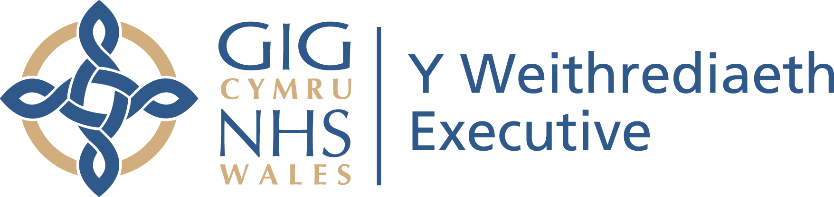
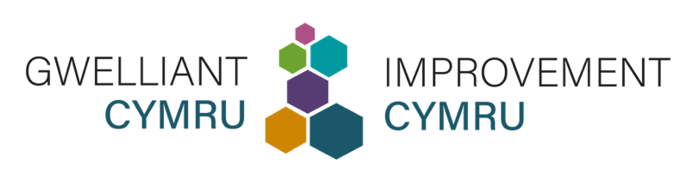

Stori newyddion ar y fewnrwyd  ar gyfer Gwasanaethau, Ymddiriedolaethau, a Byrddau Iechyd Lleol y GIG | Intranet news story  for NHS Services, Trusts, and Local Health Boards

Cymraeg | English
Gwasanaethau'r GIG yn cael eu hannog i ofyn i'r gymuned anabledd dysgu am Broffiliau Iechyd  Mae staff gofal iechyd sy'n darparu gwasanaethau gofal i bobl sydd ag anabledd dysgu yn cael eu hannog i ofyn am eu Proffil Iechyd, sef dogfen sy'n helpu i oresgyn rhwystrau cyfathrebu.  Mae pobl sydd ag anabledd dysgu yn fwy tebygol o brofi problemau iechyd y gellir eu hosgoi, oedi o ran triniaeth, a marwolaethau cynamserol a/neu y gellir eu hosgoi. Nod y Proffil Iechyd yw grymuso'r gymuned i rannu gwybodaeth bwysig am ei hiechyd yn hawdd.  Mae Lloyd Martin, yr unigolyn ieuengaf sydd ag anabledd dysgu i gwblhau marathon llawn, yn gwerthfawrogi ei Broffil Iechyd gymaint â'i Record Byd Guinness oherwydd ei fod yn helpu gwasanaethau gofal i ddiwallu ei anghenion trwy wneud addasiadau rhesymol.  Mae’r dyn 20 oed, a gydiodd yng nghalonnau yn Efrog Newydd wrth iddo ddawnsio’i ffordd drwy’r pellter 26.2 milltir yn ei farathon diweddaraf, yn defnyddio ei Broffil Iechyd i oresgyn y math o anghydraddoldebau iechyd y mae llawer o’i gymheiriaid yn eu hwynebu.  Dywedodd Lloyd: “Mae Proffil Iechyd yn fy helpu i rannu gwybodaeth bwysig amdanaf i ac am fy iechyd. Mae'n cynnwys gwybodaeth fel fy hanes meddygol, sut rwy'n cyfathrebu, fy alergeddau, fy meddyginiaeth, a'r cymorth sydd ei angen arnaf. Mae'r staff yn gwybod yn union sut i fy helpu pan fyddaf yn mynd i apwyntiadau. Mae yr un mor bwysig â fy nhystysgrif record y byd.”  Gellir rhoi'r Proffil Iechyd i staff gofal iechyd, fel meddygon a nyrsys, i'w helpu i roi'r gofal cywir sy'n canolbwyntio ar y claf ar yr adeg gywir.  Dywedodd Beth Williams, Nyrs Gofrestredig Anabledd Dysgu a Rheolwr Gwella yn Gwelliant Cymru: “Mae’r Proffil Iechyd wedi’i gyd-gynhyrchu gyda phobl sydd wedi cael profiad bywyd i fynd i’r afael â’r anghydraddoldebau y maent yn dod ar eu traws mewn modd annheg.”  “Rydym yn gwybod bod pobl sydd ag anabledd dysgu yn wynebu her anghymesur i gael mynediad at y gofal sydd ei angen arnynt. Mae gan bawb sy’n darparu gofal iddynt gyfrifoldeb i gymryd camau gweithredol i fynd i’r afael â hyn, ac mae’r broses yn dechrau trwy ofyn am Broffil Iechyd cyn gynted â phosibl.”  Dylai staff sy’n darparu gwasanaethau gofal wneud y canlynol:  - Gofyn am Broffil Iechyd pan fydd yn cwrdd â pherson sydd ag anabledd dysgu am y tro cyntaf.  - Bod yn glir gyda chydweithwyr trwy roi gwybod iddynt pan fydd Proffil Iechyd ar gael.  - Gwirio a yw'r wybodaeth yn gyfredol trwy ofyn i'r unigolyn neu'r unigolyn y mae'n gweithio gydag ef.  - Lawrlwytho’r templed Proffil Iechyd a helpu i'w gwblhau os nad oes gan unigolyn un yn barod.  “Yn anffodus, mae ein hymchwil wedi darganfod bod pobl sydd ag anabledd dysgu yn marw tua 20 mlynedd ynghynt na’u cyfoedion yn y boblogaeth gyffredinol,” ychwanegodd Beth.  “Un o’r ffactorau sy’n cyfrannu at hyn yw pan fo pobl sydd ag anableddau dysgu yn ymweld ag ysbyty neu amgylchedd meddygol, maent yn fwy tebygol o gael anhawster i fynegi eu hunain a chael mynediad at y gofal sydd ei angen arnynt.  “Mae'r Proffil Iechyd yn ei gwneud hi'n haws i bobl sydd ag anabledd dysgu gyfathrebu eu hanghenion. Mae hyn yn gwella canlyniadau cleifion, profiadau staff, ac yn arbed adnoddau gwerthfawr i'r system.  “Rydym wir eisiau annog staff gofal iechyd i fod yn rhagweithiol ac i ofyn i bobl sydd ag anabledd dysgu am eu Proffil Iechyd. Gall wneud gwahaniaeth anhygoel i brofiad rhywun o ofal ac yn y pen draw ei fywyd.”  Mae amrywiaeth o adnoddau ar-lein ar gyfer gweithwyr gofal iechyd proffesiynol ar gael ar wefan Gwelliant Cymru, gan gynnwys templedi Proffil Iechyd, Nodiadau Cyfarwyddyd, a mwy.  Ewch i: www.improvementcymru.net/proffil-iechyd | NHS services urged to ask learning disability community for Health Profiles  Healthcare staff who provide care services to people with a learning disability are being urged to ask for their Health Profile, a document helping to overcome communication barriers.  People with a learning disability are more likely to experience avoidable health problems, delayed treatment, and premature and/or avoidable deaths. The Health Profile aims to empower the community to easily share important information about their health.  Lloyd Martin, the youngest person with a learning disability to complete a full marathon, values his Health Profile as much as his Guinness World Record because it helps care services to meet his needs by making reasonable adjustments.  The 20-year-old, who captured hearts in New York as he danced his way through the 26.2 mile distance in his most recent marathon, uses his Health Profile to overcome the type of health inequalities faced by many of his peers.  Lloyd said: “A Health Profile helps me to share important information about me and my health. It includes information like my medical history, how I communicate, my allergies, my medication, and the support I need. The staff know exactly how to help me when I go to appointments. It’s just as important as my world record certificate.”  The Health Profile can be given to healthcare staff, such as doctors and nurses, to help them give the right patient-centred care at the right time.  Beth Williams, a Registered Learning Disability Nurse and Improvement Manager at Improvement Cymru, said: “The Health Profile has been co-produced with people who have lived experience to tackle the inequalities they unfairly encounter.”  “We know that people with a learning disability face a disproportionate challenge to access the care they need. Everyone who provides care to them has a responsibility to take active steps to address this, and it starts by asking for a Health Profile at the earliest opportunity.”  Staff who provide care services should:  - Ask for a Health Profile when you first meet a person with a learning disability.  - Be clear with colleagues by letting them know when a Health Profile is available.  - Check information is up to date by asking the individual or the person they are with.  - Download the Health Profile template and help to complete it if an individual doesn’t already have one.  “Sadly, our research has found that people with a learning disability die roughly 20 years earlier than their peers in the general population,” added Beth.  “One of the contributing factors towards this is because when people with learning disabilities visit a hospital or medical environment, they are more likely to experience difficulty in expressing themselves and accessing the care that they need.  “The Health Profile makes it easier for people with a learning disability to communicate their needs. This improves patient outcomes, staff experiences, and saves valuable resources for the system.  “We really want to encourage healthcare staff to be proactive and to ask people with a learning disability for their Health Profile. It can make an incredible difference to someone’s experience of care and ultimately their life.”  A range of online resources for healthcare professionals are available on the Improvement Cymru website, including Health Profile templates, Guidance Notes, and more.  Please visit: www.improvementcymru.net/health-profile.

