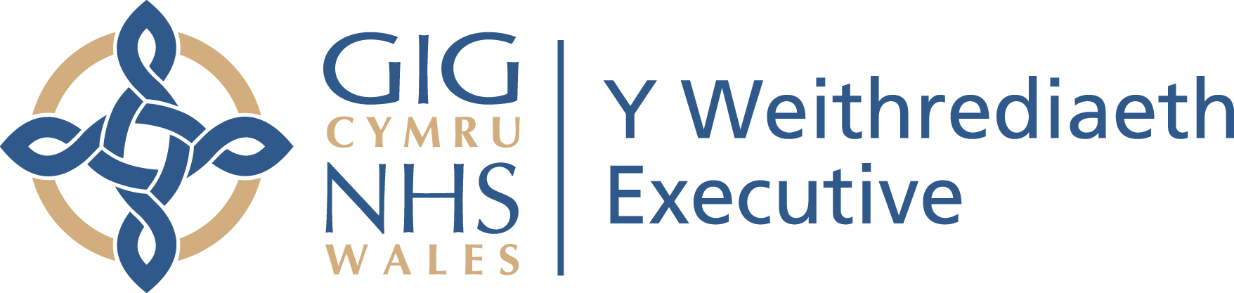
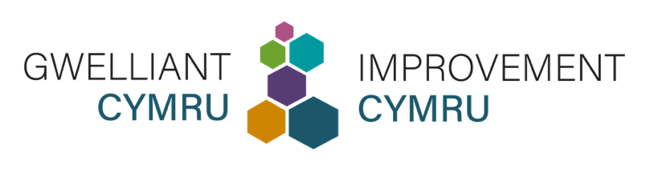

Cynnwys tudalen y fewnrwyd  ar gyfer Gwasanaethau, Ymddiriedolaethau, a Byrddau Iechyd Lleol y GIG | Intranet page content  for NHS Services, Trusts, and Local Health Boards

Cymraeg | English
Y Proffil Iechyd ar gyfer pobl sydd ag anabledd dysgu  Rydym wedi llunio’r dudalen hon i roi'r wybodaeth sydd ei hangen arnoch pan fyddwch yn darparu gofal i unigolyn sydd ag anabledd dysgu ac er mwyn i chi gael rhagor o wybodaeth am rôl Proffil Iechyd.  Pwrpas y Proffil Iechyd  Mae'r Proffil Iechyd wedi'i ddatblygu i roi'r wybodaeth allweddol sydd ei hangen arnoch i ddarparu gofal iechyd diogel sy'n canolbwyntio ar yr unigolyn i bobl sydd ag anabledd dysgu.  Mae Proffil Iechyd yn arf cyfathrebu pwysig i bobl sydd ag anabledd dysgu. Gall gynnwys gwybodaeth am sut maent yn cyfathrebu, eu meddyginiaeth ac alergeddau, a'r addasiadau rhesymol y gall fod eu hangen arnynt.  Bydd bod yn ymwybodol o'r wybodaeth hon yn eich helpu i wneud addasiadau rhesymol i ddarparu gofal sy'n diwallu anghenion unigolyn sydd ag anabledd dysgu.  Mae’r wybodaeth wedi cael ei chyd-gynhyrchu gyda phobl sydd â phrofiad bywyd, gan gynnwys defnyddwyr gwasanaeth, eu teuluoedd, gofalwyr a staff cymorth, a gweithwyr proffesiynol sy'n gweithio ym maes iechyd a gofal cymdeithasol.  Yr hyn y dylech chi ei wneud:  Dylai staff sy’n darparu gwasanaethau gofal wneud y canlynol:  - Gofyn am Broffil Iechyd pan fydd yn cwrdd â pherson sydd ag anabledd dysgu am y tro cyntaf.  - Bod yn glir gyda chydweithwyr trwy roi gwybod iddynt pan fydd Proffil Iechyd ar gael.  - Gwirio a yw'r wybodaeth yn gyfredol trwy ofyn i'r unigolyn neu'r unigolyn y mae'n gweithio gydag ef.  - Lawrlwytho’r templed Proffil Iechyd a helpu i'w gwblhau os nad oes gan unigolyn un yn barod.  Dogfennau a gwybodaeth ddefnyddiol  Tudalen we: www.improvementcymru.net/proffil-iechyd  Lawrlwythwch y templed - Proffil Iechyd ar gyfer Oedolion  Lawrlwythwch y templed - Proffil Iechyd ar gyfer Plant a Phobl Ifanc  Canllawiau i Weithwyr Iechyd Proffesiynol  Gwerthusiad o ddefnyddioldeb y Proffil Iechyd  Oes gennych chi gwestiynau?  Gellir cysylltu â rhaglen Anabledd Dysgu Gwelliant Cymru yn: improvementcymru_ld@wales.nhs.uk  Cysylltwch ag arweinydd Anabledd Dysgu [insert name of NHS organisation] yn: [insert email address]  Cysylltwch â Thîm Cydraddoldeb [insert name of NHS organisation] yn: [insert email address] | The Health Profile for people with a learning disability  We’ve put this page together to give you the information you need when you provide care to a person with a learning disability and for you to know more about the role of a Health Profile.  The purpose of the Health Profile  The Health Profile has been developed to provide you with the key information you need to provide safe and person-centred healthcare for people with a learning disability.  A Health Profile is an important communication tool for people with a learning disability. It can include information about how they communicate, their medication and allergies, and the reasonable adjustments they may need.  Being aware of this information will help you to make reasonable adjustments to provide care that meets the needs of a person with a learning disability.  It has been co-produced with people with lived experience, including service users, their families, carers and support staff, and professionals working in health and social care.  What you should do  Staff who provide care services should:  - Ask for a Health Profile when you first meet a person with a learning disability.  - Be clear with colleagues by letting them know when a Health Profile is available.  - Check information is up to date by asking the individual or the person they are with.  - Download the Health Profile template and help to complete it if an individual doesn’t already have one.  Helpful documents and information  Webpage: www.improvementcymru.net/health-profile  Download the template - Health Profile for Adults  Download the template - Health Profile for Children and Young People  Guidance Notes for Health Professionals  Evaluation of the useability of the Health Profile  Any questions?  Improvement Cymru’s Learning Disability programme can be contacted at: improvementcymru_ld@wales.nhs.uk  Contact [insert name of NHS organisation]’s Learning Disability lead at: [insert email address]  Contact [insert name of NHS organisation]’s Equalities Team at: [insert email address]

