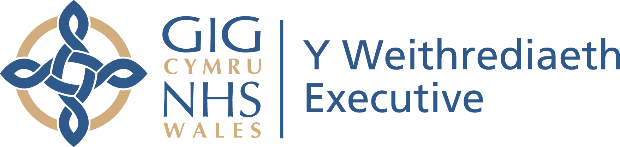
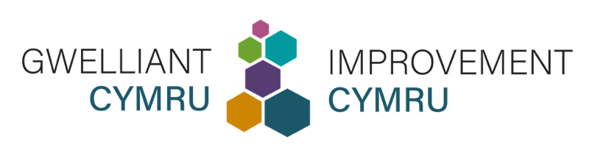

Negeseuon cyfryngau cymdeithasol  ar gyfer Gwasanaethau, Ymddiriedolaethau, a Byrddau Iechyd Lleol y GIG | Social media posts  for NHS Services, Trusts, and Local Health Boards

Cymraeg | English
Os oes gennych chi #AnableddDysgu, rhowch eich Proffil Iechyd i'n staff pan fyddwch chi'n defnyddio ein gwasanaethau.  Mae'r wybodaeth yn eich Proffil Iechyd yn ein helpu i ddiwallu'ch anghenion a gwneud addasiadau rhesymol i chi.  📲 Lawrlwythwch Proffil Iechyd: www.improvementcymru.net/proffil-iechyd | If you have a #LearningDisability, please hand your Health Profile to our staff when you use our services.  The information in your Health Profile helps us to meet your needs and make reasonable adjustments for you.  📲 Download a Health Profile: www.improvementcymru.net/health-profile
#AWyddochChi bod y Proffil Iechyd yn ei gwneud hi'n haws i bobl sydd ag #AnableddDdysgu gyfathrebu?  Gall ein staff gofal iechyd ddefnyddio'r wybodaeth bwysig hon i roi'r gofal cywir sy'n canolbwyntio ar y claf ar yr adeg gywir.  🔗 Lawrlwythwch Proffil Iechyd: www.improvementcymru.net/proffil-iechyd | #DidYouKnow the Health Profile makes it easier for people with a #LearningDisability to communicate?  Our healthcare staff can use this important information to give the right patient-centred care at the right time.  🔗 Download a Health Profile: www.improvementcymru.net/health-profile
Gwyddom y gall pobl sydd ag #AnableddDdysgu wynebu anawsterau pan fyddant yn defnyddio rhai o’n gwasanaethau.  Pan fyddwch chi'n dod â'ch Proffil Iechyd, mae'n helpu i oresgyn y rhwystrau hyn a gwella'ch profiad.  📩 Lawrlwythwch Proffil Iechyd: www.improvementcymru.net/proffil-iechyd | We know people with a #LearningDisability can face difficulties when they use some of our services.  When you bring your Health Profile, it helps to overcome these barriers and improve your experience.  📩 Download a Health Profile: www.improvementcymru.net/health-profile
Sut gall y Proffil Iechyd helpu pobl sydd ag #AnableddDysgu?  💬 Dywedwch wrthym am eich anghenion  🤝 Helpwch ein staff i wneud addasiadau rhesymol i chi  💙 Derbyniwch ofal sy’n canolbwyntio ar y claf ar yr adeg gywir  Lawrlwythwch Proffil Iechyd: www.improvementcymru.net/proffil-iechyd | How can the Health Profile help people with a #LearningDisability?  💬 Tell us about your needs  🤝 Help our staff make reasonable adjustments for you  💙 Receive patient-centred care at the right time  Download a Health Profile: www.improvementcymru.net/health-profile

