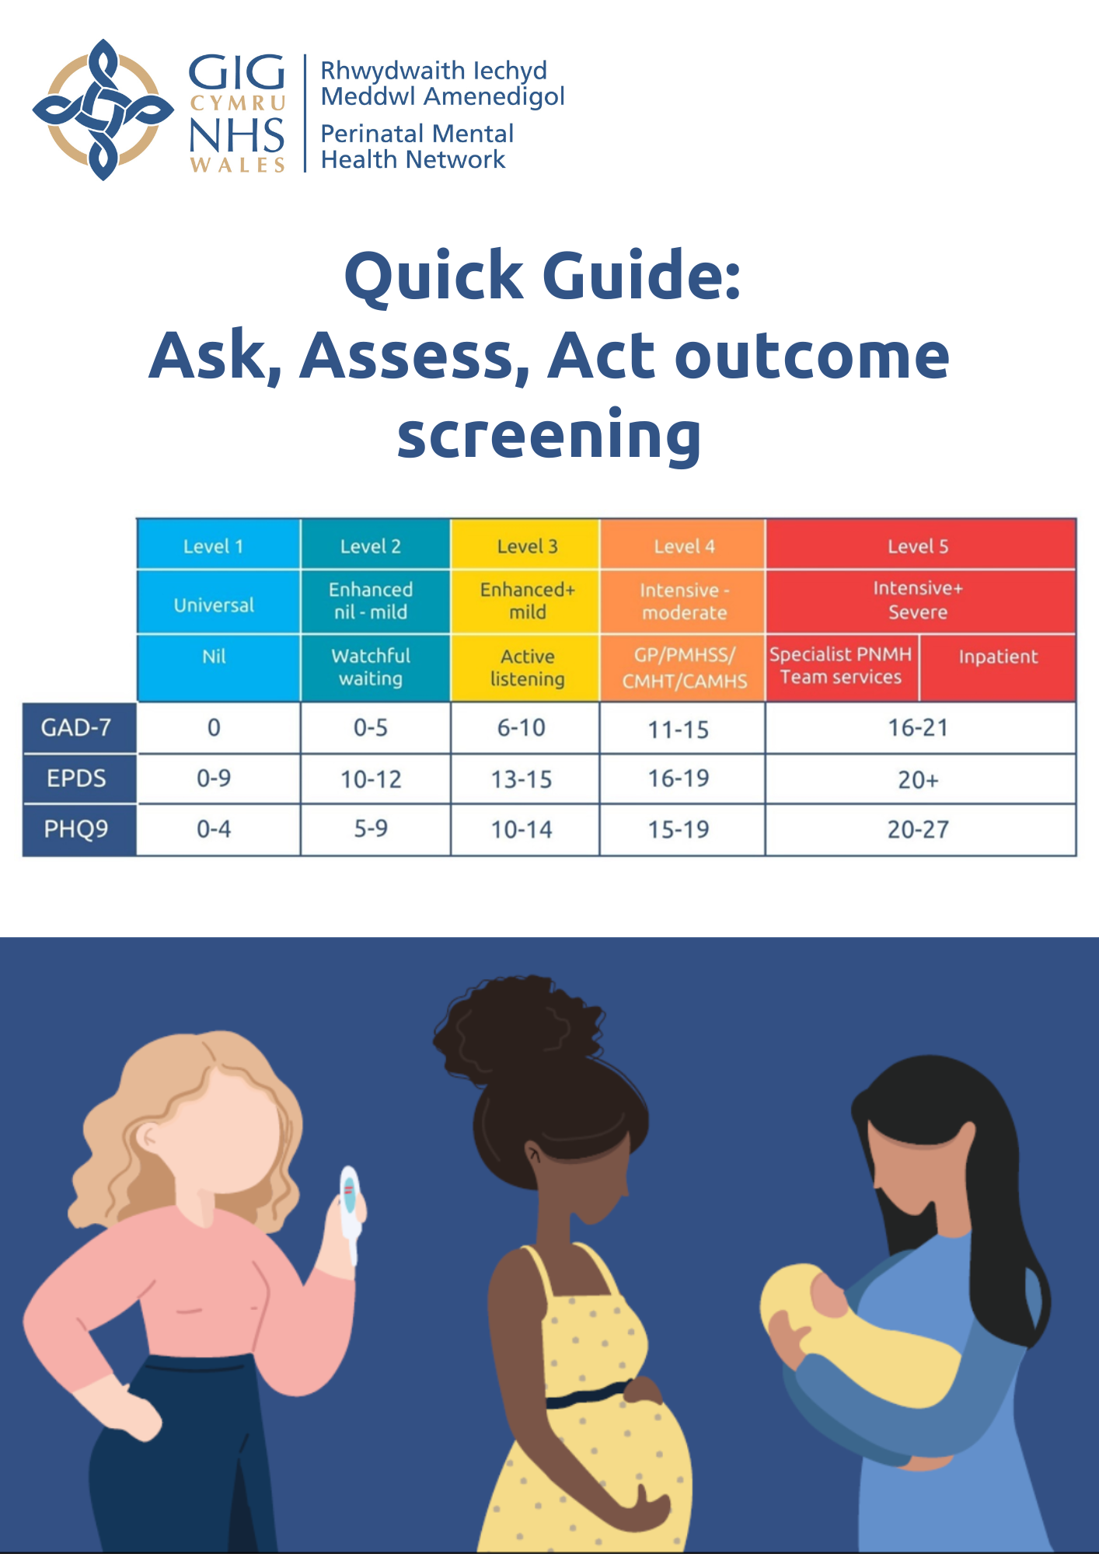

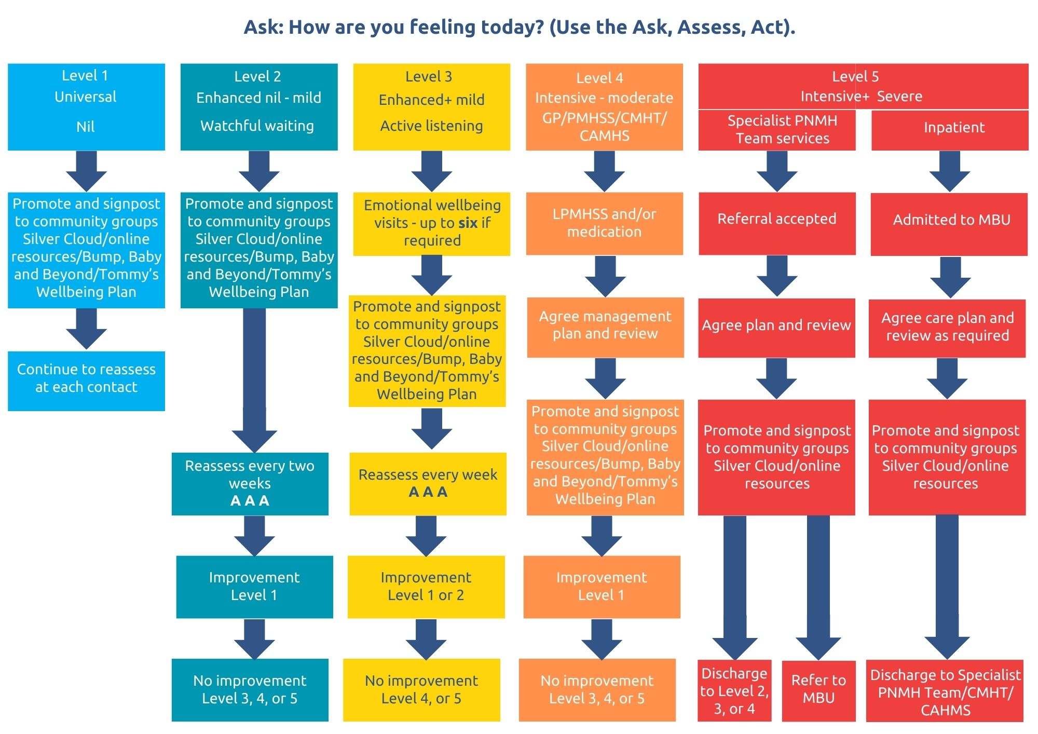
Local info - 1 | Local info - 2 | Local info - 3 | Local info - 4 | Local info - 5
 |  |  |  | SPNMH Team | Inpatient

Note: This is not intended to be an exhaustive list, please refer to Pathway 10 or your individual health board for area specific support.

