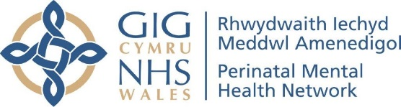
10.00 am | Welcome and Introductions  Sharon Fernandez - National Clinical Lead for Perinatal
10.05 am | Creative Health: A Complementary Approach  Hannah Sercombe, Occupational Therapist, working in and with the creative sector to address people's health and care needs in innovative ways. Creative Health’ refers to creative approaches and activities which have benefits for our health and wellbeing.
10.35 am | Mind’s Mums Matter  Julian John & Julia James will be presenting on Mums Matter which is an early intervention service run by Mind. It is an eight-week course designed for mums who are experiencing mental health challenges in the perinatal period. The course was designed by and for women with lived experiences of perinatal mental health needs.
11.05 am | Lullaby Project Cymru – Music as a Creative Intervention in Acute Settings  Jay Mendivil, Lullaby Project Manager of Live Music Now Cymru will be joined by Professional Violinist Haz Smith and two Lullaby Participants/ Voluntary Champions.
11.35 am | Birth Cafe - a transformational approach to birth story-telling  Dr Tracy Breathnach PhD, will share information about a project she ran with People Speak Up called 'Birth Cafe' which was based on her PhD research. Birth Cafe supports mothers to find new ways of telling their birth stories to increase healing and support post-traumatic growth.
12.05 pm | LUNCH
12.45 pm | Shine/Disgleirio  Karin Diamond, Artistic Director of Re-Live, an Arts in Health charity based in Wales, will share information about Shine/Disgleiro, a new online project for perinatal mothers to support mental health and well-being through Arts in Health practice.
1.15 pm | Tea and Toast: Poetry for new mums  Anna Wolf, Director of London Arts and Health, has lived experience of birth trauma and has worked with UCH maternuity (2018) Tea and Toast : Poems for New Mums, Maternal Journal (2021) and the The Mum Poem Press (2021) Songs of Love and Strength exploring this topic. At London Arts and Health, Anna has driven content and ideas around cultural social prescribing, practitioner care and networking with key stakeholders in creative health across London.
1.45 pm | The Writing Tree Project  Sarah Douglas and Gwyn Lewis will share with us their project aimed at improving nature connection and wellbeing for couples and their baby through mindful time spent in a forest (also known as forest bathing) and creative writing.
2.15 pm | Piloting a collaborative project, providing creative sessions for new parents and their babies  Deborah Aguirre Jones - visual artist and co-ordinator; Bronwen Wilson - dance and movement artist;  These weekly creative sessions provide a relaxing environment for parents with an option to bring their babies or come alone. Professional artists together with a peer mentor/support worker and assistant psychologist run accessible, optional creative activities such as movement, music, drawing and clay.
2.45 pm | Questions and Answers
3.00 pm | Close

