NATIONAL PRIMARY CARE FIT PATHWAYS
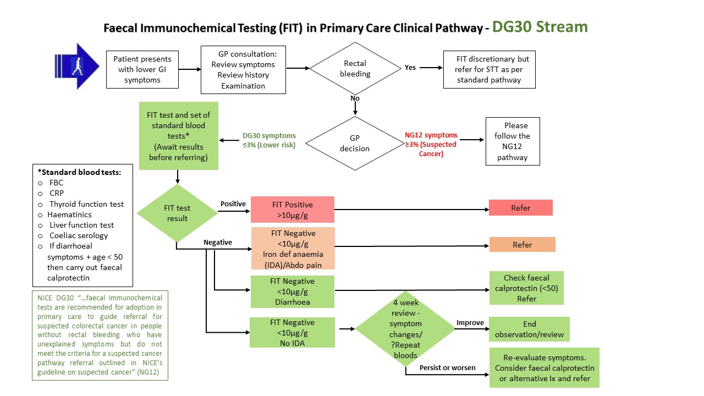
STT = Straight to test
Ix = Investigations

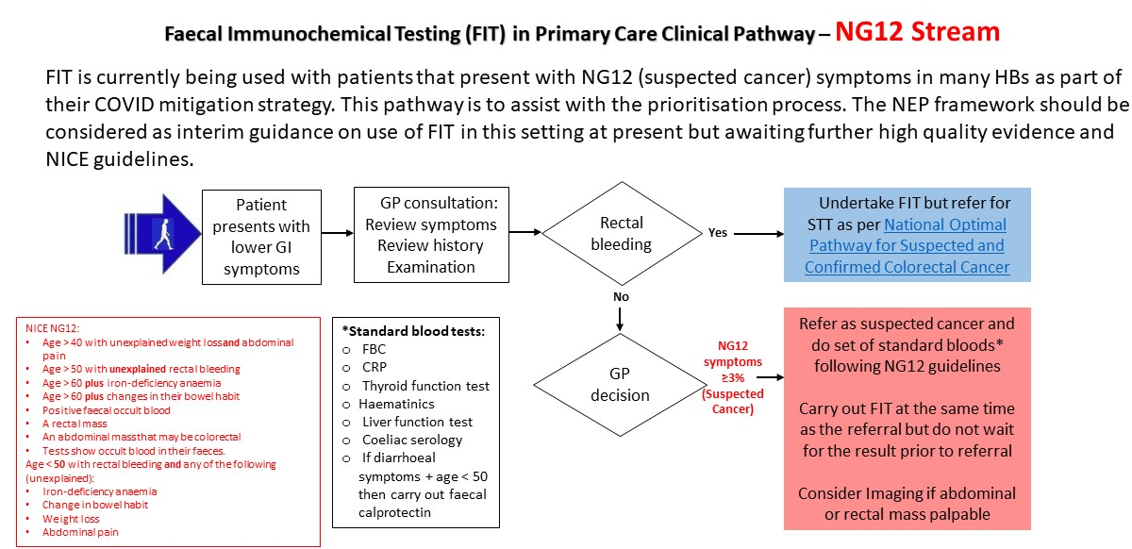
STT = Straight to test

NATIONAL SECONDARY CARE FIT PATHWAYS

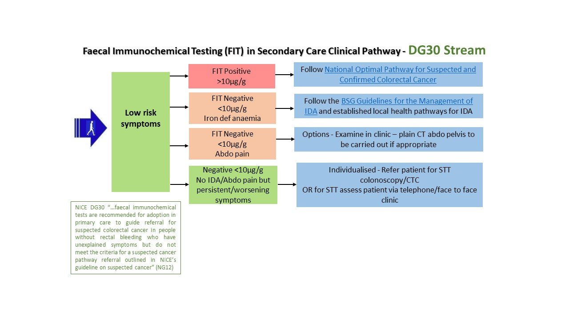
STT = Straight to test

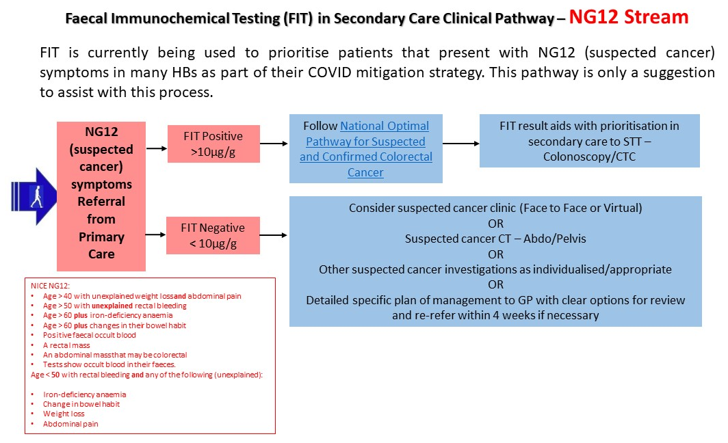

STT = Straight to test

THE VAGUE OR UNDEFINED/NON-SPECIFIC SYMPTOM GROUP AND USE OF FIT
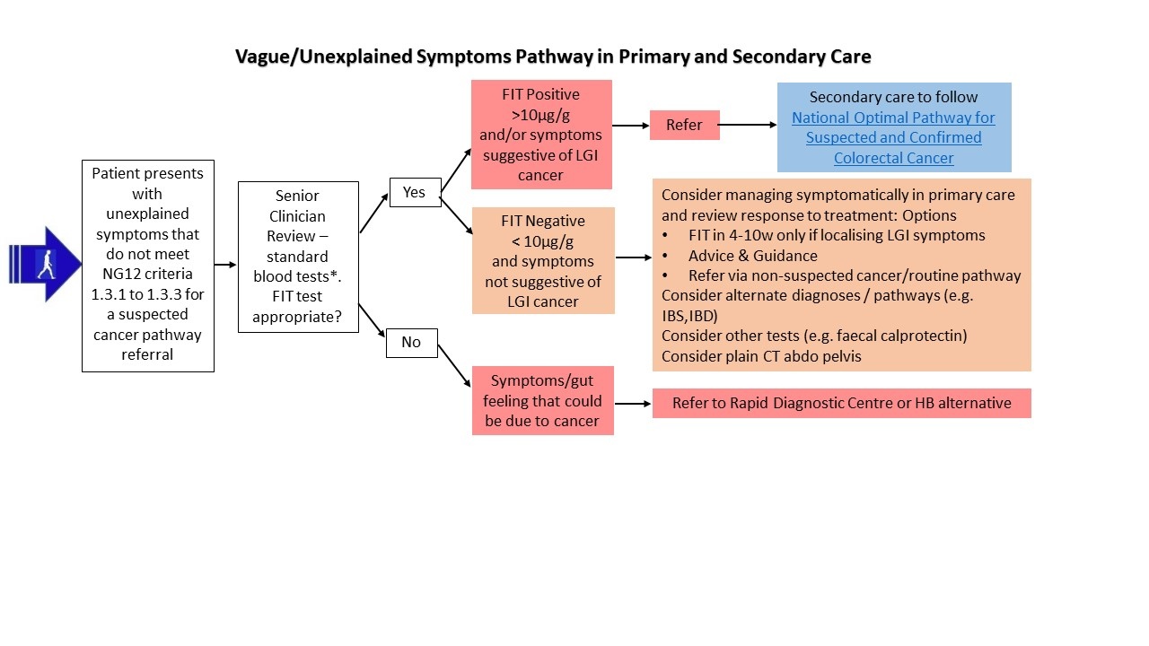
Vague/Non-Specific Symptoms Pathway in Primary and Secondary Care

