NATIONAL PRIMARY CARE FIT PATHWAYS
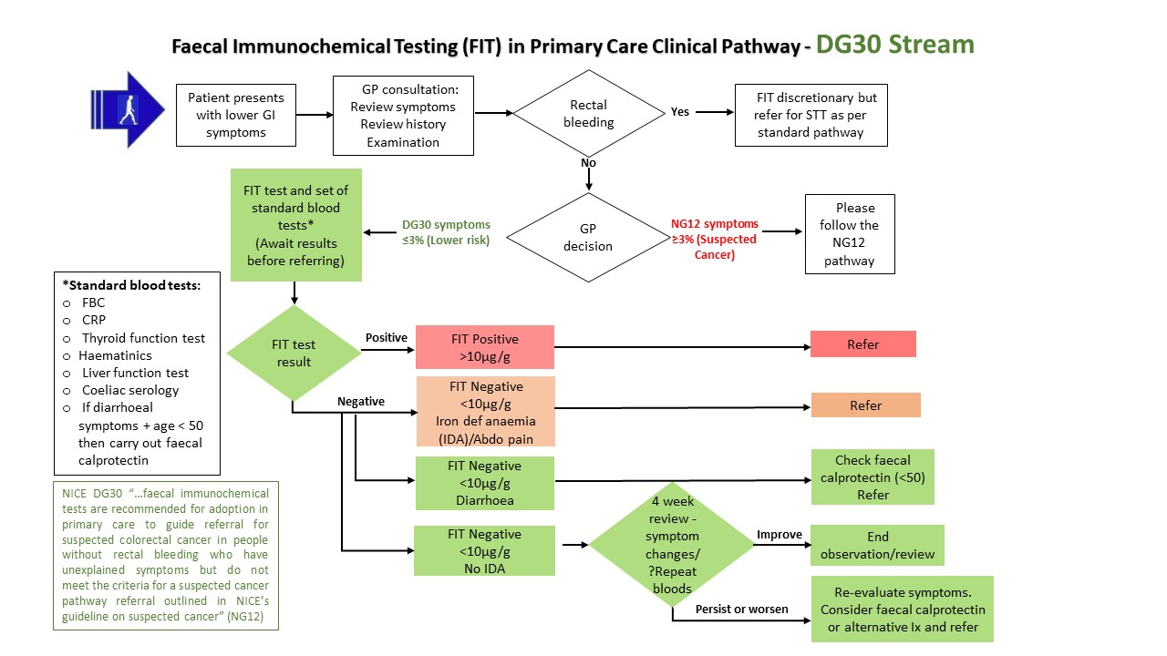
STT = Straight to test
Ix = Investigations

*Standard blood tests:
- FBC
- CRP
- U&Es
- Thyroid function test
- Liver function test
- Coeliac serology
- If diarrhoeal symptoms then carry out faecal calprotectin

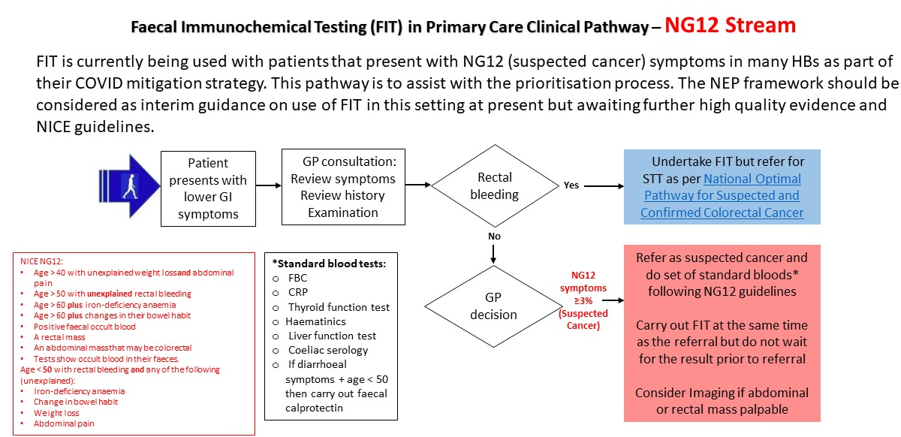
*Standard blood tests:
- FBC
- CRP
- U&Es
- Thyroid function test
- Liver function test
- Coeliac serology
- If diarrhoeal symptoms then carry out faecal calprotectin
STT = Straight to test

NATIONAL SECONDARY CARE FIT PATHWAYS
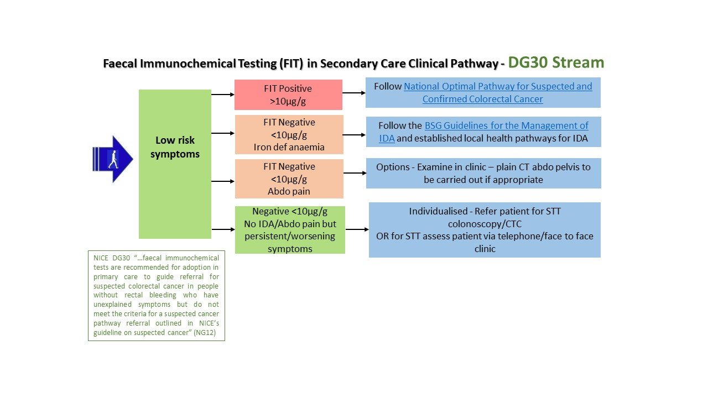
STT = Straight to test

Individualised - Refer patient for STT colonoscopy/CTC
OR if inappropriate for STT assess patient via telephone/face to face

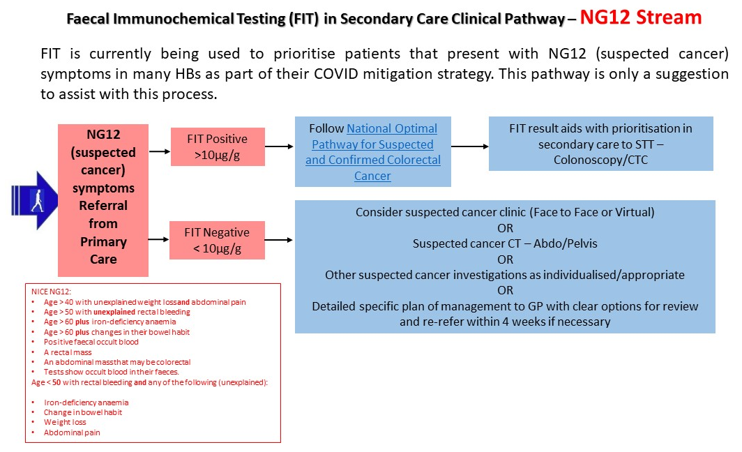

STT = Straight to test

THE VAGUE OR UNDEFINED/NON-SPECIFIC SYMPTOM GROUP AND USE OF FIT
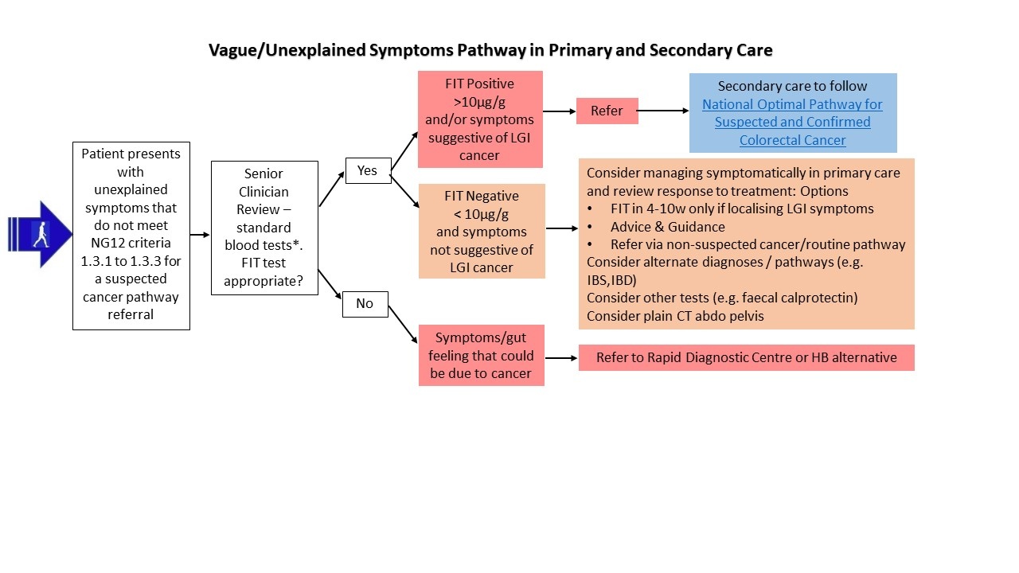
Vague/Non-Specific Symptoms Pathway in Primary and Secondary Care
*Standard blood tests:
- FBC
- CRP
- U&Es
- Thyroid function test
- Liver function test
- Coeliac serology
- If diarrhoeal symptoms then carry out faecal calprotectin

