Appendix 1: Primary Care Information


Faecal Immunochemical Test (FIT): Information for Primary Care
This document contains guidance for the implementation of the Faecal Immunochemical Test (FIT) in primary care.
What is FIT?
FIT is a type of faecal immunochemical blood test used to detect traces of blood in stool samples. The test uses antibodies that specifically recognise human haemoglobin and therefore it is a more sensitive and specific test than the guaiac based FOB test. It also measures the faecal Hb concentration (f-Hb) as microgram of Hb per gram (μg/g) of faeces.
NICE Guidance DG30 (July 2017) states: “Faecal Immunochemical Tests (FIT) are recommended for adoption in primary care to guide referral for suspected colorectal cancer in people without rectal bleeding who have unexplained symptoms but do not meet the criteria for a suspected cancer pathway referral.”
FIT is currently being used with patients that present with NG12 (suspected cancer) symptoms in many Health Boards as part of their COVID mitigation strategy. This guidance therefore recommends that if used for prioritisation in this group within secondary care for patients that present with NG12 (suspected cancer) symptoms, a FIT is requested at the same time as referring the patient to secondary care.
Who should be offered a FIT test?
NICE DG30 (lower risk symptoms): Offer a FIT prior to considering referral for any patient with abdominal symptoms but without rectal bleeding who doesn’t fit the NG12 guidance on suspected cancer.
NICE NG12 (higher risk symptoms/suspected cancer): Offer a FIT to any patient that presents with suspected cancer symptoms at the same time as referring the patient to secondary care.
Benefits of FIT
- Possible reduction in unnecessary invasive procedures.
- FIT specifically measures human haemoglobin (Hb) rather than any other blood in the diet.
- FIT is a quality assured test as the analysers that carry out the testing are fully automated.
- A numerical figure result is provided which can help to inform future management of patients.
Clinical Pathway
Please see Figure 1 for the national FIT pathway for both primary and secondary care.
Testing Kits
- When can GPs start using the test?
  - FITs will be available to request from …. Please insert date dependent on availability within HB
- How will we access the FIT test kits?
- You will make an online request which will be processed by the laboratory. The FIT kits will be sent to the patient from the laboratory in a pack that contains patient information and instructions and the patient will return their sample directly back to the laboratory.
Pathology Process
Different laboratories follow different processes. Please see Figures 2 and 3 for the process from the Bowel Screening Wales/Cwm Taf Morgannwg laboratory pathway – please use the one appropriate to your Health Board.
Safety Netting
Whilst FIT is a very sensitive test, even at a level of < 10 mcg/g there will be false negative results and cases of colorectal cancer (CRC) (sometimes in the presence of iron deficiency anaemia (IDA) or abdominal pain), therefore safety netting is essential and FIT should always be used as part of comprehensive assessment.
a negative FIT result either in the absence of suspected cancer features such as IDA, a palpable abdominal or rectal mass or strong clinical suspicion, can exclude CRC (though not necessarily pre-cancerous polyps to the same extent) in the vast majority of cases and the patient is unlikely to require an onward referral. Studies have predominately been secondary care based, however two recent and relevant studies to our framework include a primary care study from Oxford and one that is a large primary and secondary care based study from London both published very recently. This clearly demonstrates our approach as being evidence based and practically feasible with adequate safety netting within the national FIT pathways proposed.
As previously mentioned it is essential to note that not all patients with CRC will have a positive FIT result, and some patients’ symptoms might also be an indication of another type of cancer that will require onward referral and/or investigation. Equally if a patient has a positive FIT but a negative endoscopy, they may require further investigation to rule out another type of cancer.
Knowing the potential for missed cancers reinforces the need for safety netting. The following steps are an essential part of the safety netting process:
- Discussing the reason for the test with the patient.
- Reinforce to patients that the test is not 100% accurate and that they should return if symptoms continue or worsen.
- Checking that the patient's contact details are up to date.
- Check the patient’s FBC/ferritin in their blood work-up.
- Perform an abdominal/rectal examination on all consenting patients.
- It would be good practice to use the read code 4791 as this will allow you to easily review which patients you have requested a FIT for.
- The longer the test is complete but not processed, the more likely you are to get a false negative. It is therefore important to ask that the patient complete the test as soon as they are able to and send it to the lab as quickly as possible.

Tracking of tests issued to patients but not completed
Please refer to the process appropriate to your Health Board:
Cwm Taf Morgannwg laboratory: If the patient does not return the test to the laboratory within 1 week, the laboratory will flag this up with the referring clinician who should then contact the patient to discuss if the sample has been sent.
Bowel Screening Wales laboratory: The laboratory will alert local coordinators based in Health Boards if the sample has not been received within 14 days.
Results
- How soon can I expect the results?
The results should be available within 1 week of the patient sending in the sample.

- Where can the results be accessed?
The FIT result is reported via Welsh Clinical Portal and GP Link.

- What do I need to do with the results?
Please refer to the national FIT pathway (Figure 1) to assist with your decision making.

What if a patient has a query about the test?
If a patient has questions about the test they should be signposted back to the doctor that referred them. If the patient requires the information in a different language and/or interpreting services then these should be requested as usual.
What if a patient has recently completed their Bowel Cancer Screening?
Irrespectively of how recently your patient was screened by the national Bowel Cancer Screening programme, their new FIT result should NOT be ignored in considering a patient presenting with new symptoms of concern which should be considered on their own merit.
In symptomatic patients FIT is used as a ‘rule out’ tests and the test is made as sensitive as possible (>10 µg Hb/g faeces) in order that the chance of missing cancer is minimised. In screening the test is used as a ‘rule in’ test and the test is much less sensitive (>150 µg Hb/gram faeces currently) in order to not overwhelm colonoscopy capacity. A negative screening FIT is therefore very different from a negative symptomatic FIT. If your patient has symptoms, don’t be falsely reassured by a negative screening FIT result as pathology could still be present.
Where can I access further information and support?
Insert contact details of Health Board team

FIGURE 1 – NATIONAL FIT PATHWAYS

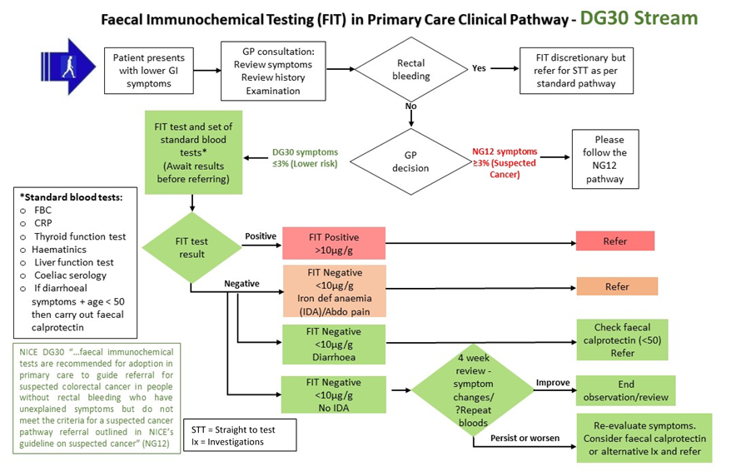

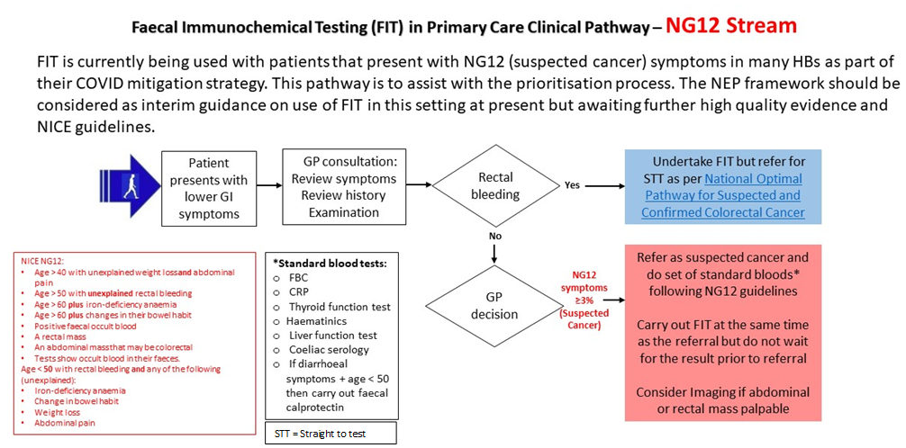

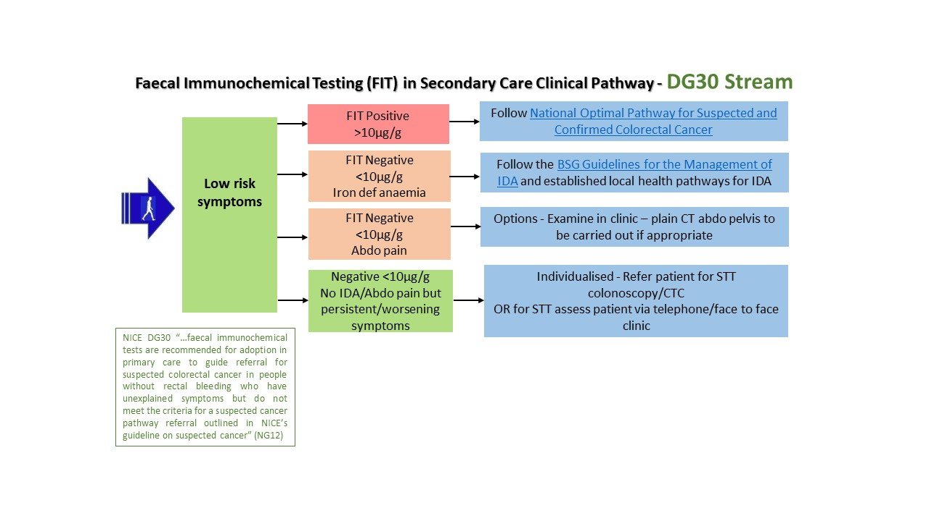
STT = Straight to test

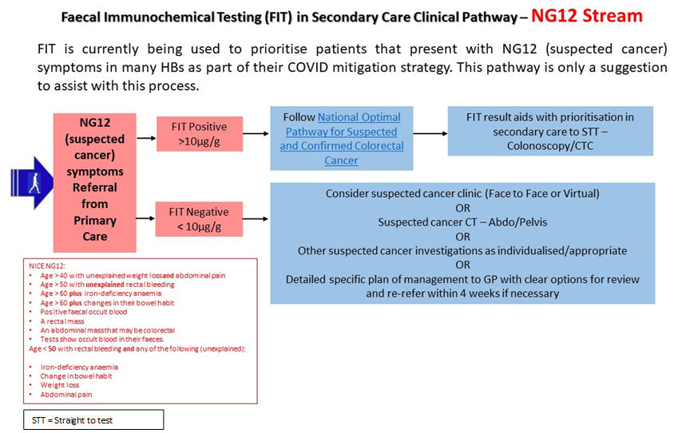

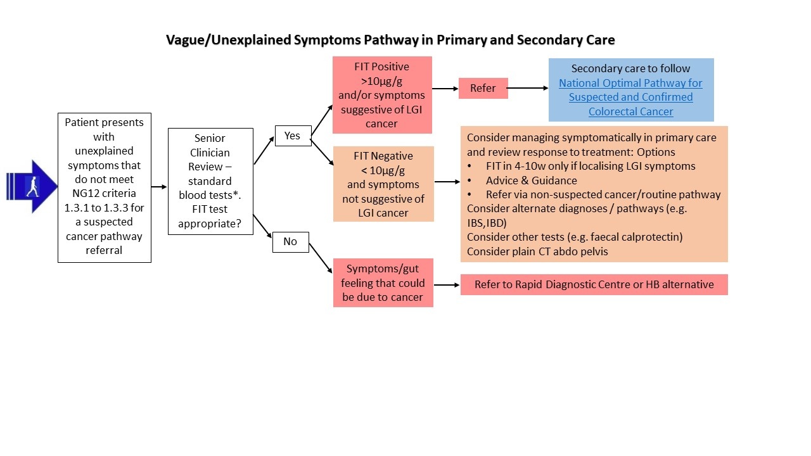
Vague/Non-Specific Symptoms Pathway in Primary and Secondary Care

FIGURE 2 – CWM TAF MORGANNWG LABORATORY PATHOLOGY PATHWAY

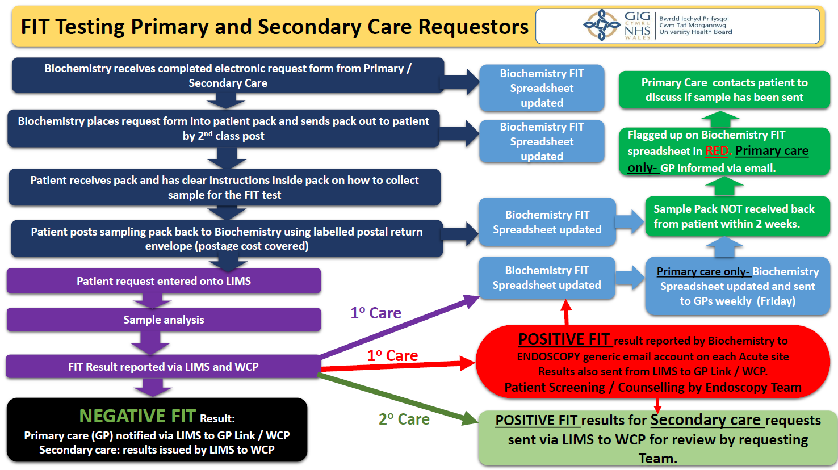

FIGURE 3 – BOWEL SCREENING WALES LABORATORY PATHOLOGY PATHWAY

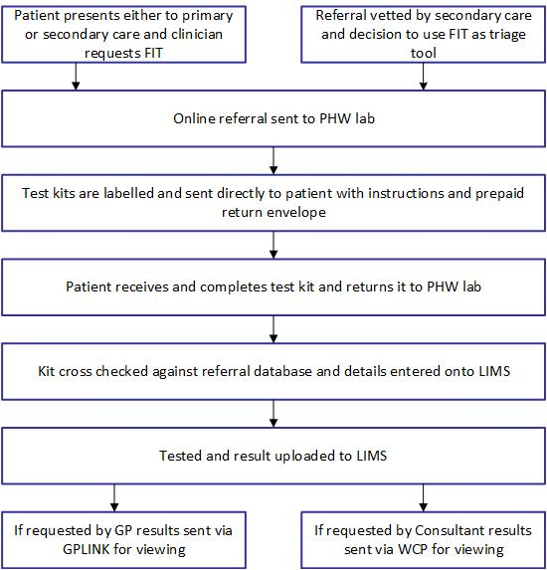

Nicholson B et al Aliment Pharmacol Ther. 2020;52:1031–1041.
Loveday C, et al. Gut 2020;0:1–8. doi:10.1136/gutjnl-2020-321650

